Stalin on the Proletarian Dictatorship
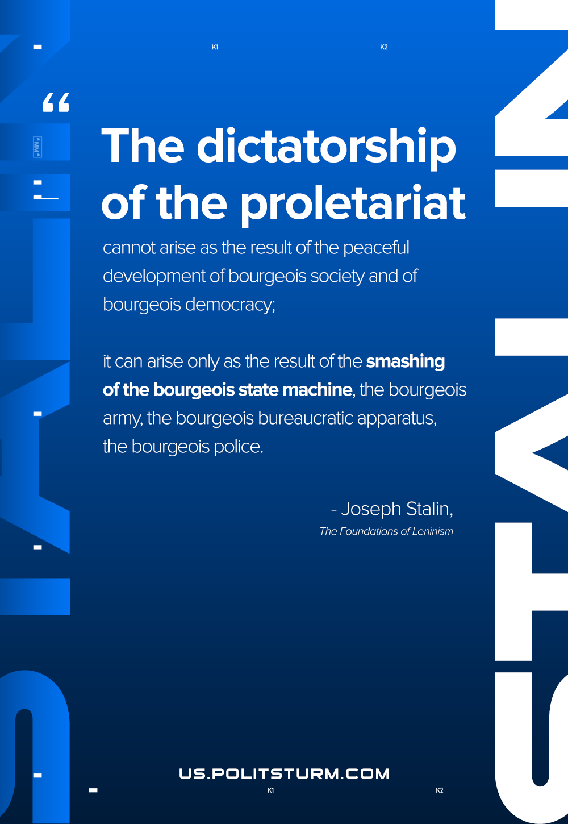

Original article
2020-11-22

The dictatorship of the proletariat cannot arise as the result of the peaceful development of bourgeois society and of bourgeois democracy; it can arise only as the result of the smashing of the bourgeois state machine, the bourgeois army, the bourgeois bureaucratic apparatus, the bourgeois police.
The Foundations of Leninism

Original article

