Stalin on the Principle of International Solidarity of the Workers
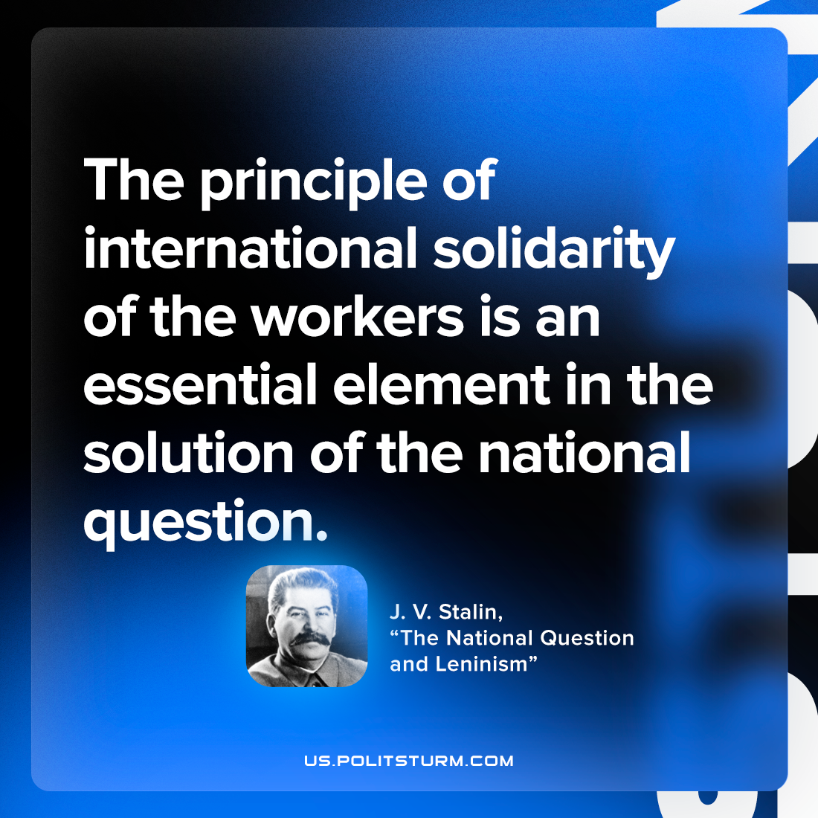

Original article
2023-02-18

"The principle of international solidarity of the workers is an essential element in the solution of the national question."
Joseph Stalin, "Marxism and the National Question"

Original article

