Stalin on the Practical Activity of the Party
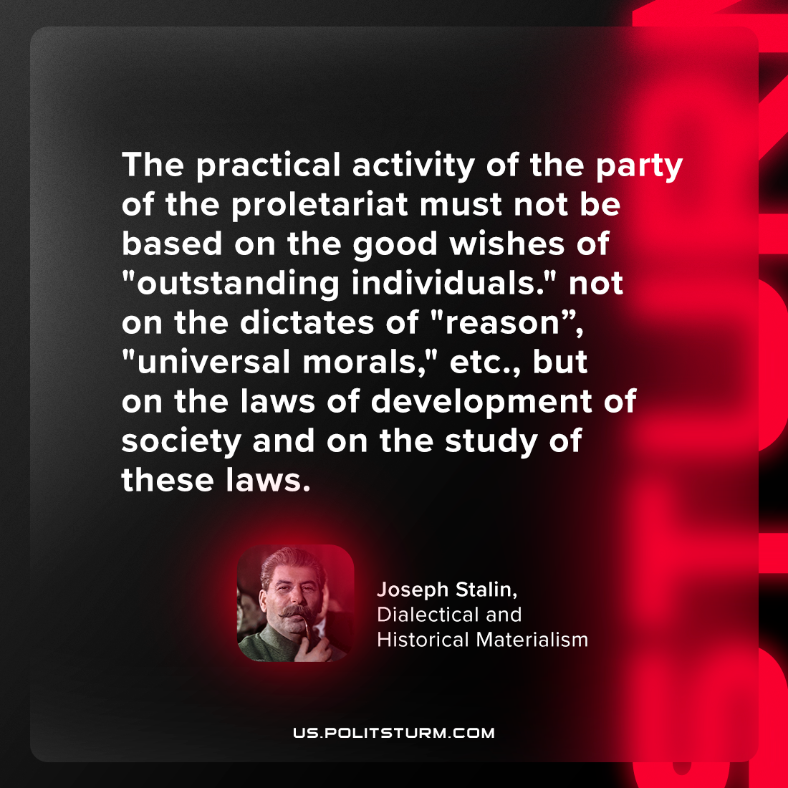

Original article
2024-06-08

"The practical activity of the party of the proletariat must not be based on the good wishes of "outstanding individuals." not on the dictates of "reason," "universal morals," etc., but on the laws of development of society and on the study of these laws."
Joseph Stalin, Dialectical and Historical Materialism

Original article

