Stalin on The Political Spinelessness
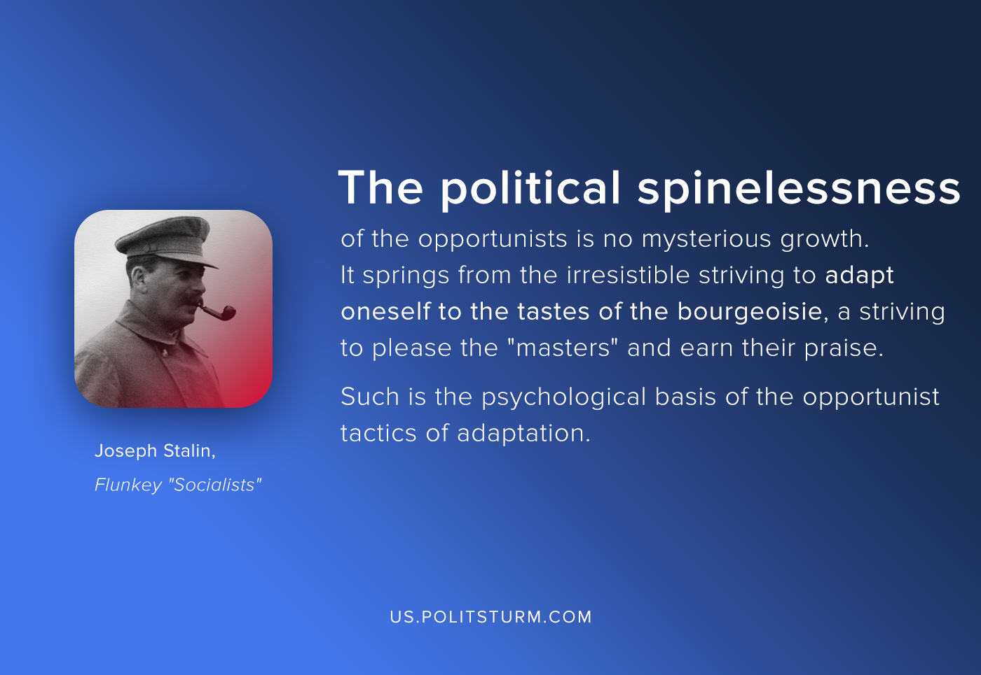

Original article
2020-07-30
1 min read

The political spinelessness of the opportunists is no mysterious growth. It springs from the irresistible striving to adapt oneself to the tastes of the bourgeoisie, a striving to please the “masters” and earn their praise. Such is the psychological basis of the opportunist tactics of adaptation. And so, to stand well with the “gentry,” to please them, or at all events to avert their wrath over the murder of the Exarch, our Menshevik opportunists grovel like flunkeys before them and take upon themselves the function of police sleuths!
Joseph Stalin, Flunkey “Socialists”

Original article

