Stalin on the Peculiarity of the Socialist Revolution
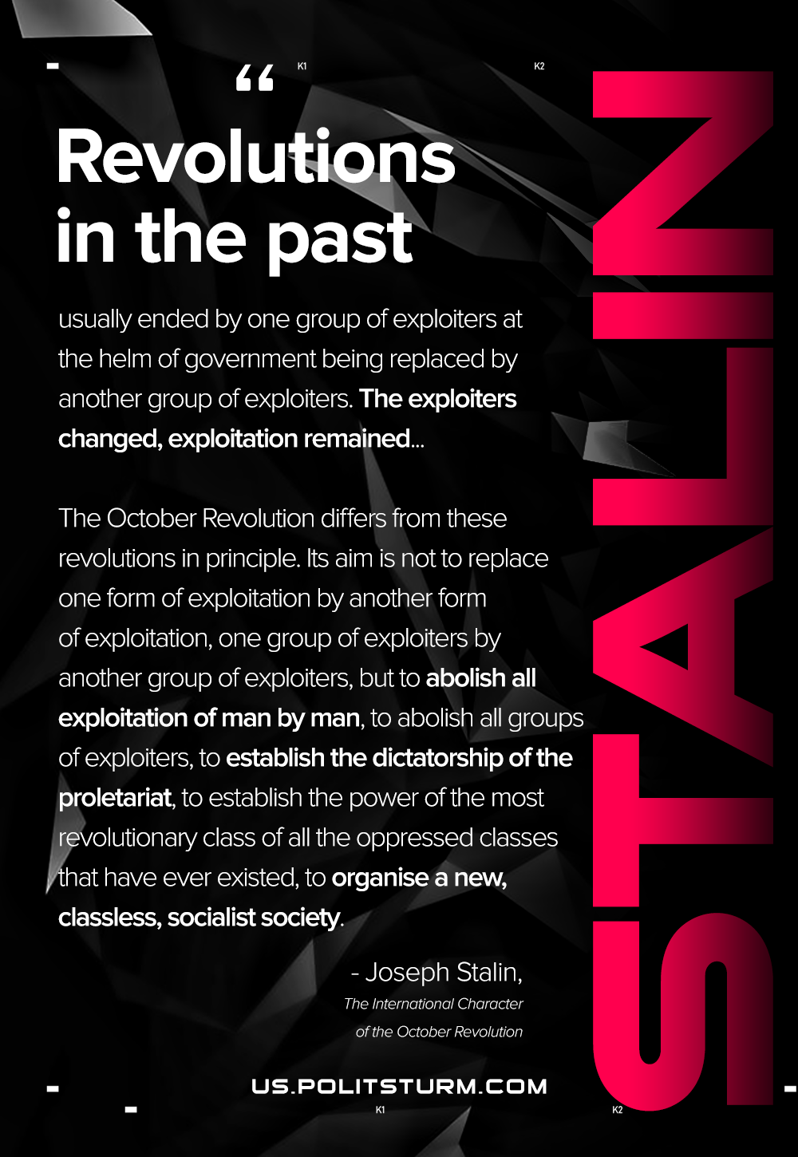

Original article
2020-12-13
1 min read

Revolutions in the past usually ended by one group of exploiters at the helm of government being replaced by another group of exploiters. The exploiters changed, exploitation remained.
Such was the case during the liberation movements of the slaves. Such was the case during the period of the uprisings of the serfs. Such was the case during the period of the well-known “great” revolutions in England, France and Germany. I am not speaking of the Paris Commune, which was the first glorious, heroic, yet unsuccessful attempt on the part of the proletariat to turn history against capitalism.
The October Revolution differs from these revolutions in principle. Its aim is not to replace one form of exploitation by another form of exploitation, one group of exploiters by another group of exploiters, but to abolish all exploitation of man by man, to abolish all groups of exploiters, to establish the dictatorship of the proletariat, to establish the power of the most revolutionary class of all the oppressed classes that have ever existed, to organise a new, classless, socialist society.
It is precisely for this reason that the victory of the October Revolution signifies a radical change in the history of mankind, a radical change in the historical destiny of world capitalism, a radical change in the liberation movement of the world proletariat, a radical change in the methods of struggle and the forms of organisation, in the manner of life and traditions, in the culture and ideology of the exploited masses throughout the world.
That is the basic reason why the October Revolution is a revolution of an international, world order.
Joseph Stalin, The International Character of the October Revolution

Original article

