Stalin on the October Revolution as an Example for the Whole World
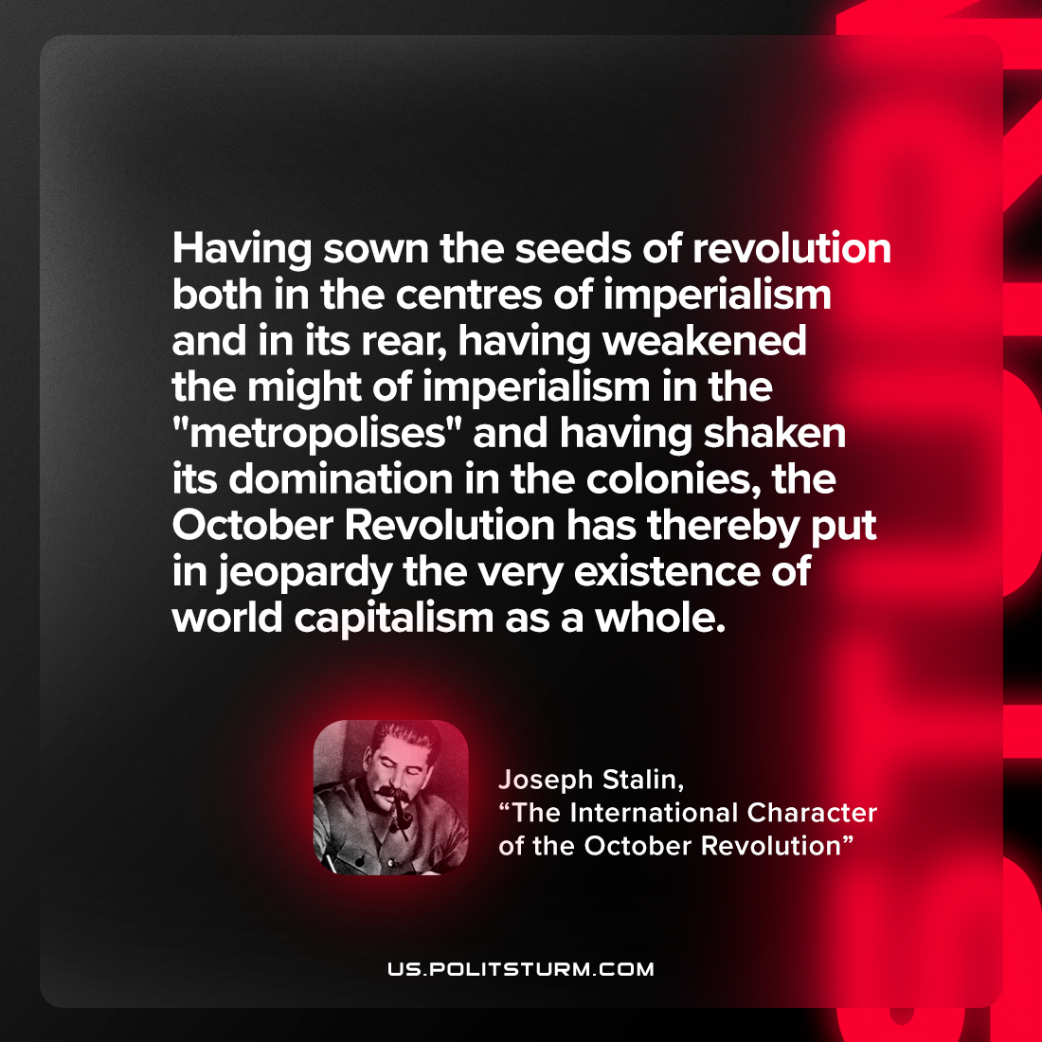

Original article
2023-02-04

"Having sown the seeds of revolution both in the centres of imperialism and in its rear, having weakened the might of imperialism in the "metropolises" and having shaken its domination in the colonies, the October Revolution has thereby put in jeopardy the very existence of world capitalism as a whole."
Joseph Stalin, "The International Character of the October Revolution"

Original article

