Stalin on the National Struggle
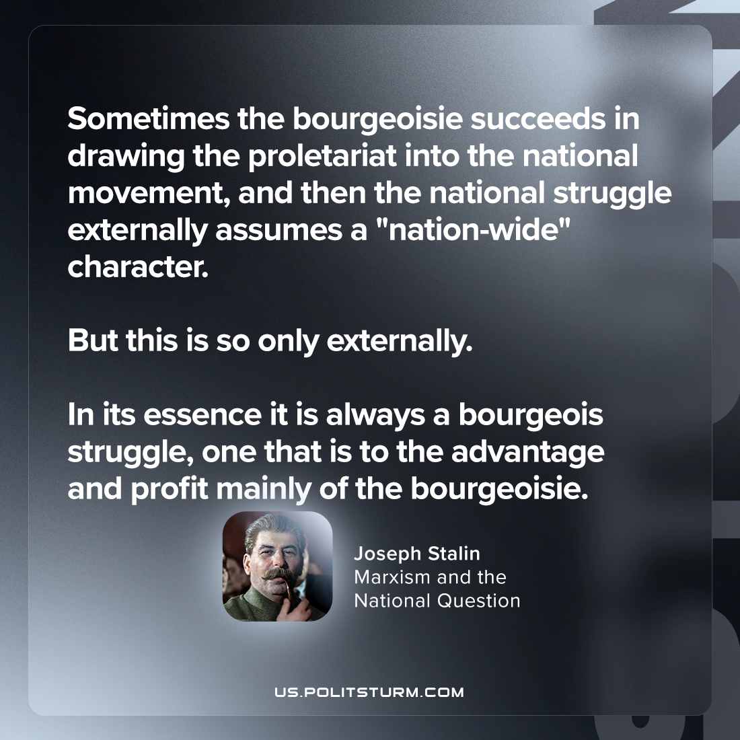

Original article
2024-03-23

“Sometimes the bourgeoisie succeeds in drawing the proletariat into the national movement, and then the national struggle externally assumes a "nation-wide" character. But this is so only externally. In its essence it is always a bourgeois struggle, one that is to the advantage and profit mainly of the bourgeoisie.”
Joseph Stalin, Marxism and the National Question

Original article

