Stalin on the National Struggle under Capitalism
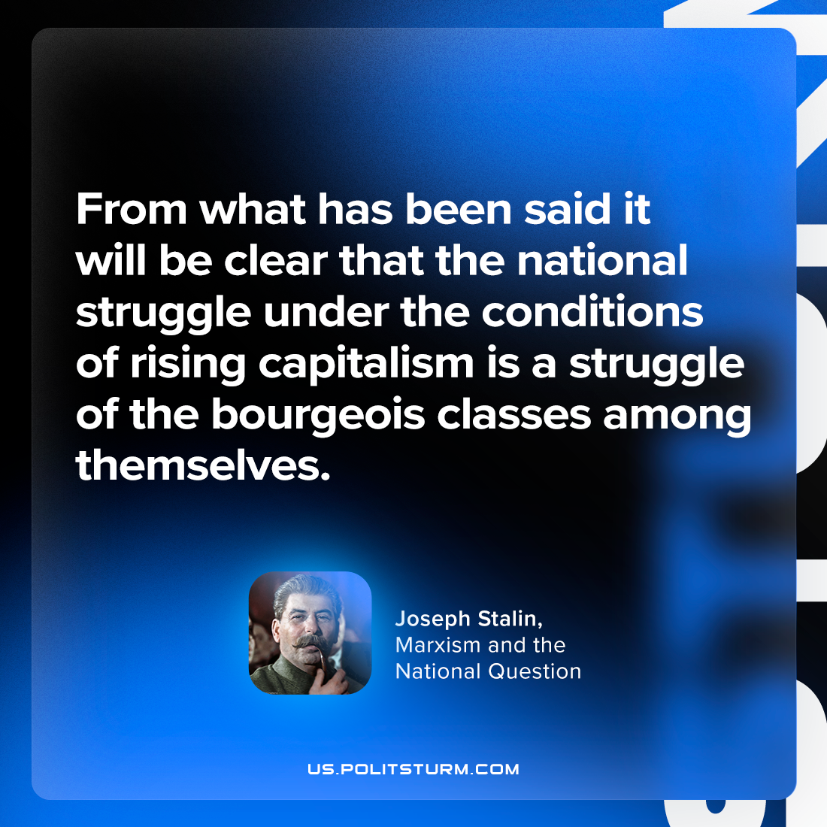

Original article
2023-12-14

"From what has been said it will be clear that the national struggle under the conditions of rising capitalism is a struggle of the bourgeois classes among themselves."
Joseph Stalin, Marxism and the National Question

Original article

