Stalin on the National Oppression
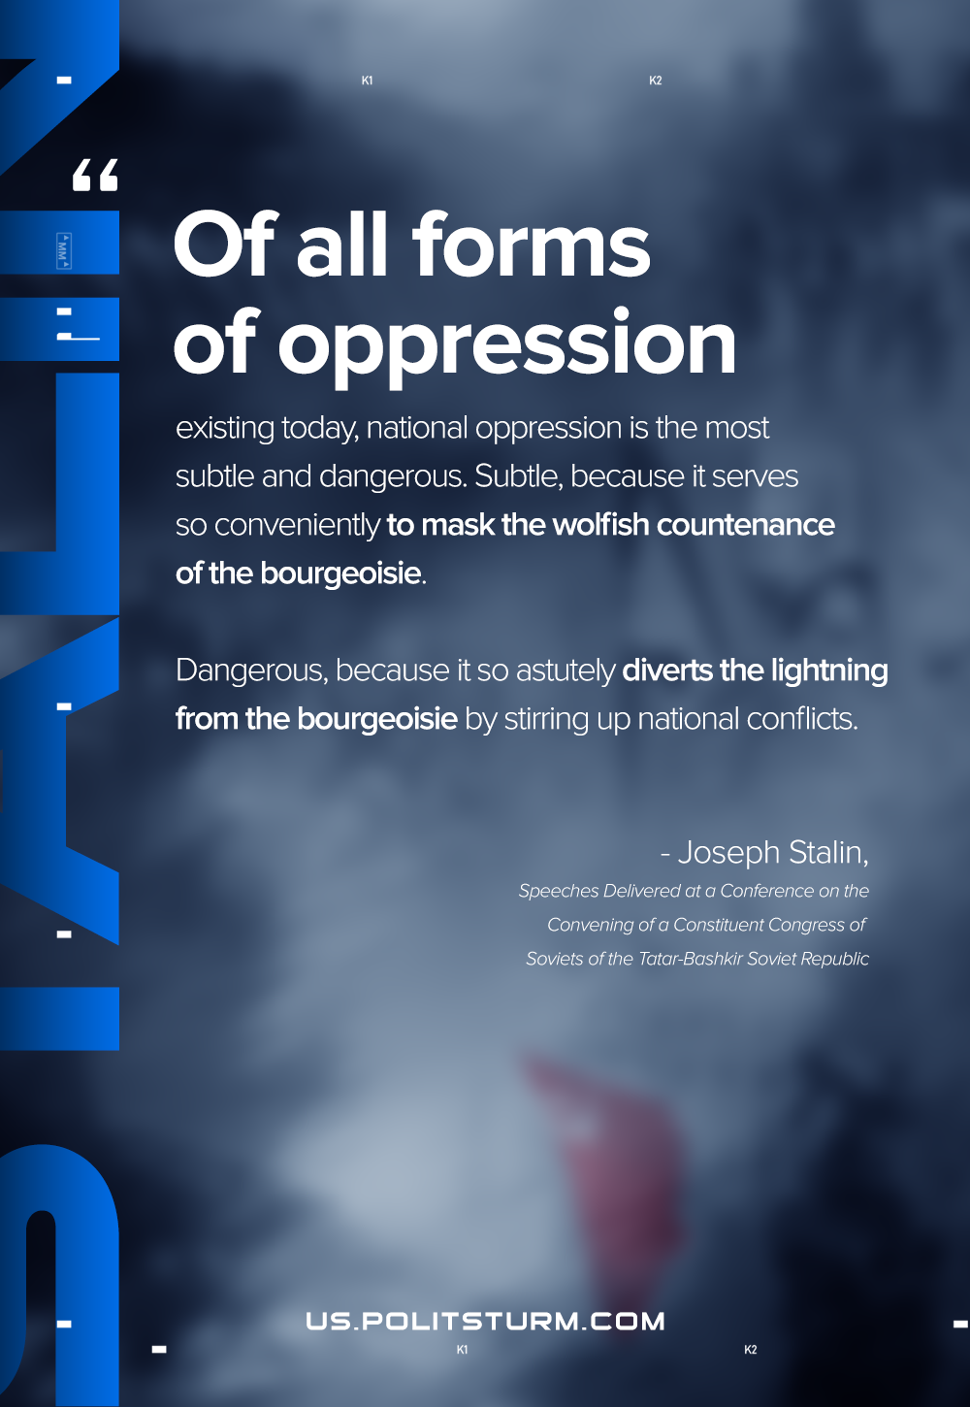

Original article
2020-12-09

Of all forms of oppression existing today, national oppression is the most subtle and dangerous. Subtle, because it serves so conveniently to mask the wolfish countenance of the bourgeoisie. Dangerous, because it so astutely diverts the lightning from the bourgeoisie by stirring up national conflicts.
Joseph Stalin, “Speeches Delivered at a Conference on the Convening of a Constituent Congress of Soviets of the Tatar-Bashkir Soviet Republic”

Original article

