Stalin on the Modern World
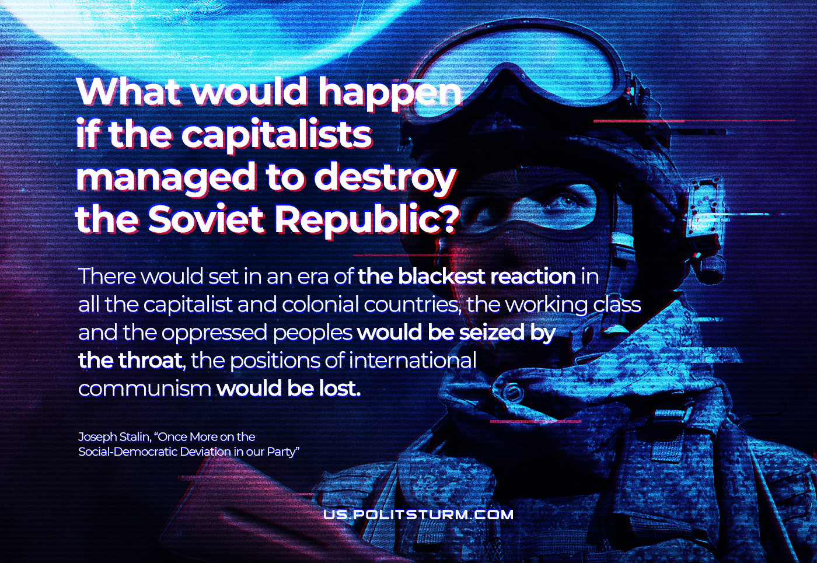

Original article
2022-03-05

What would happen if the capitalists managed to destroy the Soviet Republic? A period of the blackest reaction would set in in all capitalist and colonial countries. The working class and the oppressed nations would be crushed. The positions of international Communism would be destroyed.
Joseph Stalin, Once More on the Social-Democratic Deviation in our Party.

Original article

