Stalin on the Middle Course
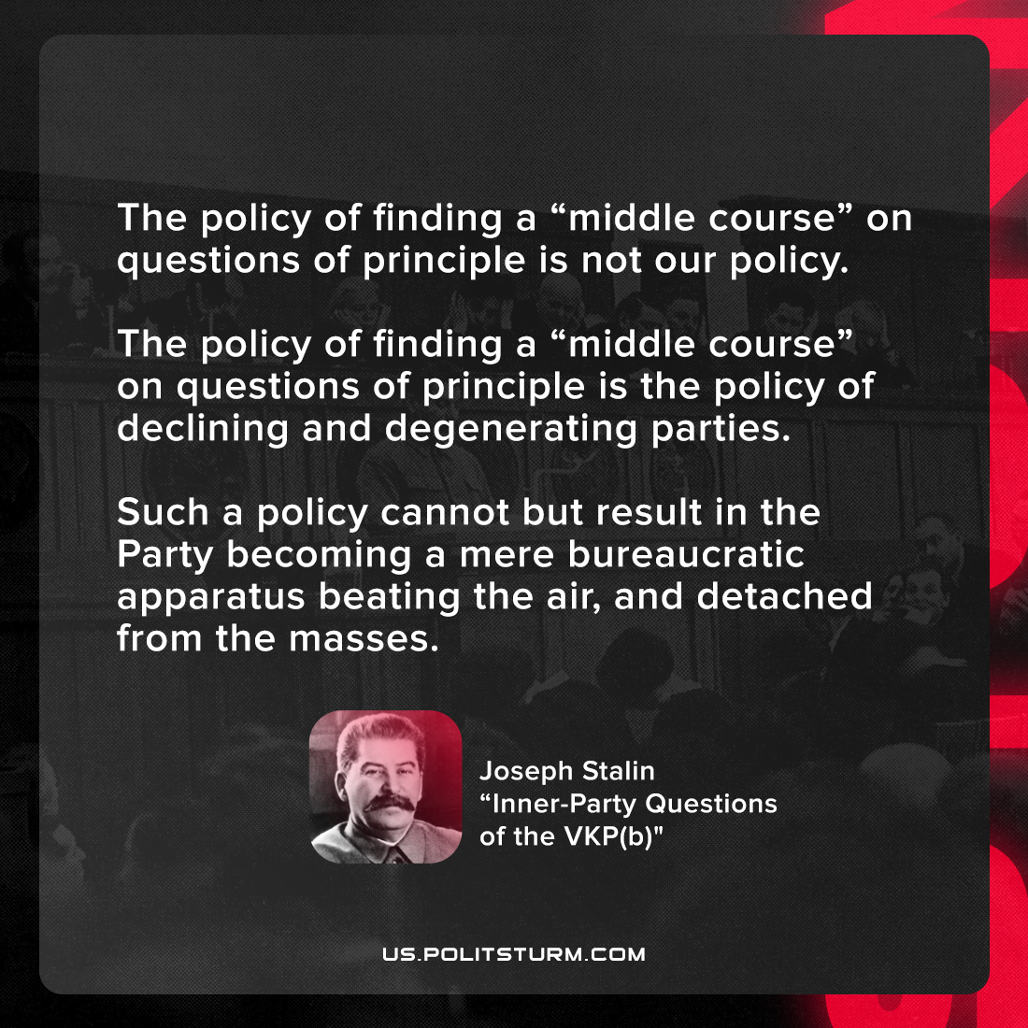

Original article
2021-10-22

The policy of finding a “middle course” on questions of principle is not our policy. The policy of finding a “middle course” on questions of principle is the policy of declining and degenerating parties. Such a policy cannot but result in the Party becoming a mere bureaucratic apparatus beating the air, and detached from the masses.

Joseph Stalin, “Inner-Party Questions of the VKP(b): A Report to the 7th Enlarged Plenum of ECCI, Moscow”

Original article

