Stalin on the Essense of the Bourgeois Diplomacy
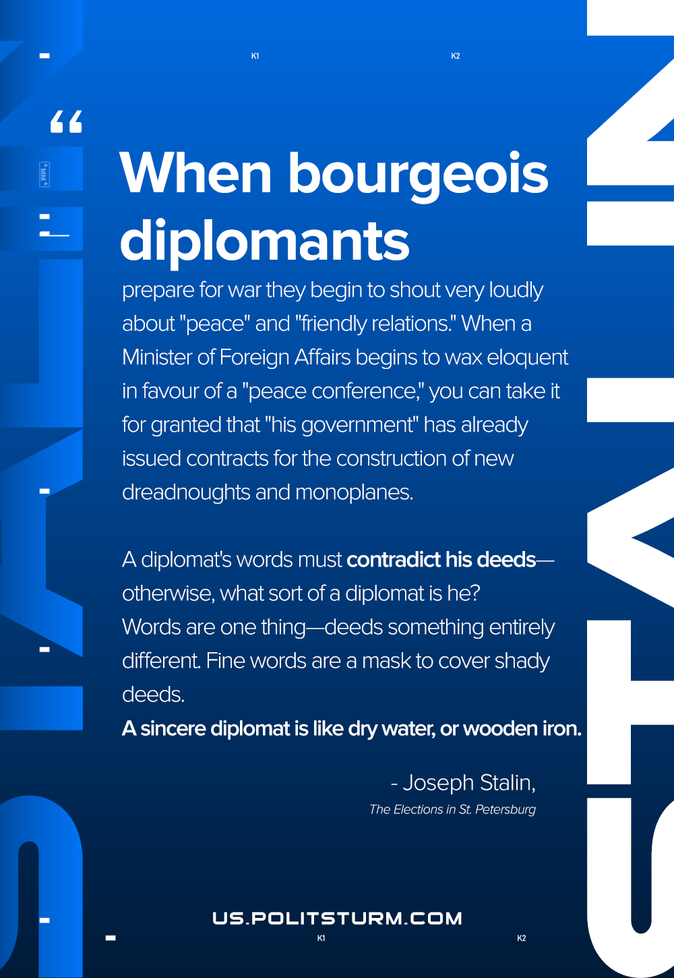

Original article
2020-12-21
1 min read

When bourgeois diplomats prepare for war they begin to shout very loudly about “peace” and “friendly relations.”
When a Minister of Foreign Affairs begins to wax eloquent in favour of a “peace conference,” you can take it for granted that “his government” has already issued contracts for the construction of new dreadnoughts and monoplanes. A diplomat’s words must contradict his deeds—otherwise, what sort of a diplomat is he? Words are one thing—deeds something entirely different. Fine words are a mask to cover shady deeds. A sincere diplomat is like dry water, or wooden iron.
Joseph Stalin, The Elections in St. Petersburg

Original article

