Stalin on the Essence of the State
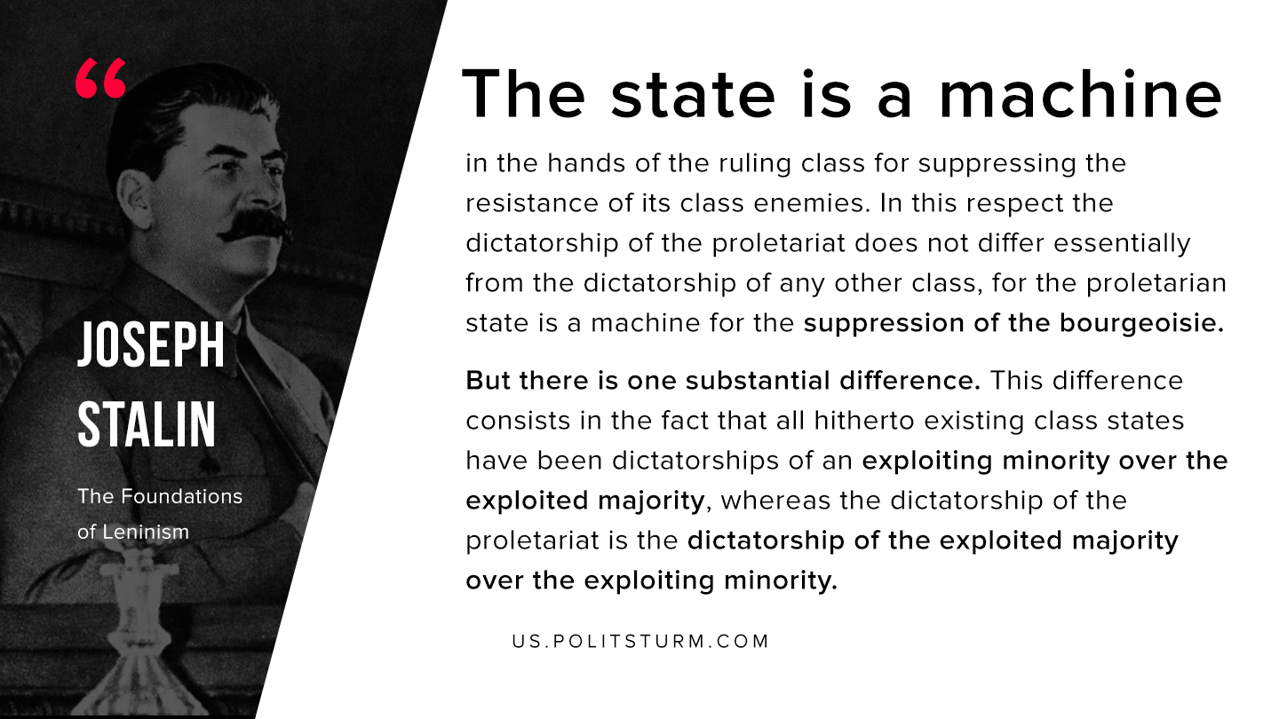

Original article
2020-06-20
1 min read

The state is a machine in the hands of the ruling class for suppressing the resistance of its class enemies. In this respect the dictatorship of the proletariat does not differ essentially from the dictatorship of any other class, for the proletarian state is a machine for the suppression of the bourgeoisie. But there is one substantial difference. This difference consists in the fact that all hitherto existing class states have been dictatorships of an exploiting minority over the exploited majority, whereas the dictatorship of the proletariat is the dictatorship of the exploited majority over the exploiting minority.
Joseph Stalin, “The Foundations of Leninism”

Original article

