Stalin on the Cult of His Personality (from an interview with L. Feuchtwanger)
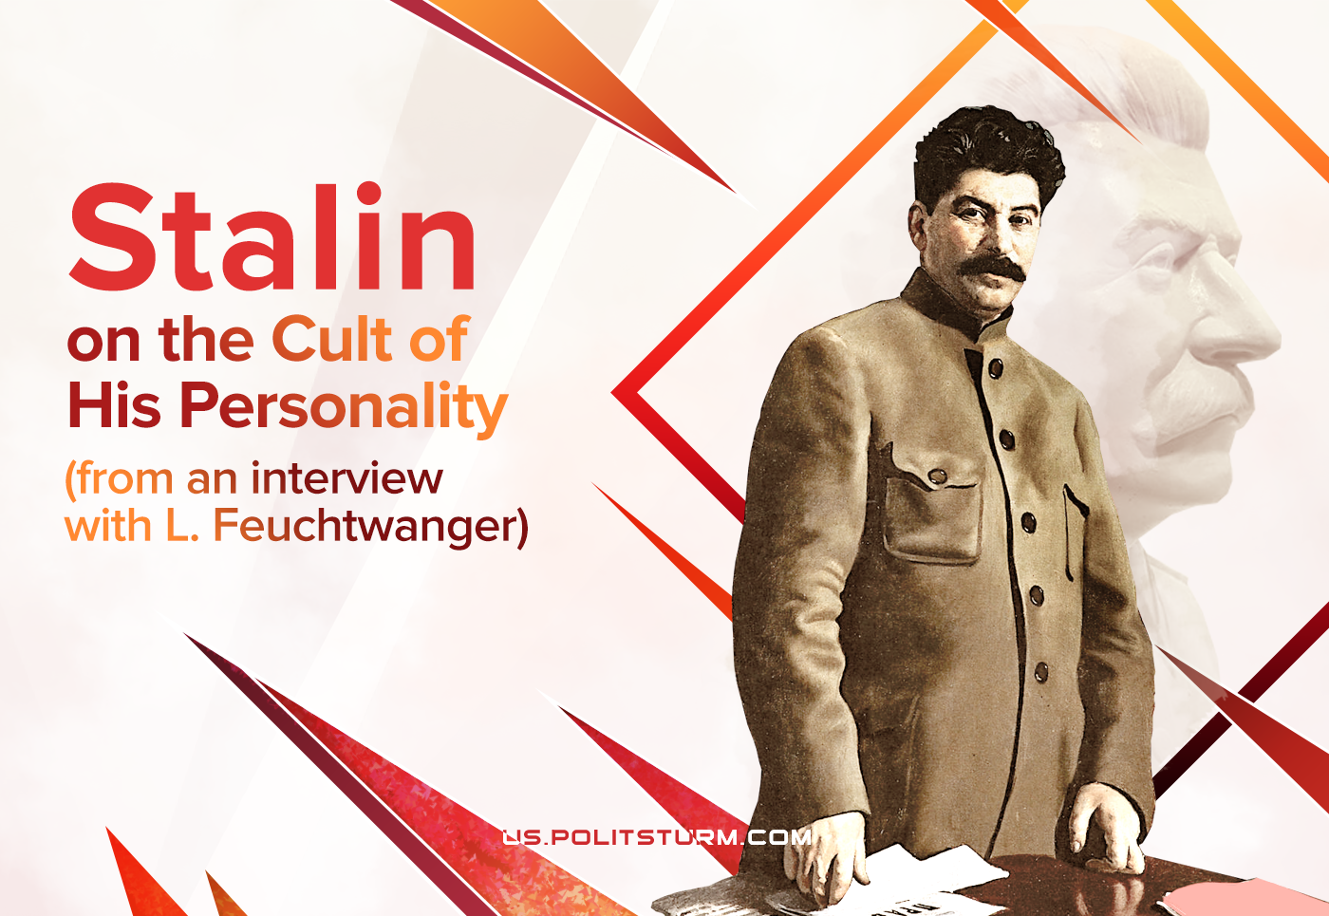

Original article
2021-07-15
6 min read

In 1937 Lion Feuchtwanger travelled to the USSR and took an interview with Stalin. He described this interview in his book “Moscow, 1937”. However, the original text of the interview had been hidden in the archives and was never published until nowadays. We translated an excerpt from it, showing Stalin’s point of view on the problem.
“…Feuchtwanger. I have been here for 4-5 weeks. One of the first impressions: some forms of expression of respect and love for you seem to me exaggerated and tasteless. You give the impression of a simple and modest person. Are these forms an unnecessary burden for you?
Stalin. I totally agree with you. It is unpleasant when exaggerated to hyperbolic sizes. People come to ecstasy because of the little things. Of the hundreds of greetings, I respond only to one or two, I don’t allow most of them to be printed, I don’t allow overly enthusiastic greetings to be printed as soon as I learn about them. 9/10 of these greetings – really bad taste. And they give me an unpleasant feeling.
I would like not to justify – as it is impossible to justify – but to explain humanly, from whence such unrestrained reaching for ecstasy delight around my person comes from. Apparently, in our country we managed to solve a big problem, for which generations of people have fought for centuries: Babouvists, Hebertists, all sorts of French, English, German revolutionaries. Apparently, the solution of this task (cherished by the workers and peasant masses) – liberation from exploitation – causes tremendous delight. People are too happy that they managed to get rid of exploitation. They literally don’t know what to do with their joy.
A very big thing is liberation from exploitation, and the masses celebrate this in their own way. All this is attributed to me – of course, this is certainly not true, what can one person do? In me they see a collective concept and they light a fire of zeal’s raptures around me.
Feuchtwanger. As a person sympathetic to the USSR, I see and feel that the feelings of love and respect for you are completely sincere and elementary. Precisely because you are so loved and respected, can’t you stop with your words these forms of delight that confuse some of your friends abroad?
Stalin. I tried to do this several times. But nothing works. You tell them it’s not good, it won’t do. People think that I am speaking out of false modesty.
They wanted to hold the celebration on the occasion of my 55th birthday. I passed through the Central Committee of the CPSU (b) the prohibition of this. Complaints began to come in, that I was preventing them from celebrating, and expressing their feelings, that it’s not about me. Others said that I was breaking. How can these manifestations of enthusiasm be prevented? Force is impossible. There is freedom of expression. You can ask in a friendly way.
This is a manifestation of a certain lack of culture. Over time, it will get boring. It is difficult to prevent you from expressing your joy. It is a shame to take strict measures against the workers and peasants.
Victories are too great. Previously, the landlord and capitalist were a demiurge, workers and peasants were not considered people. Now the bondage has been removed from the working people. Huge victory! The landlords and capitalists have been expelled, the workers and peasants are the masters of life. They are delighted with veal.
Error loading image
Our people are still lagging behind in terms of general culture, so the expression of delight is the following. A law or a ban cannot do anything here. You can get into a funny situation. And the fact that some people abroad are upset by this – there is nothing you can do about it. Culture is not immediately achieved. We are doing a lot in this area: for example, in 1935 and 1936 alone, we built over two thousand new schools in cities. We are trying by all means to raise the level of culture, but the results will show in 5-6 years. The cultural rise is slow. Delights grow violently and ugly.
Feuchtwanger. I am not talking about the feeling of love and respect on the part of the workers and peasants, but about other cases. Your busts exposed in different places are ugly and poorly made. At the exhibition of the planning of Moscow, where, nevertheless, first of all, they think about you – why is there a bad bust? At the Rembrandt exhibition, unfolded with great taste, why is there a bad bust?
Stalin. The question is natural. I was referring to the broad masses, not bureaucrats from various institutions. As for the bureaucrats, they can be said to have no taste. They are afraid that if there is no bust of Stalin, then either the newspaper or the boss will scold them, or the visitor will be surprised. This is an area of careerism, a peculiar form of “self-defence” of bureaucrats: in order not to be touched, a bust of Stalin must be exposed.
Alien elements, careerists, are attached to any party that wins. They try to defend themselves on the principle of mimicry – they exhibit busts, write slogans that they themselves do not believe in. As for the poor quality of the busts, this is done not only on purpose (I know it happens) but also out of an inability to choose. For example, I saw portraits of me and my comrades on the May Day demonstration: similar to devils. People carry it with delight and do not understand that portraits are not good. You cannot issue an order for good busts to be exhibited – well, to hell with them! There is no time to do such things, we have other things to do and worries, you don’t even look at these busts…”

Original article

