Stalin on the Building of Socialism
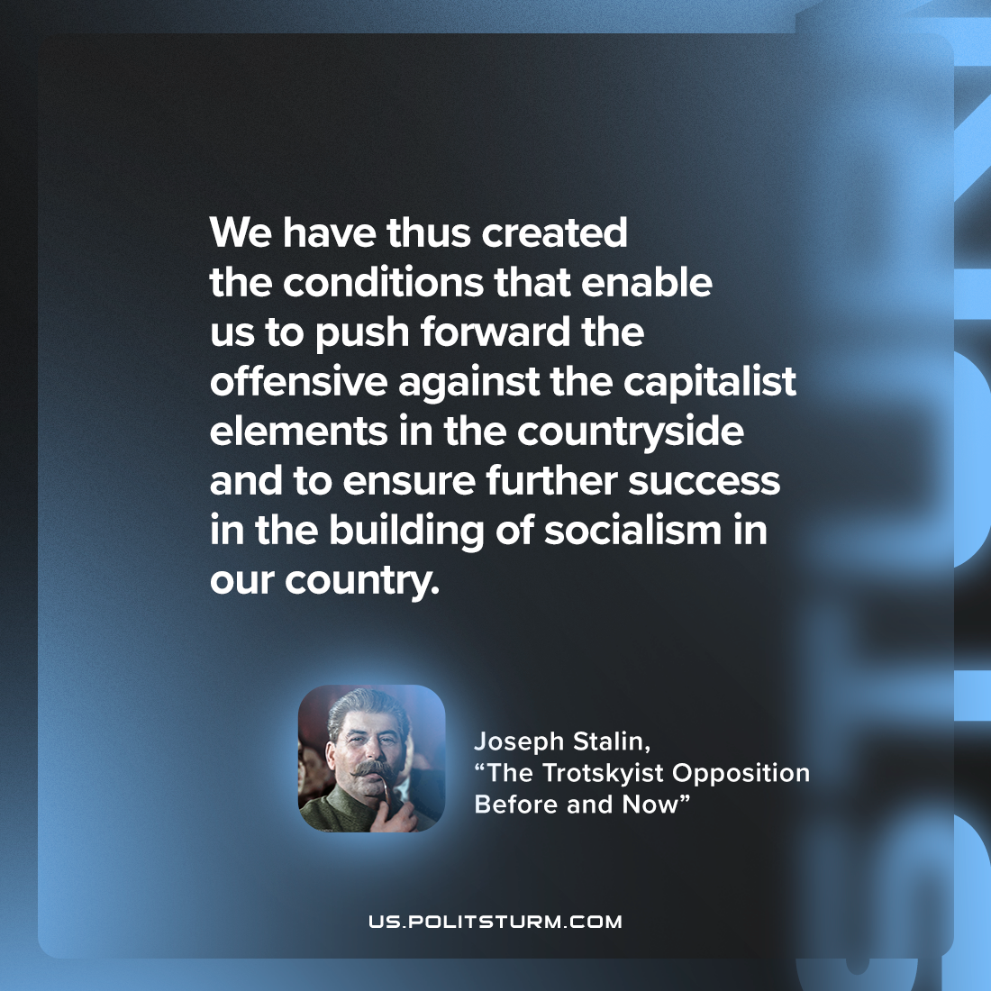

Original article
2023-03-25

"We have thus created the conditions that enable us to push forward the offensive against the capitalist elements in the countryside and to ensure further success in the building of socialism in our country."
Joseph Stalin, “The Trotskyist Opposition Before and Now”

Original article

