Stalin on Socialism
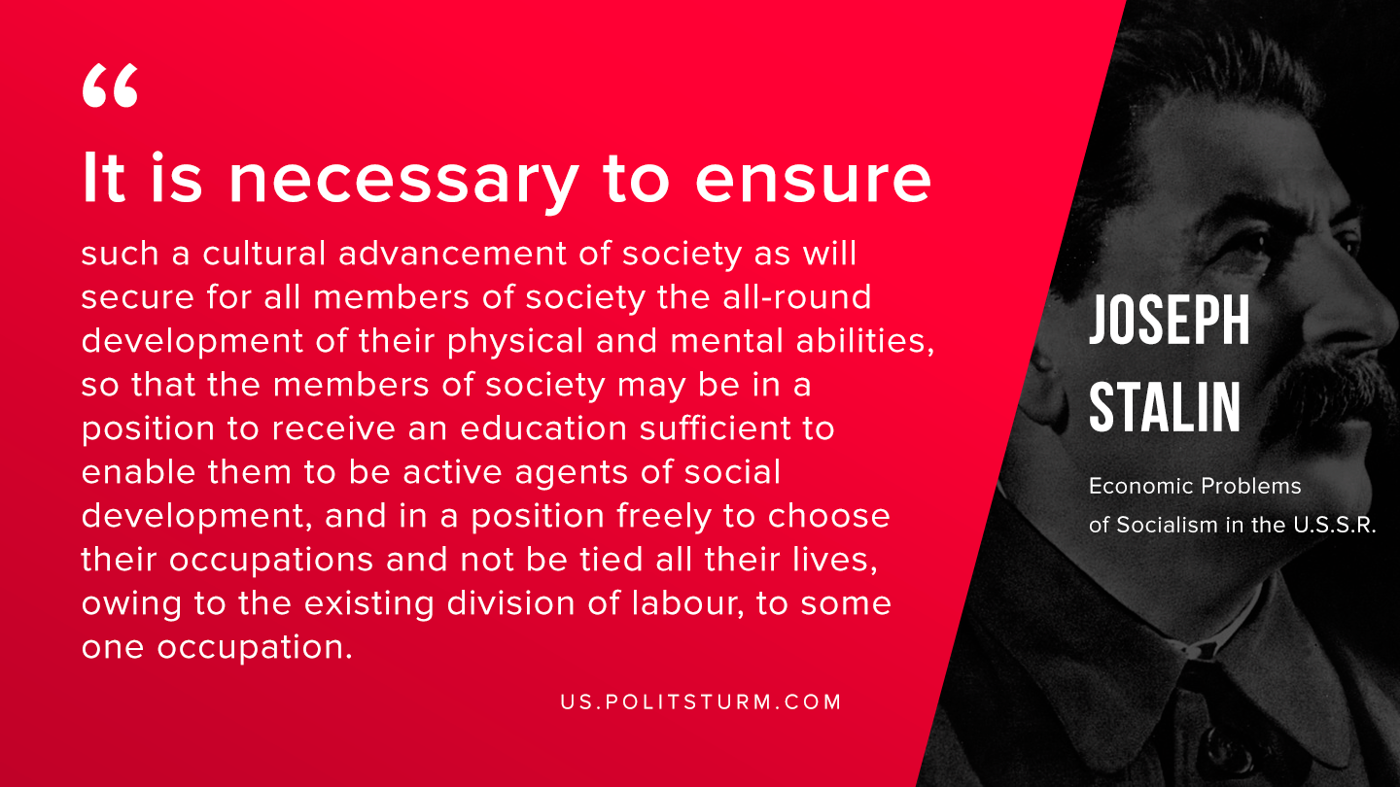

Original article
2019-11-13
1 min read

It is necessary to ensure such a cultural advancement of society as will secure for all members of society the all-round development of their physical and mental abilities, so that the members of society may be in a position to receive an education sufficient to enable them to be active agents of social development, and in a position freely to choose their occupations and not be tied all their lives, owing to the existing division of labour, to some one occupation.
J.W. Stalin, “Economic Problems of Socialism in U.S.S.R”

Original article

