Stalin on Social-Democratic Deviation
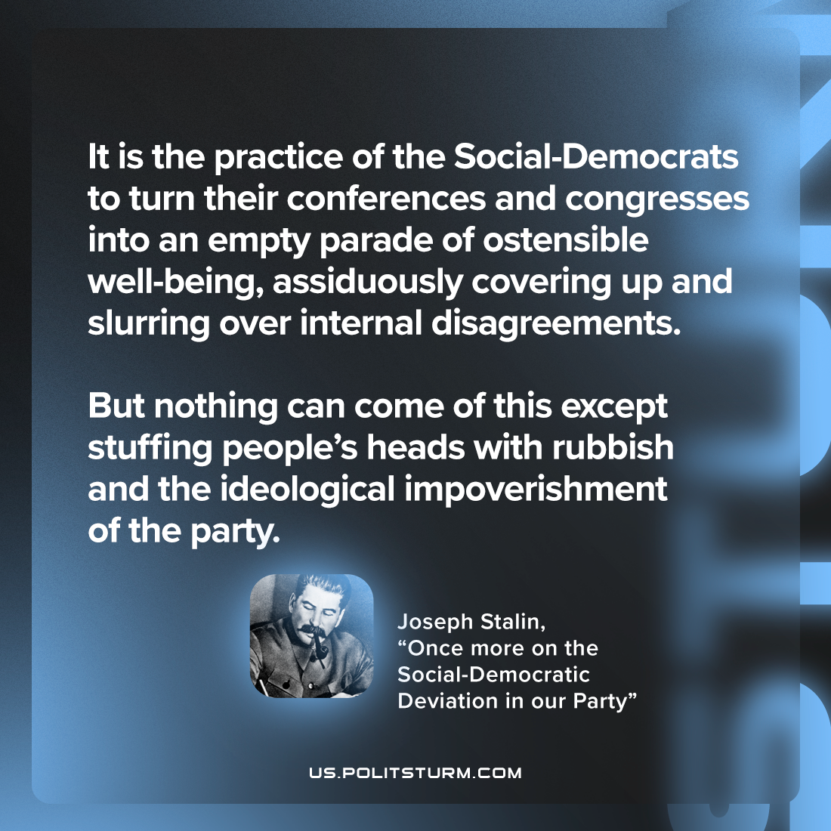

Original article
2023-03-12

"It is the practice of the Social-Democrats to turn their conferences and congresses into an empty parade of ostensible well-being, assiduously covering up and slurring over internal disagreements. But nothing can come of this except stuffing people’s heads with rubbish and the ideological impoverishment of the party."
Joseph Stalin, “Once More on the Social-Democratic Deviation in our Party”

Original article

