Stalin on Russian Revolutionary Sweep
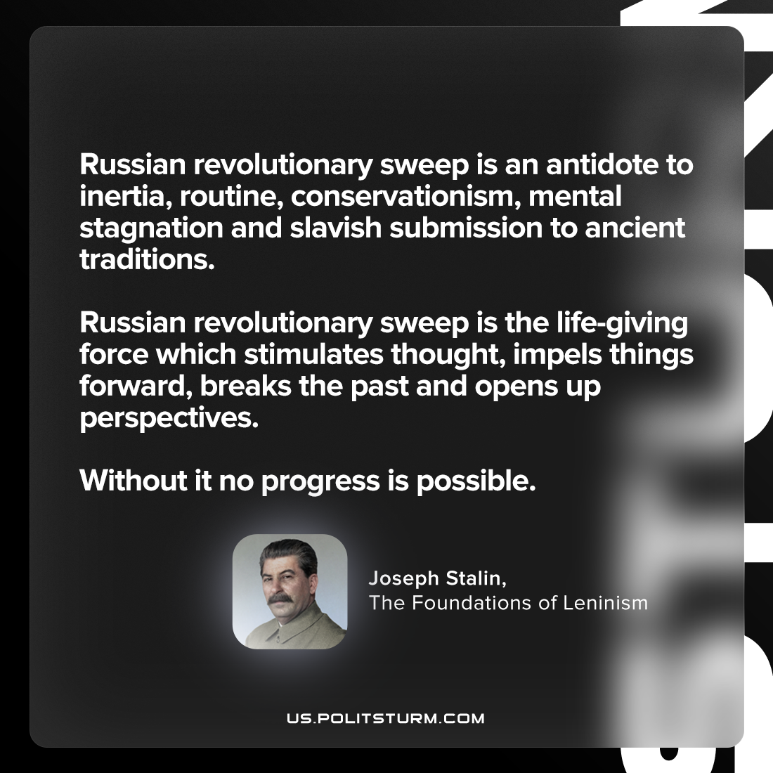

Original article
2023-07-02

"Russian revolutionary sweep is an antidote to inertia, routine, conservationism, mental stagnation and slavish submission to ancient traditions. Russian revolutionary sweep is the life-giving force which stimulates thought, impels things forward, breaks the past and opens up perspectives. Without it no progress is possible."
Joseph Stalin, The Foundations of Leninism

Original article

