Stalin on Rights and "Lefts" Deviations
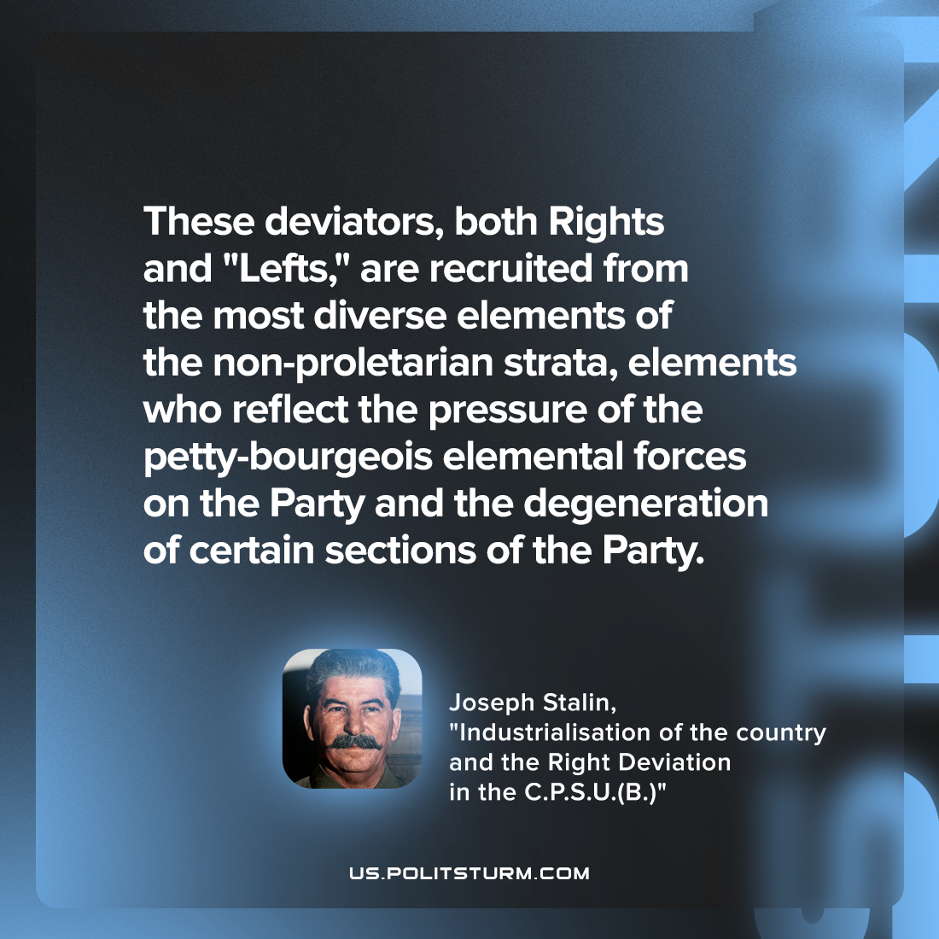

Original article
2023-02-23

"These deviators, both Rights and "Lefts," are recruited from the most diverse elements of the non-proletarian strata, elements who reflect the pressure of the petty-bourgeois elemental forces on the Party and the degeneration of certain sections of the Party."
Joseph Stalin, "Industrialisation of the country and the Right Deviation in the C.P.S.U.(B.)"

Original article

