Stalin on Right to Self-Determination and Imperialism
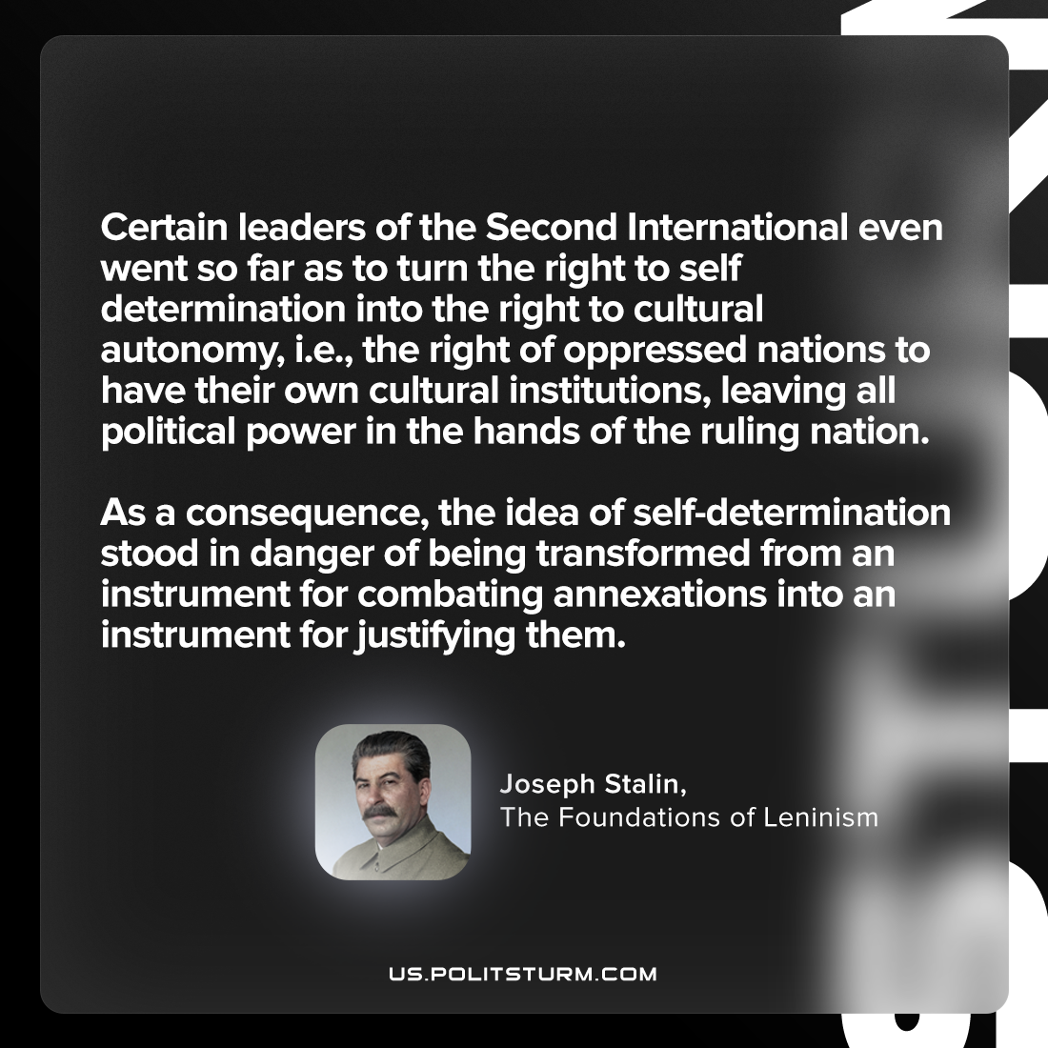

Original article
2023-07-23

"Certain leaders of the Second International even went so far as to turn the right to self-determination into the right to cultural autonomy, i.e., the right of oppressed nations to have their own cultural institutions, leaving all political power in the hands of the ruling nation. As a consequence, the idea of self-determination stood in danger of being transformed from an instrument for combating annexations into an instrument for justifying them."
Joseph Stalin, The Foundations of Leninism

Original article

