Stalin on Reformism
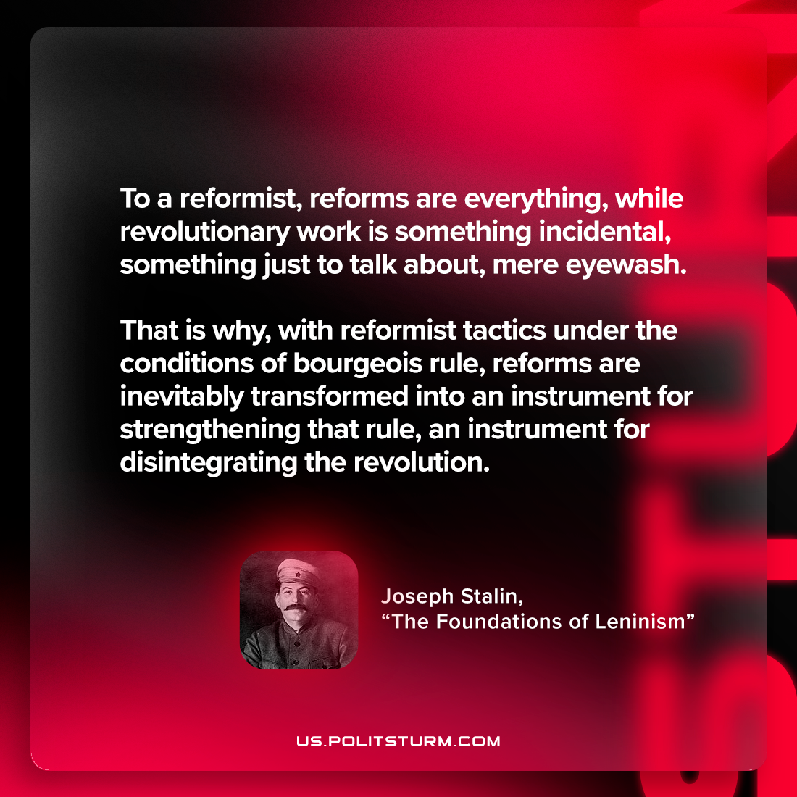

Original article
2023-01-07

"To a reformist, reforms are everything, while revolutionary work is something incidental, something just to talk about, mere eyewash. That is why, with reformist tactics under the conditions of bourgeois rule, reforms are inevitably transformed into an instrument for strengthening that rule, an instrument for disintegrating the revolution."
Joseph Stalin, "The Foundations of Leninism"

Original article

