Stalin on Pressure of the Bourgeoise Ideology
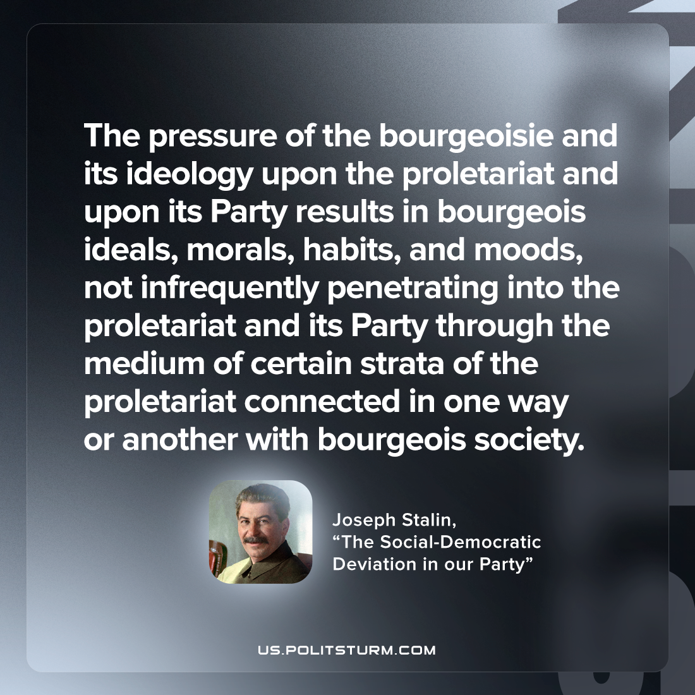

Original article
2023-04-29

"The pressure of the bourgeoisie and its ideology upon the proletariat and upon its Party results in bourgeois ideals, morals, habits, and moods, not infrequently penetrating into the proletariat and its Party through the medium of certain strata of the proletariat connected in one way or another with bourgeois society."
Joseph Stalin, “Once More on the Social-Democratic Deviation in our Party”

Original article

