Stalin on Mutual Trust
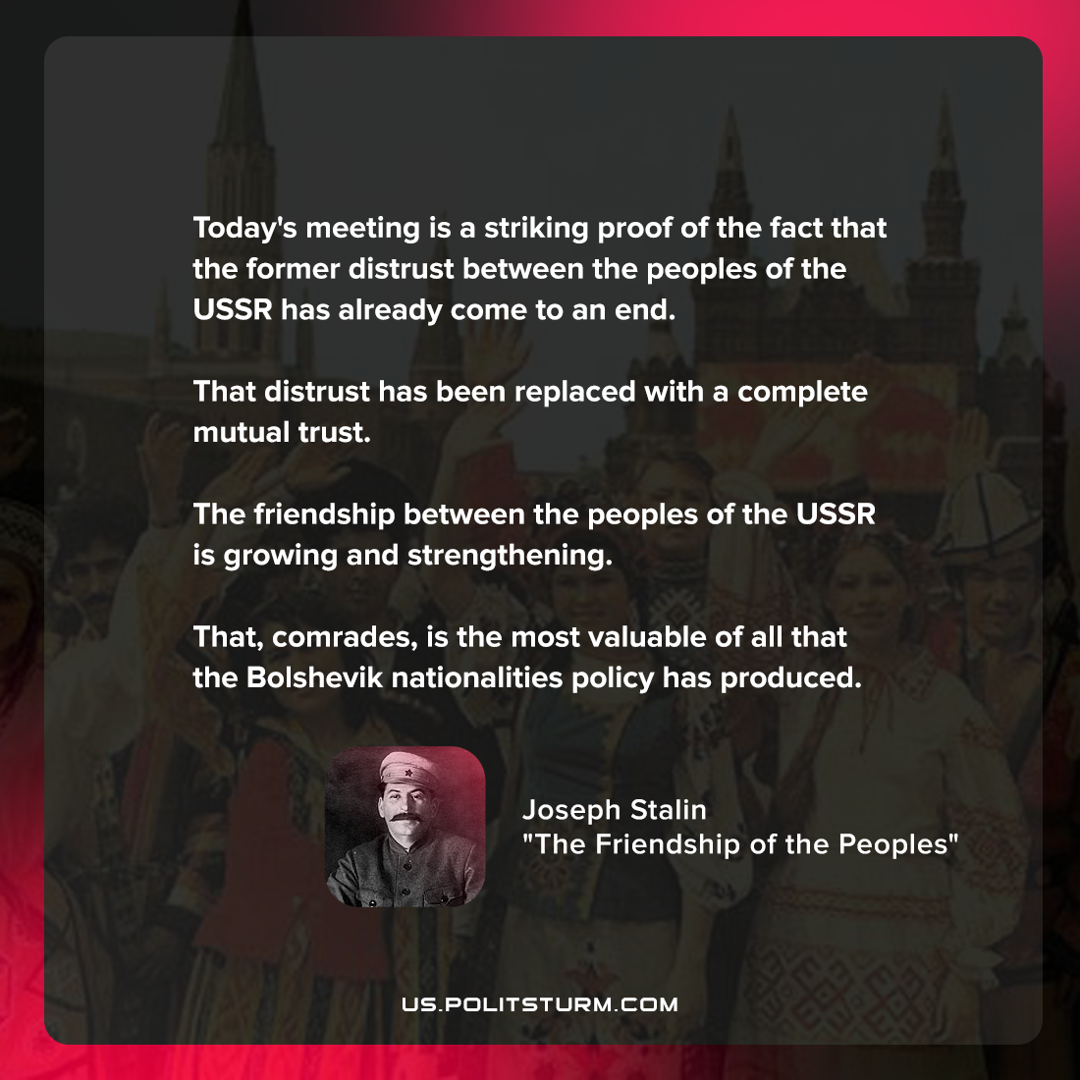

Original article
2022-04-18

Today’s meeting is a striking proof of the fact that the former distrust between the peoples of the USSR has already come to an end. That distrust has been replaced with a complete mutual trust. The friendship between the peoples of the USSR is growing and strengthening. That, comrades, is the most valuable of all that the Bolshevik nationalities policy has produced.

Joseph Stalin, “The Friendship of the Peoples”

Original article

