Stalin on Market and Nationalism
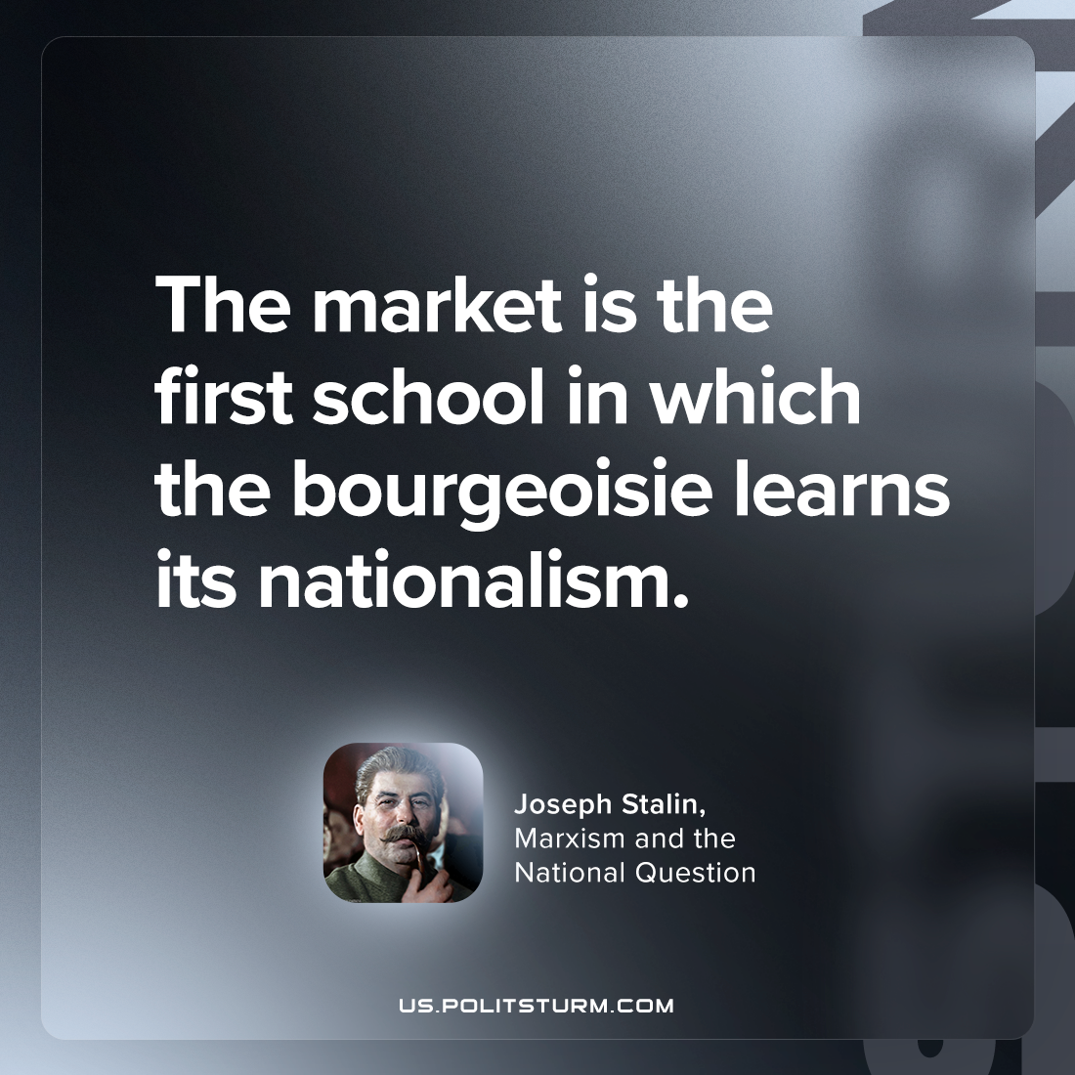

Original article
2023-04-13

"The market is the first school in which the bourgeoisie learns its nationalism."
Joseph Stalin, "Marxism and the National Question"

Original article

