Stalin on Liberty
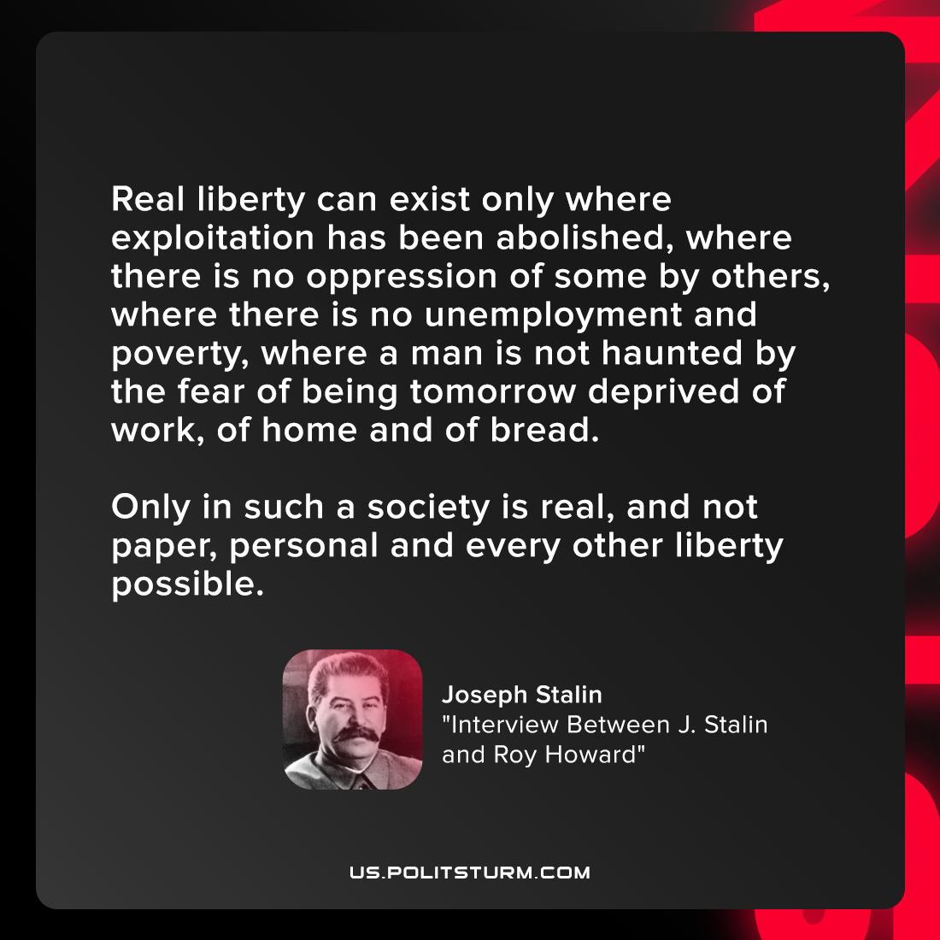

Original article
2021-10-03
1 min read

Under capitalism the exploited masses do not, nor can they ever, really participate in governing the country, if for no other reason than that, even under the most democratic regime, under conditions of capitalism, governments are not set up by the people but by the Rothschilds and Stinneses, the Rockefellers and Morgans. Democracy under capitalism is capitalist democracy, the democracy of the exploiting minority, based on the restriction of the rights of exploited majority and directed against this majority.

Joseph Stalin, “The Foundations of Leninism”

Original article

