Stalin on Lenin
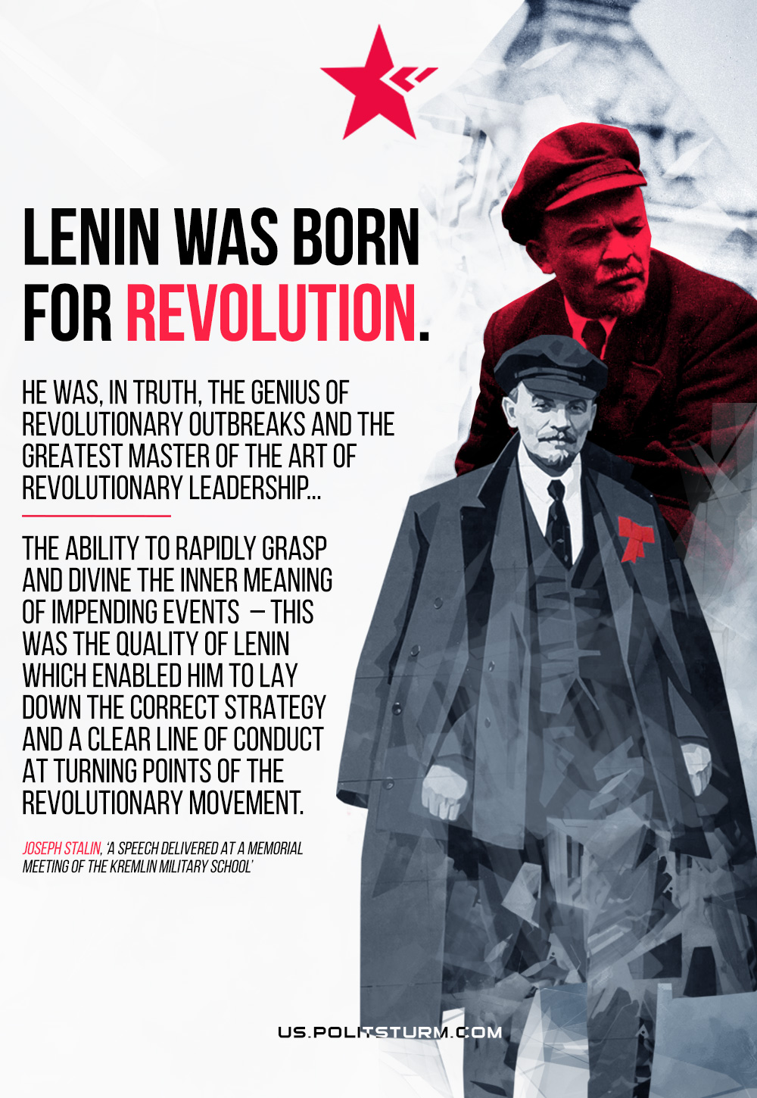

Original article
2022-04-22
1 min read

Lenin was born for revolution. He was, in truth, the genius of revolutionary outbreaks and the greatest master of the art of revolutionary leadership… The insight of genius, the ability rapidly to grasp and divine the inner meaning of impending events this was the quality of Lenin which enabled him to lay down the correct strategy and a clear line of conduct at turning points of the revolutionary movement.

Joseph Stalin, “A Speech Delivered at a Memorial Meeting of the Kremlin Military School”

Original article

