Stalin on "Left Communists"
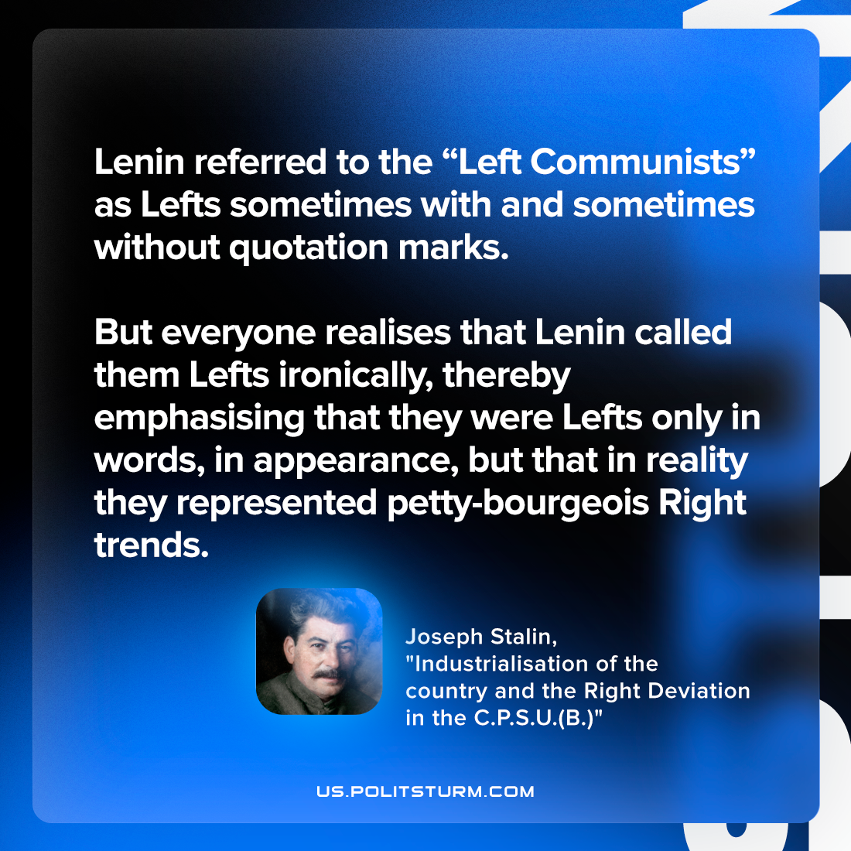

Original article
2023-04-30

"Lenin referred to the “Left Communists” as Lefts sometimes with and sometimes without quotation marks. But everyone realises that Lenin called them Lefts ironically, thereby emphasising that they were Lefts only in words, in appearance, but that in reality they represented petty-bourgeois Right trends."
Joseph Stalin, "Industrialisation of the country and the Right Deviation in the C.P.S.U.(B.)"

Original article

