Stalin on Individuals Role in History
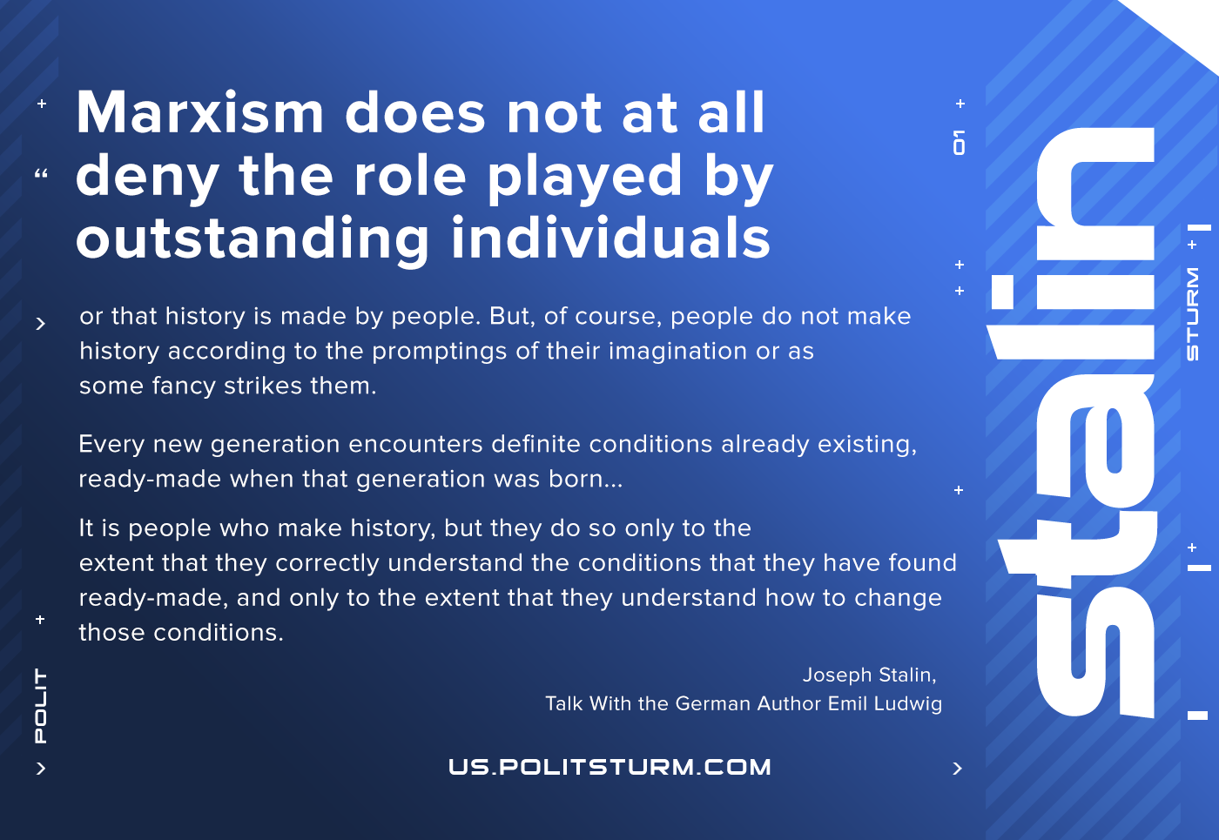

Original article
2021-06-29
1 min read

Marxism does not at all deny the role played by outstanding individuals or that history is made by people. But, of course, people do not make history according to the promptings of their imagination or as some fancy strikes them.
Every new generation encounters definite conditions already existing, ready-made when that generation was born. And great people are worth anything at all only to the extent that they are able correctly to understand these conditions, to understand how to change them. If they fail to understand these conditions and want to alter them according to the promptings of their imagination, they will land themselves in the situation of Don Quixote.
Thus it is precisely Marx’s view that people must not be counterposed to conditions. It is people who make history, but they do so only to the extent that they correctly understand the conditions that they have found ready-made, and only to the extent that they understand how to change those conditions.
Joseph Stalin, “Talk With the German Author Emil Ludwig”

Original article

