Stalin on Imperialist Wars
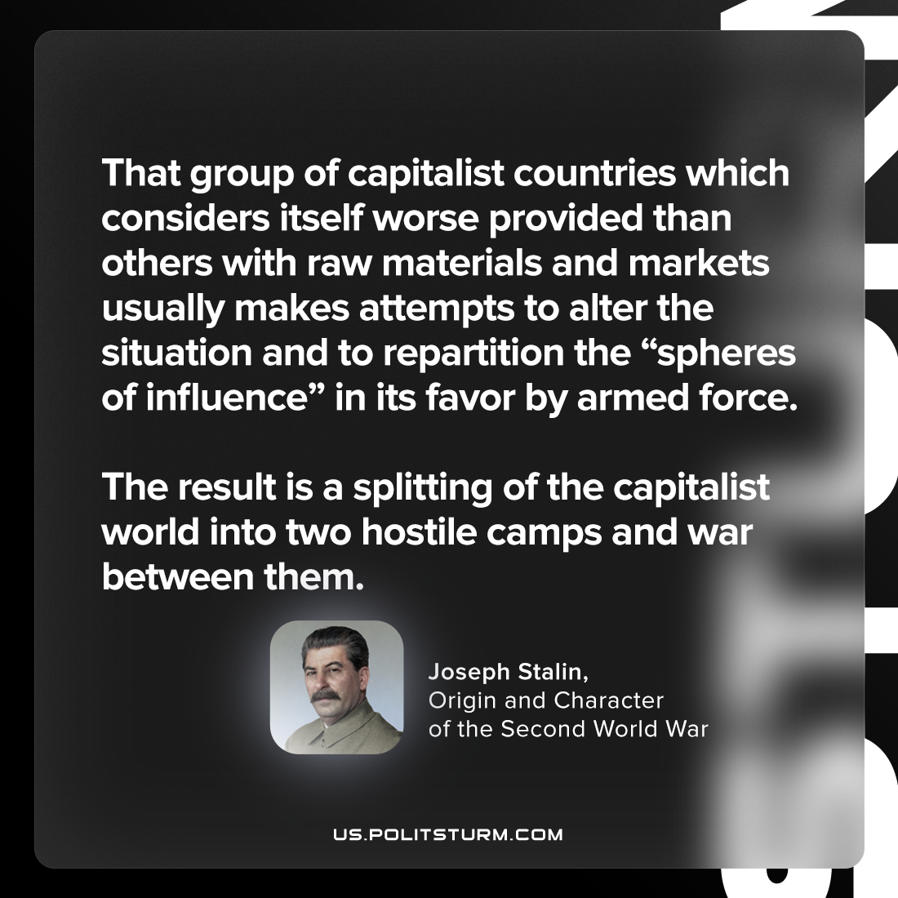

Original article
2023-06-10

"That group of capitalist countries which considers itself worse provided than others with raw materials and markets usually makes attempts to alter the situation and to repartition the “spheres of influence” in its favor by armed force. The result is a splitting of the capitalist world into two hostile camps and war between them."
Joseph Stalin, Origin and Character of the Second World War

Original article

