Stalin on Imperialist Relations in the World
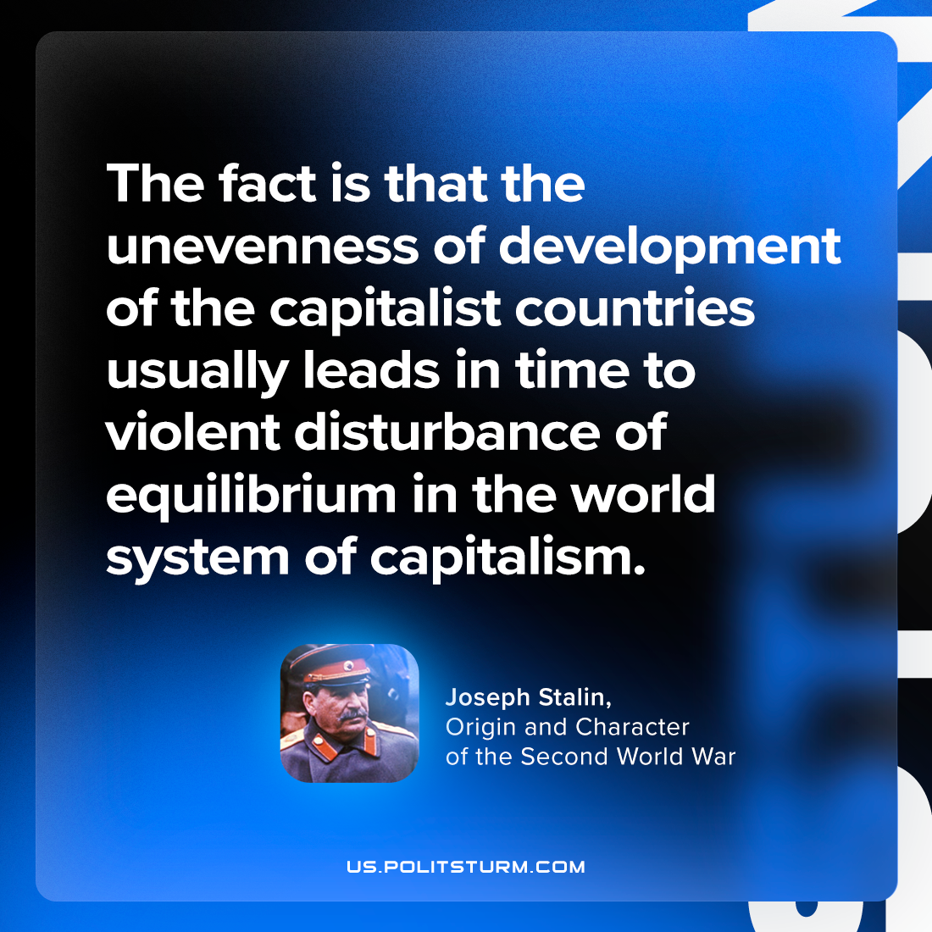

Original article
2023-09-21

"The fact is that the unevenness of development of the capitalist countries usually leads in time to violent disturbance of equilibrium in the world system of capitalism."
Joseph Stalin, Origin and Character of the Second World War

Original article

