Stalin on Imperialism
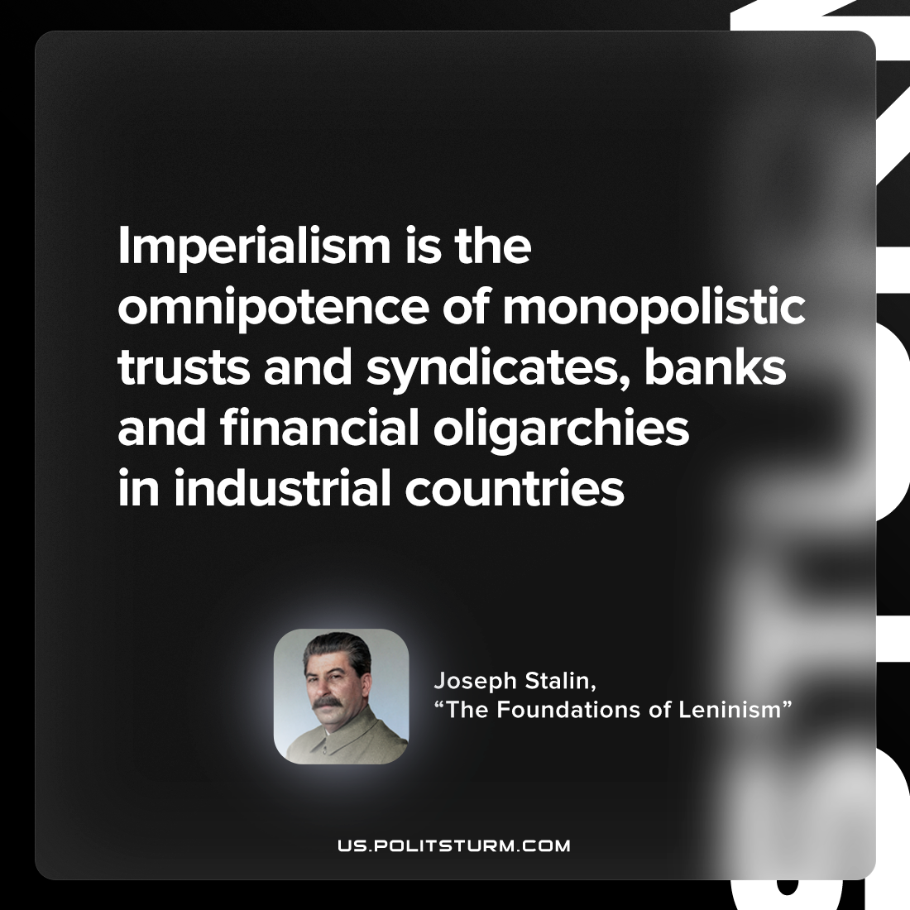

Original article
2023-05-21

"Imperialism is the omnipotence of monopolistic trusts and syndicates, banks and financial oligarchies in industrial countries"
Joseph Stalin, "The Foundations of Leninism"

Original article

