Stalin on Fate of a Country and the Toiling Masses
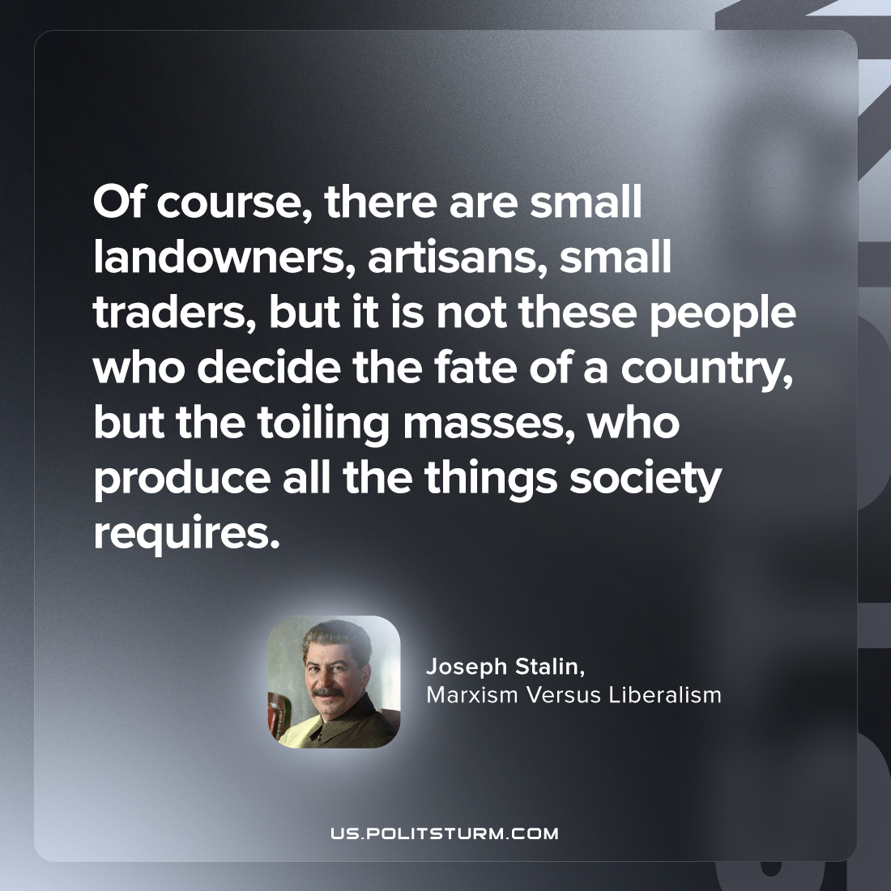

Original article
2023-06-29

"Of course, there are small landowners, artisans, small traders, but it is not these people who decide the fate of a country, but the toiling masses, who produce all the things society requires."
Joseph Stalin, Marxism Versus Liberalism

Original article

