Stalin on Expansion of Production under Capitalism
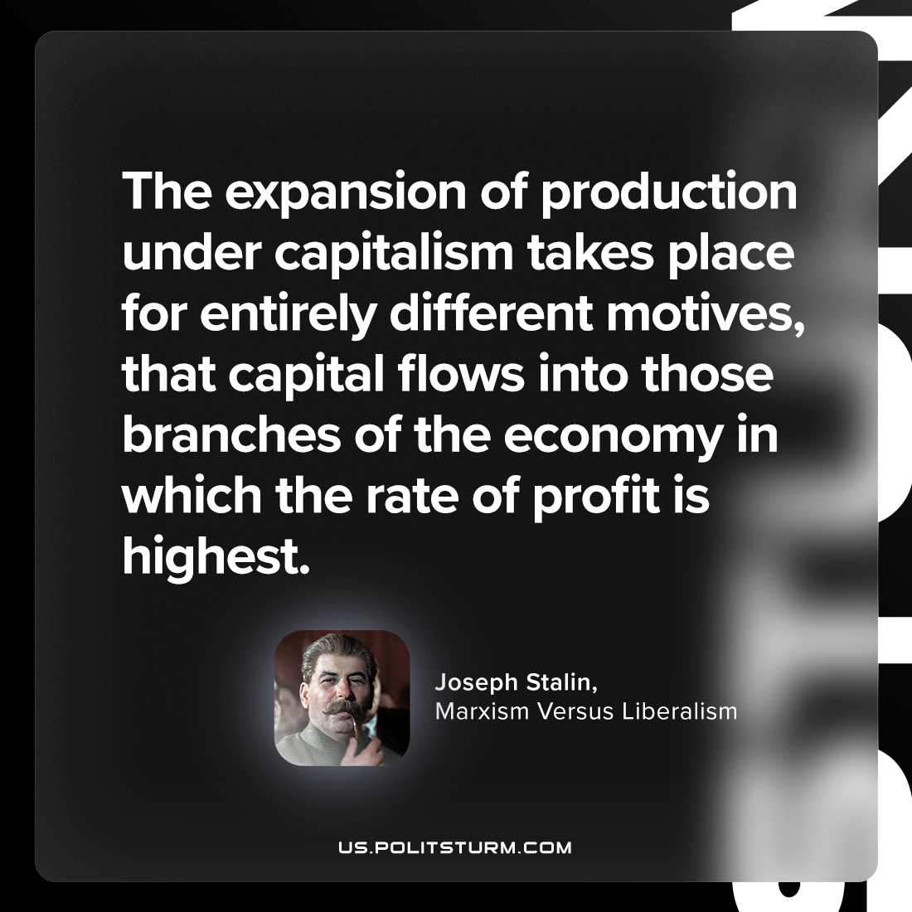

Original article
2023-09-19

"The expansion of production under capitalism takes place for entirely different motives, that capital flows into those branches of the economy in which the rate of profit is highest."
Joseph Stalin, Marxism Versus Liberalism

Original article

