Stalin on Equality
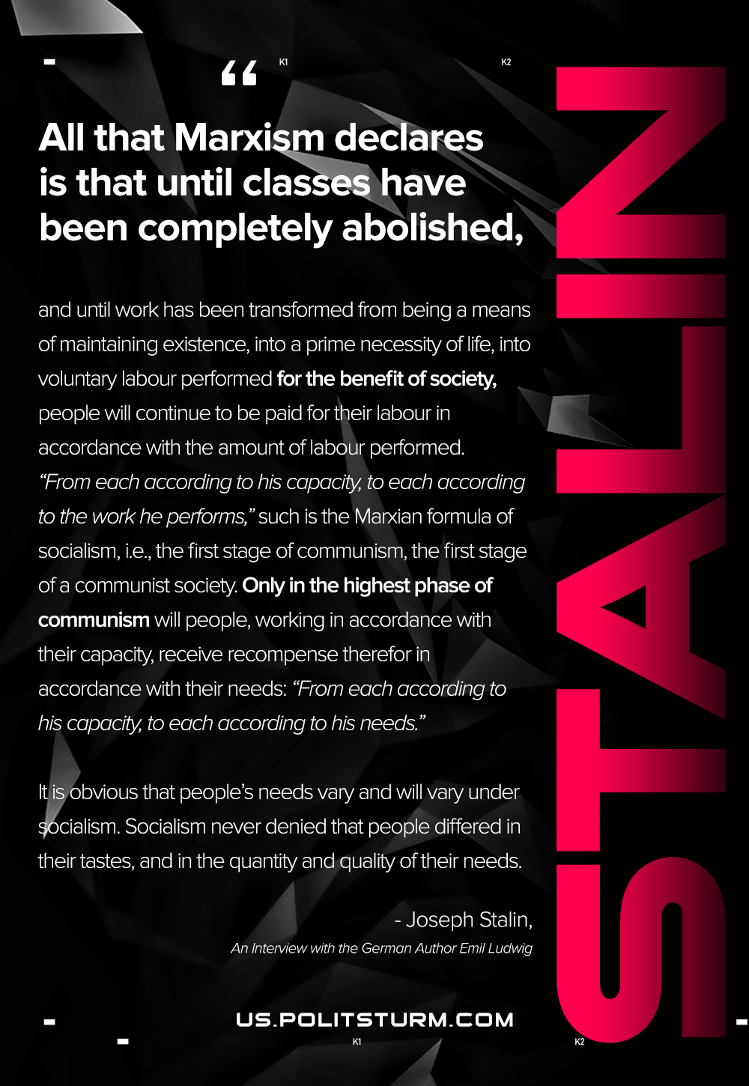

Original article
2021-01-12
1 min read

All that Marxism declares is that until classes have been completely abolished, and until work has been transformed from being a means of maintaining existence, into a prime necessity of life, into voluntary labor performed for the benefit of society, people will continue to be paid for their labor in accordance with the amount of labor performed. “From each according to his capacity, to each according to the work he performs,” such is the Marxian formula of socialism, i.e., the first stage of communism, the first stage of a communist society. Only in the highest phase of communism will people, working in accordance with their capacity, receive recompense therefor in accordance with their needs: “From each according to his capacity, to each according to his needs.”
It is obvious that people’s needs vary and will vary under socialism. Socialism never denied that people differed in their tastes, and in the quantity and quality of their needs.
Joseph Stalin, “An Interview with the German Author Emil Ludwig”

Original article

