Stalin on Discussions
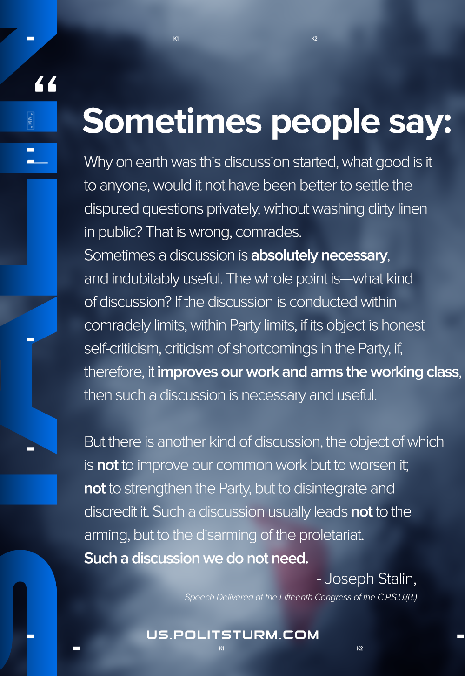

Original article
2020-12-17
1 min read

Sometimes people say: Why on earth was this discussion started, what good is it to anyone, would it not have been better to settle the disputed questions privately, without washing dirty linen in public? That is wrong, comrades.
Sometimes a discussion is absolutely necessary, and indubitably useful. The whole point is—what kind of discussion? If the discussion is conducted within comradely limits, within Party limits, if its object is honest self-criticism, criticism of shortcomings in the Party, if, therefore, it improves our work and arms the working class, then such a discussion is necessary and useful.
But there is another kind of discussion, the object of which is not to improve our common work but to worsen it; not to strengthen the Party, but to disintegrate and discredit it. Such a discussion usually leads not to the arming, but to the disarming of the proletariat. Such a discussion we do not need.
Joseph Stalin, speech delivered at the Fifteenth Congress of the C.P.S.U.(B.)

Original article

