Stalin on Democratic Centralism
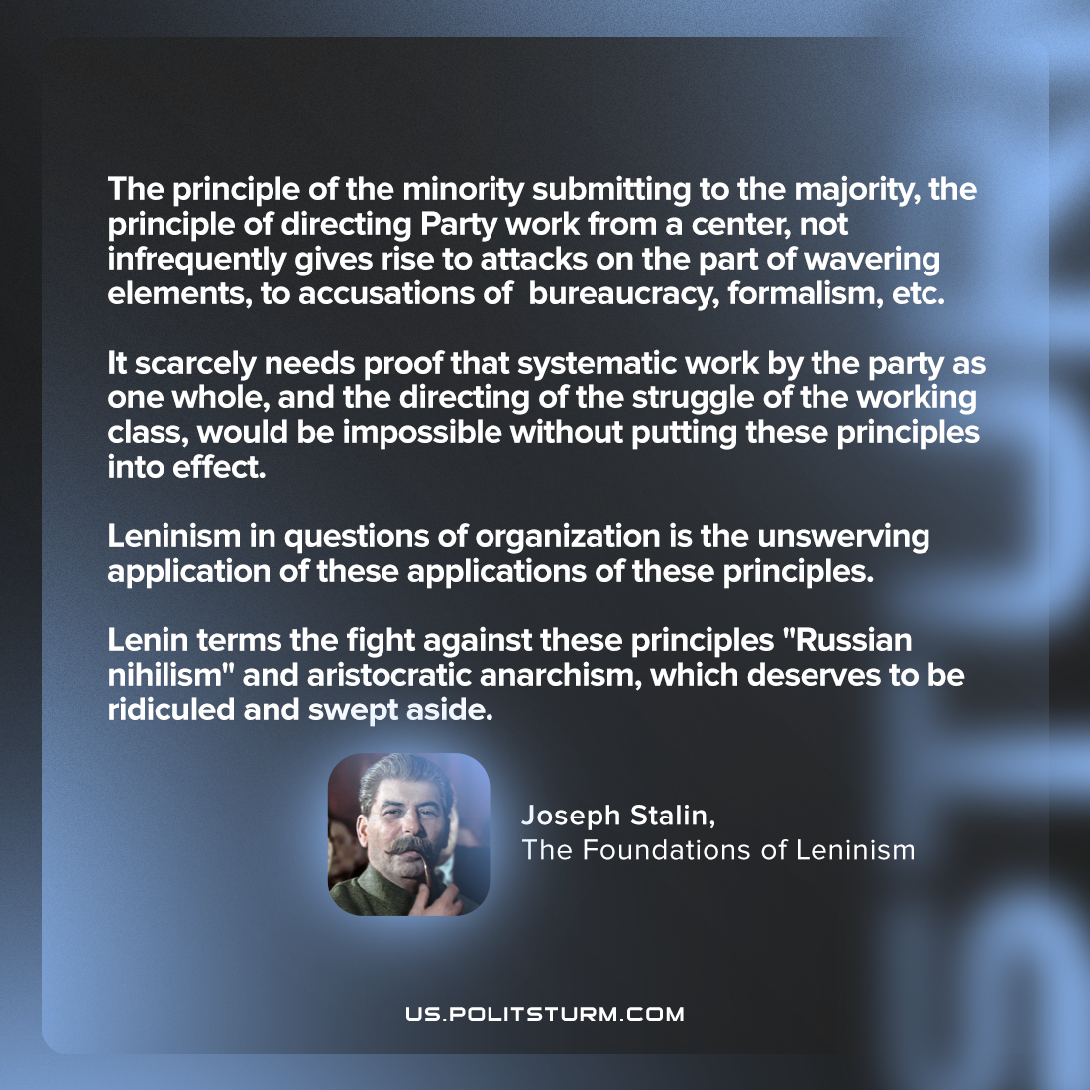

Original article
2023-07-27
1 min read

"The principle of the minority submitting to the majority, the principle of directing Party work from a center, not infrequently gives rise to attacks on the part of wavering elements, to accusations of "bureaucracy," "formalism," etc. It scarcely needs proof that systematic work by the Party as one whole, and the directing of the struggle of the working class, would be impossible without putting these principles into effect. Leninism in questions of organization is the unswerving application of these applications of these principles. Lenin terms the fight against these principles "Russian nihilism" and "aristocratic anarchism," which deserves to be ridiculed and swept aside."
Joseph Stalin, The Foundations of Leninism

Original article

