Stalin on Crises and Wars of Capitalism
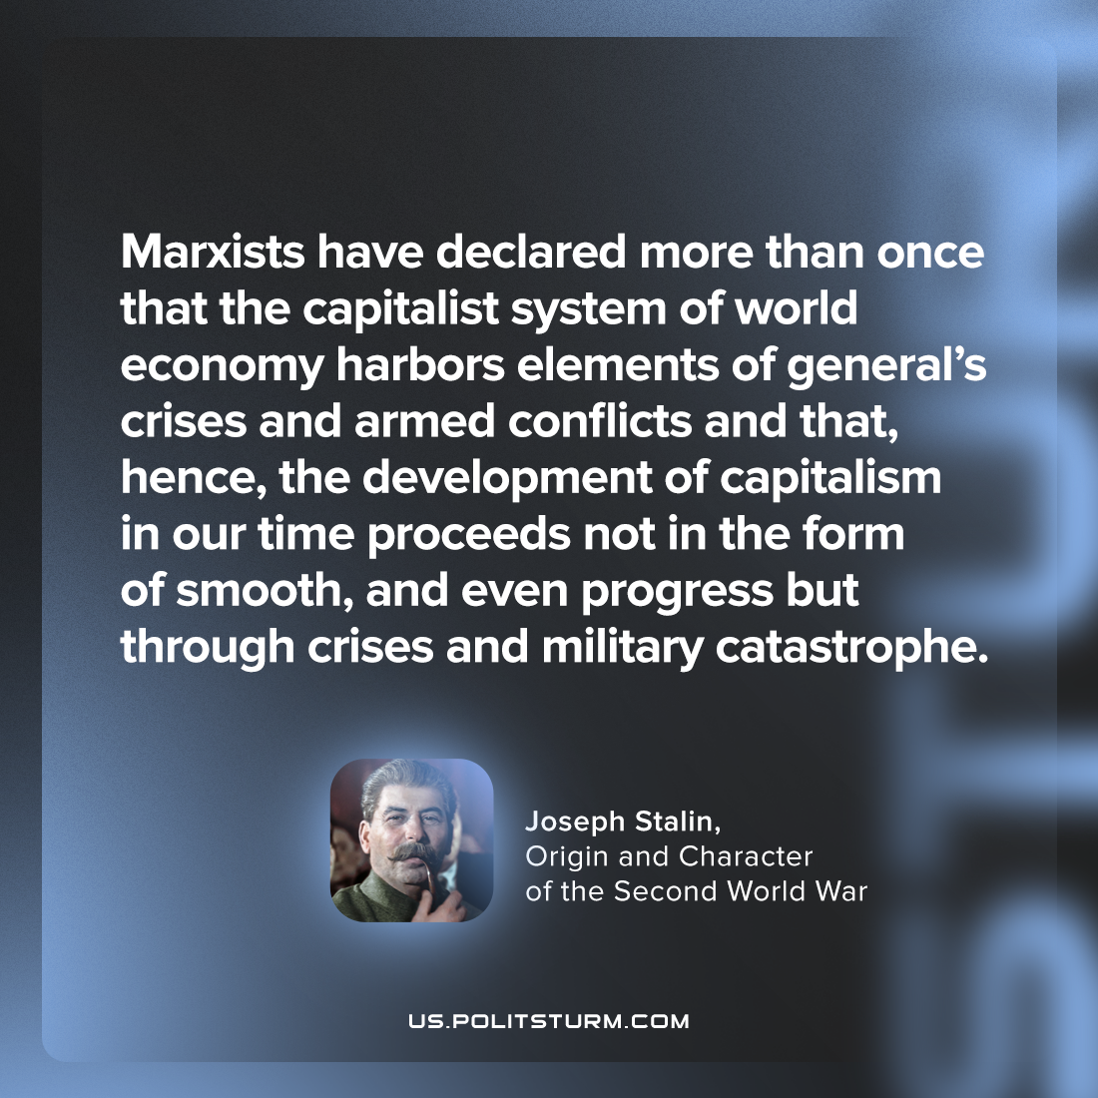

Original article
2023-06-08

"Marxists have declared more than once that the capitalist system of world economy harbors elements of general’s crises and armed conflicts and that, hence, the development of capitalism in our time proceeds not in the form of smooth, and even progress but through crises and military catastrophe."
Joseph Stalin, Origin and Character of the Second World War

Original article

