Stalin on "Common Culture"
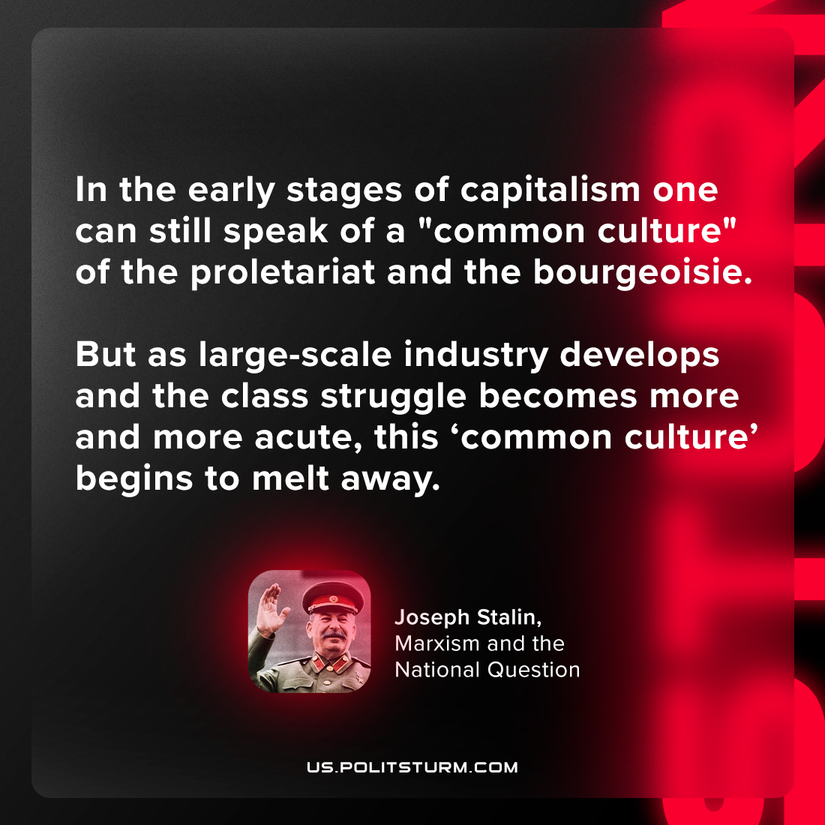

Original article
2024-04-09

“In the early stages of capitalism one can still speak of a "common culture" of the proletariat and the bourgeoisie. But as large-scale industry develops and the class struggle becomes more and more acute, this "common culture" begins to melt away.”
Joseph Stalin, Marxism and the National Question

Original article

