Stalin on "Common Culture" of a Nation under Capitalism
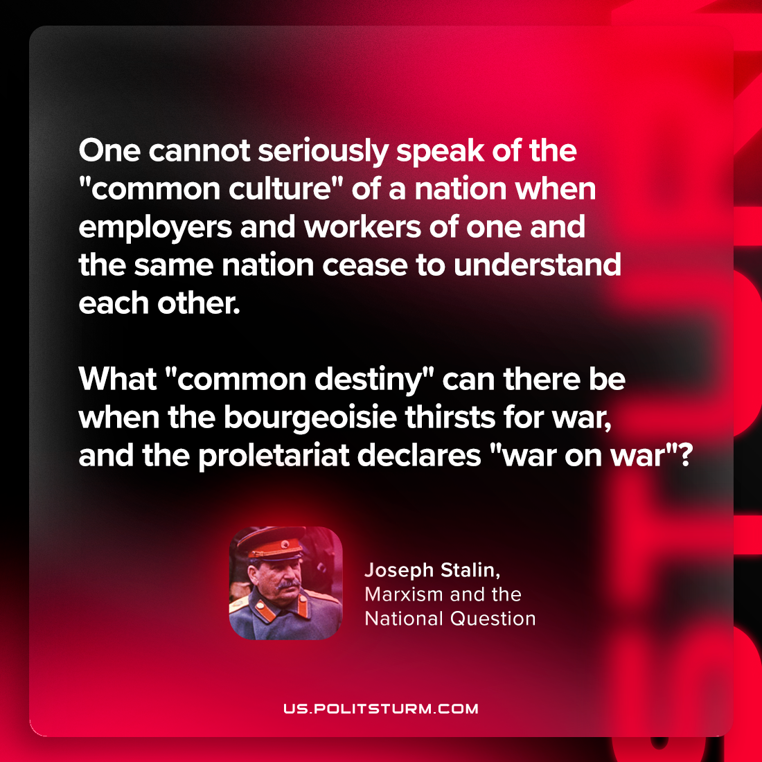

Original article
2024-01-11

'One cannot seriously speak of the "common culture" of a nation when employers and workers of one and the same nation cease to understand each other. What "common destiny" can there be when the bourgeoisie thirsts for war, and the proletariat declares "war on war"?'
Joseph Stalin, Marxism and the National Question

Original article

