Stalin on Class Struggle and October Revolution
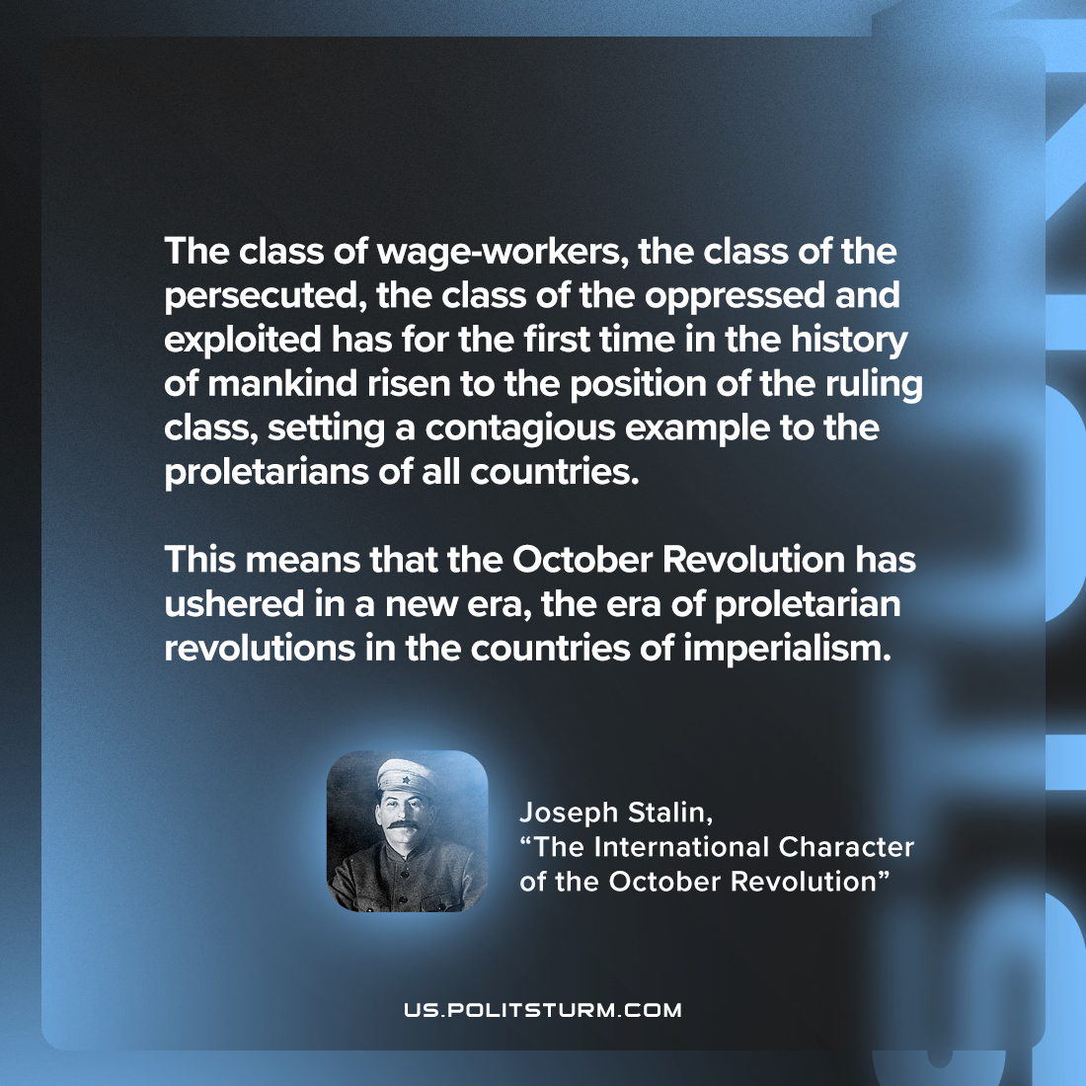

Original article
2023-01-28

"The class of wage-workers, the class of the persecuted, the class of the oppressed and exploited has for the first time in the history of mankind risen to the position of the ruling class, setting a contagious example to the proletarians of all countries. This means that the October Revolution has ushered in a new era, the era of proletarian revolutions in the countries of imperialism."
Joseph Stalin, "The International Character of the October Revolution"

Original article

