Stalin on Alliance Between the Working Class and the Working Peasantry
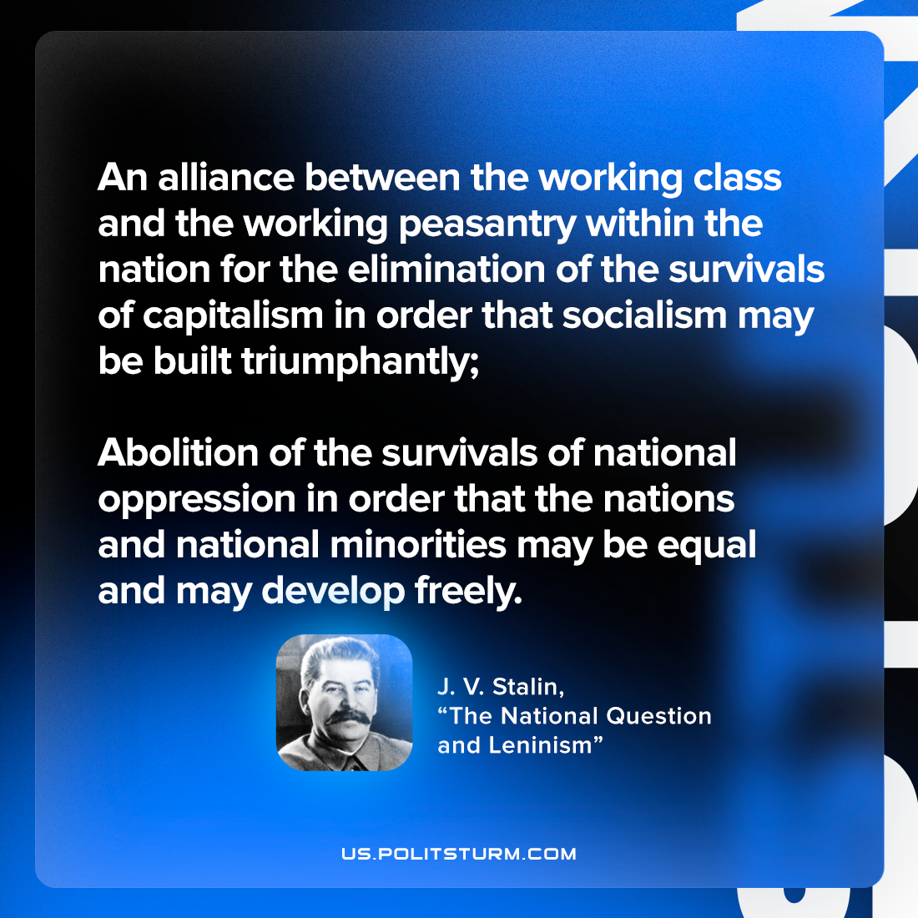

Original article
2023-03-02

"An alliance between the working class and the working peasantry within the nation for the elimination of the survivals of capitalism in order that socialism may be built triumphantly; abolition of the survivals of national oppression in order that the nations and national minorities may be equal and may develop freely."
Joseph Stalin, "Marxism and the National Question"

Original article

