Stalin on a “Middle”Line
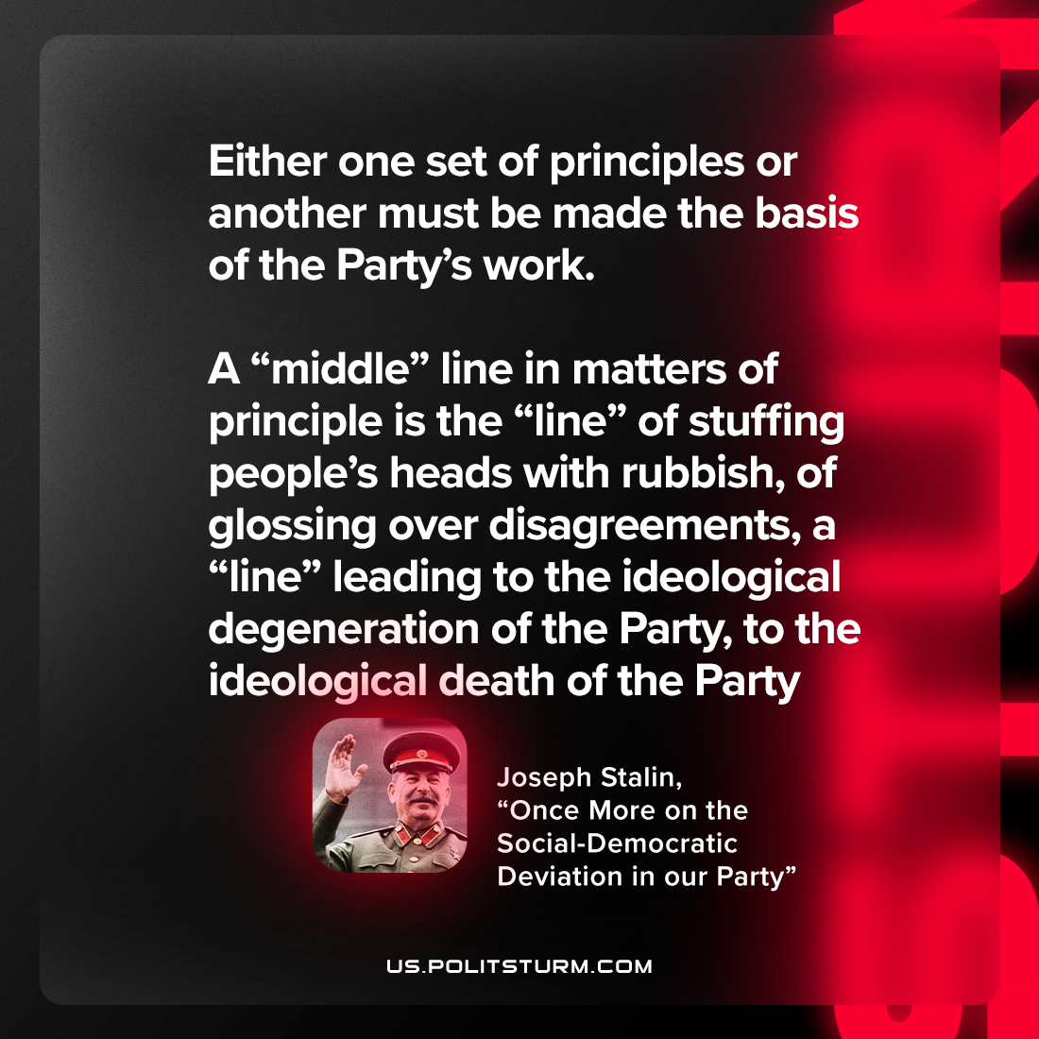

Original article
2023-03-21

"Either one set of principles or another must be made the basis of the Party’s work. A “middle” line in matters of principle is the “line” of stuffing people’s heads with rubbish, of glossing over disagreements, a “line” leading to the ideological degeneration of the Party, to the ideological death of the Party"
Joseph Stalin, “Once More on the Social-Democratic Deviation in our Party”

Original article

