Stalin Criticize Second International
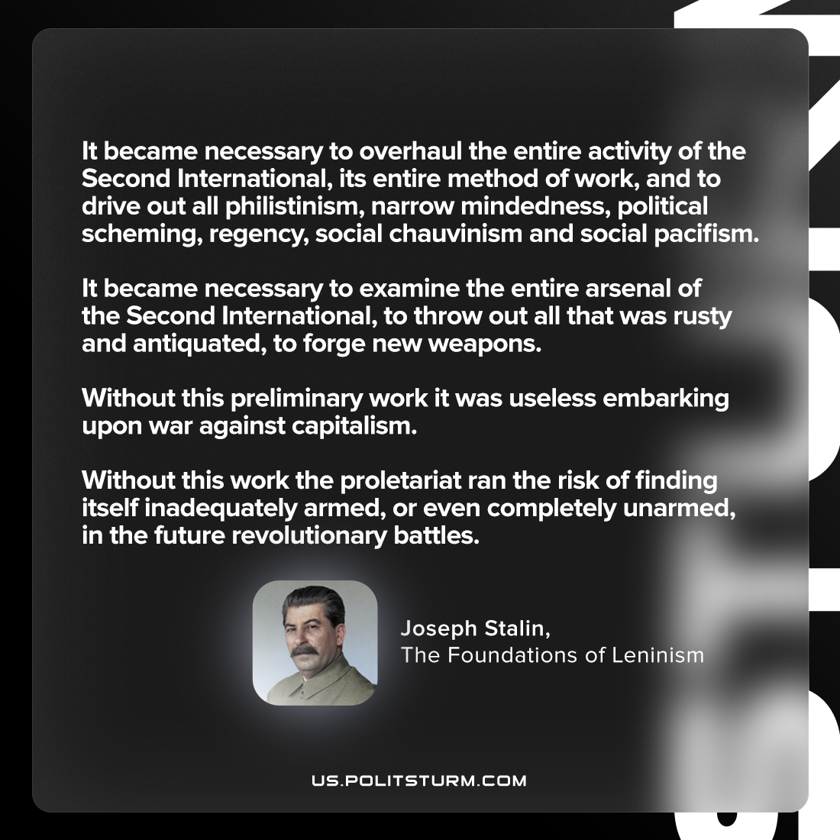

Original article
2023-08-01
1 min read

"It became necessary to overhaul the entire activity of the Second International, its entire method of work, and to drive out all philistinism, narrow-mindedness, political scheming, regency, social-chauvinism and social-pacifism. It became necessary to examine the entire arsenal of the Second International, to throw out all that was rusty and antiquated, to forge new weapons. Without this preliminary work it was useless embarking upon war against capitalism. Without this work the proletariat ran the risk of finding itself inadequately armed, or even completely unarmed, in the future revolutionary battles."
Joseph Stalin, The Foundations of Leninism

Original article

