Stalin about Contradictions
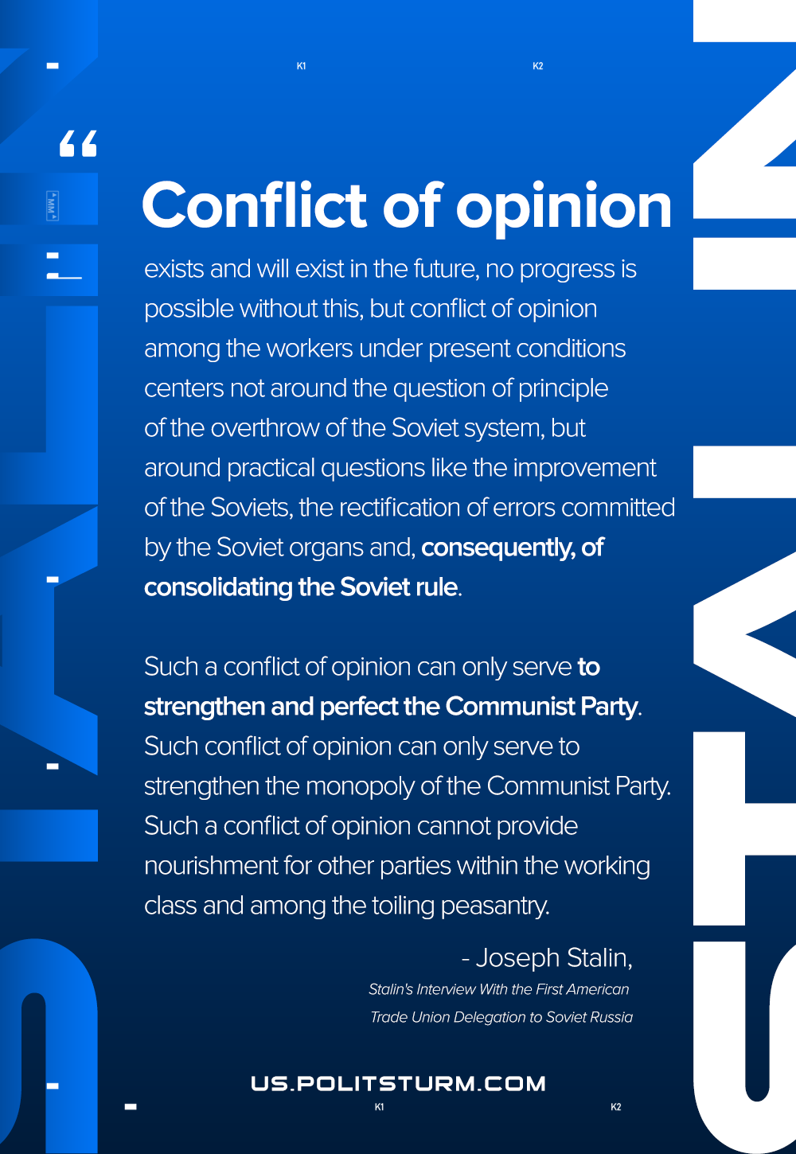

Original article
2020-12-23
1 min read

I have said already that conflict of opinion exists and will exist in the future, that no progress is possible without this, but conflict of opinion among the workers under present conditions centers not around the question of principle of the overthrow of the Soviet system, but around practical questions like the improvement of the Soviets, the rectification of errors committed by the Soviet organs and, consequently, of consolidating the Soviet rule. Such a conflict of opinion can only serve to strengthen and perfect the Communist Party. Such conflict of opinion can only serve to strengthen the monopoly of the Communist Party. Such a conflict of opinion cannot provide nourishment for other parties within the working class and among the toiling peasantry.
Joseph Stalin, Interview With the First American Trade Union Delegation to Soviet Russia

Original article

