Stalin on the Vitality of Marxism-Leninism
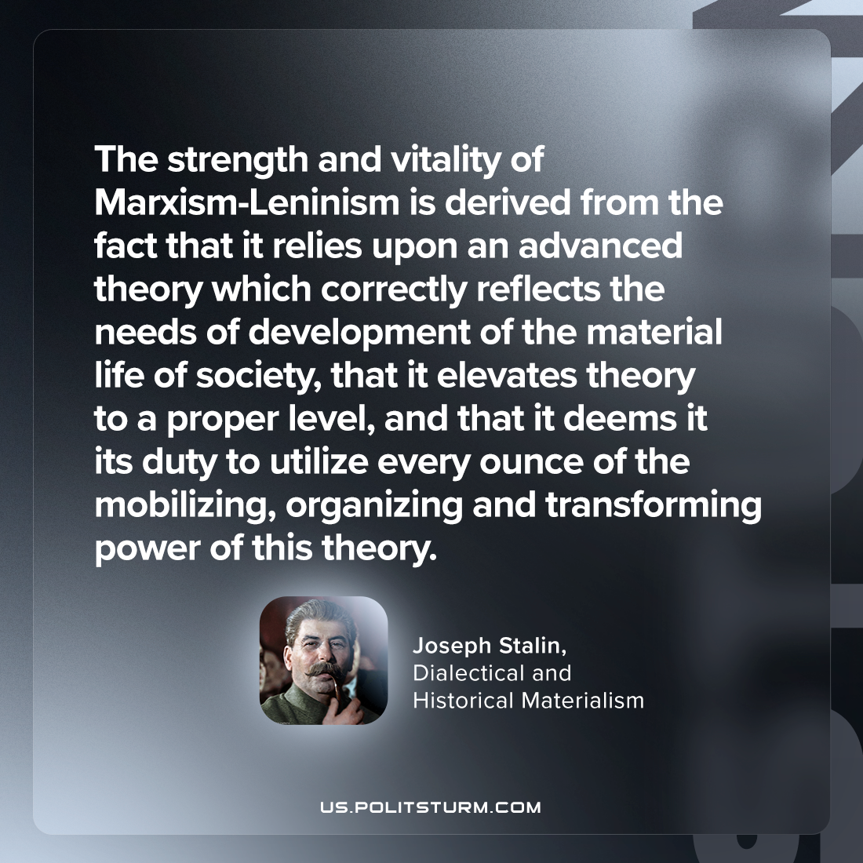

Original article
2024-06-06

"The strength and vitality of Marxism-Leninism is derived from the fact that it relies upon an advanced theory which correctly reflects the needs of development of the material life of society, that it elevates theory to a proper level, and that it deems it its duty to utilize every ounce of the mobilizing, organizing and transforming power of this theory."
Joseph Stalin, Dialectical and Historical Materialism

Original article

