South Korean Government Softens Tone on Striking Doctors
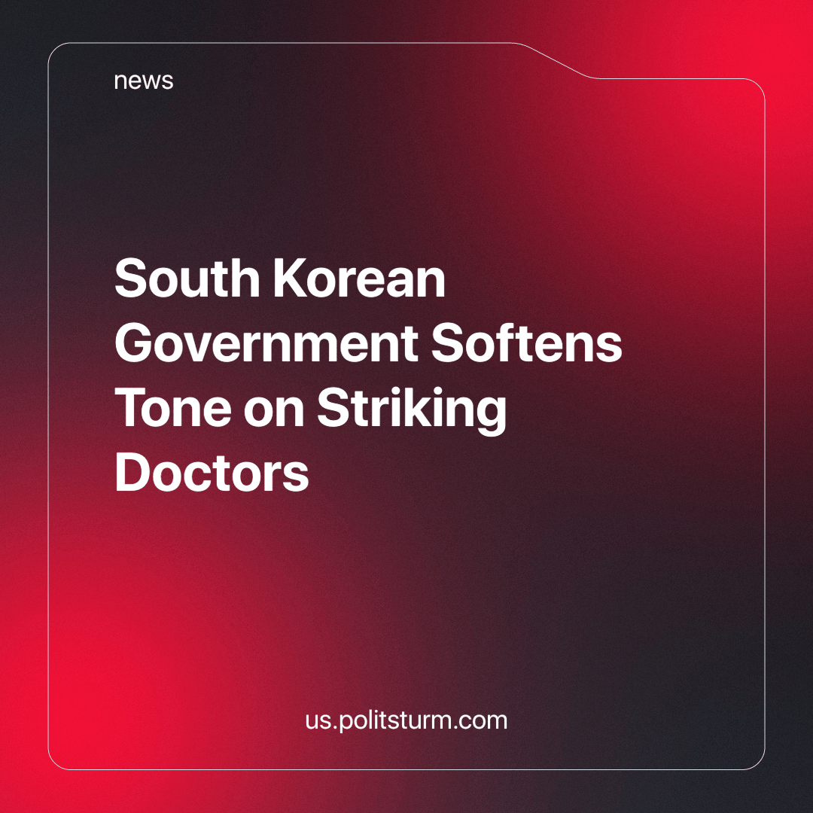

Original article
2024-05-05
1 min read

The South Korean government has announced that it will slow down its plans to increase the recruitment of medical students starting next year. Instead of admitting a large number of new students at once, the government has proposed a gradual increase over several years.
More than 9,000 of the country's 13,000 medical interns and residents have been on strike since late February when the government announced a plan to recruit an additional 2,000 students next year. The current quota is 3,058 and has not changed since 2006. The government had originally planned to increase the quota by more than 65%, which would have had an impact on the salaries of junior doctors in the next few years. While human labour is a commodity, the capitalists can cheapen it by increasing its supply.
But not so long ago, the government threatened striking doctors with dismissals, fines, license revocations and criminal prosecutions, as we have previously reported. Where threats have not worked, the capitalists hope that promises will help this time. However, doctors have already called on the government to abandon the implementation of the new plan altogether.
The organized actions of workers, from students to senior doctors, have forced the bourgeois government from threats to assurances. With its actions, the government tries to split the unity of the workers, because by interrupting such a sharp increase in the quota for a few years, some of the strikers can be convinced that the education and health system will be able to bear the burden. To expose such moves and reveal their class nature, the Korean workers need a communist party. Only the party will be able to unite not only on a professional basis (like the unions) but on a class basis, where the interests of the doctors could help protect the same Korean bus drivers (about whom we wrote earlier) who forced the government to raise their wages in a matter of hours.
Sources: 1

Original article

