Socialist Economy: The State Planning


Original article
2020-04-28
58 min read

Introduction
Planned (proportional) development of the national economy is the economic law of socialism.
// “Political economy”, Publishing House of Political Literature, 1954.
The elimination of the rule of the capitalist class and the establishment of the power of the working class requires, in addition to the elimination of private ownership of the means of production, also, the dismantling of capitalist economic relations. The fundamental elements of such relations are labor and commodity markets.
Thus, by reconstituting these elements, the leading role of the market and market relations in the economy will disappear as they are replaced by socialist relations. Before beginning a review of the principles of operation of both socio-economic formations, it should be noted that terms such as “market economy” and “planned economy” as used in the slang of modern bourgeois economics, are ill-defined abstractions and cannot simply be synonymous with capitalism and socialism, or various formations within national economy.
How does “regulation” of the economy by the market contradict with the project of building a socialist society? And how do we that reckon such capitalist “regulation”, even with planned elements, is chaotic and only sporadically enforced. The market’s susceptibility to crisis and spontaneous fluctuation is the first reason why socialists reject its “regulation”. This is not regulation in the sense of reasonable manageability — it is a spontaneous influence.
In a socialist society, this is unacceptable due to the inevitable crisis of overproduction within capitalism, leading to the ruin of enterprises, and the livelihood of workers. A situation when a person is not in demand on the labor market is unacceptable, it is unacceptable that the market’s volatility (for example, price increases) prevents a person from acquiring vital goods and services, as equally unacceptable is the speculation on such goods in times of high demand. Thus, one major drawback of the capitalist market becomes clear – a profit orientation, on top of any other factors.
As Karl Marx noted in Capital, capital turnover is slower in the heavy industry than in light industry, consequently, more time passes from the moment money is invested in production to the moment it is withdrawn at a profit. Therefore, it is obviously much more profitable for capitalists to invest in light industry because of its rapid payback and profitability. At the same time, heavy industry provides the development of light industry – it is difficult to imagine the construction of a spinning factory without the participation of a factory that will produce equipment for yarn.
But due to the fact that the development of heavy industry requires large investments and a larger payback horizon, under capitalism, its development is hindered by the growth of light industry. Production growth alongside the qualitative development of heavy industry is impossible, for example, until the demand for means of production (or other products) makes it profitable for the capitalist to invest in this area. For a person with an ingrained bourgeois understanding of economics, this order of things seems natural – in business, all industries should develop and expand only when they bring rapid ever-increasing profits.
The casual observer may be familiar with the narrative of the bourgeois propagandists, regarding the industrialization period of the USSR as illustrated by their caricature of Joseph Stalin, who, it is said, placed such emphasis on the development of heavy industry that light industry practically could not develop. They say that the Soviet people of that time could not have even a toothbrush, but instead they built steel mills, which is presented in the propaganda as an absurd paradox.
There is in fact no paradox here – if there is a developed heavy industry, it is easy to develop the production of toothbrushes, and other such light industry commodities, but to do the opposite quickly is impossible. The young Soviet Union was faced with the task of rapid industrialization or extinction, needing to turn a backward agricultural power into an industrial one. This was a powerful leap, which, with a pace set by the market economy, would certainly be impossible to achieve: but not so in the socialist state.
Therefore, there is no market spontaneity — first the establishment of heavy industry, then, as a result, the development of light industry. It is impossible to wait until light industry becomes profitable, created at the expense of foreign trade, to begin to propel heavy industry development.

1. Concept
We should not think that the use of planning in the economy is an exceptional feature of socialist economy – on the contrary, the practice of state-monopoly capitalism often resorts to the introduction of planned elements.
Historically, in the era of imperialism, a number of major capitalist countries have applied economic planning, including five-year plans, for the purpose of economic breakthrough: post-war Japan, as if in immitation of the Soviet five-year plans; South Korea’s economic reform in the era of Syngman Rhee; Nazi Germany, in which a four-year plan was circulated; Iran, whose history of the development of state-monopoly capitalism involves the production of the plan and its implementation; and most popularly modern capitalist China, which has successfully integrated it’s State Planning Commission in the capitalist economy during the reforms of Deng Xiaoping.
Despite that the application of a four-year plan by Nazi Germany is used by the anti-Soviet historiagraphers to conflate the fascist and Communist systems, their “planned economy” models are vastly different in their practical basis.
Vladimir Lenin, while developing the provisions on the national economy in the transitional period of the Soviet proletarian dictatorship, noted that capitalist relations under socialism are replaced by planned national economy, in which the proletarian state becomes the regulating economic force.
By comparison, under state-monopoly capitalism, the “state plan” is, in fact, a plan of capitalist monopolies and cannot satisfy the total scale of needs for the entire country. This is for the reason that, in the era of imperialism, the anarchy of production will always be closely associated with the extraction of excess profits and the resulting crisis of overproduction.
If the capitalist mode of production puts the extraction of maximum profit at the forefront, then the socialist national economy implies the use of the productive forces of society for the needs of all workers.
In light of this, one comment of the critics of the socialist planned national economy states that it is not possible to make a comprehensive plan due to the high level of complexity of the tasks, which, along with the staggering number of industries and the complexity of the relationships between them, will only grow. The answer of Soviet economists would be very simple — it is not necessary to cover the tasks with a plan for “everything in the world”.
The plan is based on the principle of “from General to particular” — the more private the task, the more likely it is that it can be adjusted on the spot. Thus the plan structurally resembled a fractal,
on the basis of the national state plan of the USSR, the Union republics have their own structures (i.e., the State Planning Committee of the Ukrainian SSR) and crafted their own plans. At the level of regions and districts, their own plans were already formed through planning commissions, which have already been directly executed by the enterprises.
Developing Lenin’s idea that the economic plan is a state task performed for the proletariat, Stalin defined the nature of Soviet economic plans:
Our plans are not forecast plans, not guess-work plans, but directive plans, which are binding upon our leading bodies, and which determine the trend of our future economic development on a country-wide scale.
// Joseph Stalin, “The Party and the Opposition”
Of course, in any plan there are elements that should be accounted for in advance and can be predicted with sufficient accuracy (for example, the normal population growth during one five-year period). But in general, the basis of the national economic plan is always a directive of target-setting, for the implementation of which one must still need to struggle. Indeed, as early as 1928, Soviet economists gave this answer to the question of what the general plan should be:
“It should represent our economic program, the program of reconstruction of the entire national economy of the USSR on the basis of energy with optimal use of the achievements of world technology and the application of the principle of social division of labor between economic regions. This should be the economic plan for our movement towards socialism.”
The plan starts with three questions:
1.) What is there now?
2.) What is needed in the future?
3.) How can we go from the present to the future in a consistent way?
Now, for example, the 23rd Congress of the CPSU decides, among other things, that the national economy needs more trucks, confirming the figures of current cargo traffic, the growth rate of production, and therefore the growth rate of cargo turnover. A group of research institutes was involved in the case – whether the current auto-industry in the Soviet Union could provide the required amount of product and if not, how could we make it so it could eventually provide them?
Based on such studies, recommended measures were given: expansion and modernization of current car-manufacturing enterprises, as well as the construction of new factories. Recommendations are given to the government for consideration, on the basis of which decisions are made: which car factories to expand and which plants to build. Then, guided by these recommendations, a resolution on the construction of a car factory in the city of Naberezhnye Chelny is adopted and a new introductory note appears in the State Planning Committee – in the eighth and ninth five-year plans, construction of the plant now known as the Kama Automobile Plant is scheduled. Human and material resources are allocated for this purpose, which are mobilized throughout the country.
The formation of the Kama Automobile Plant was aided by manufacturing specialists from the big Likhachov Plant in Moscow. Due to the absence of competition in the socialist economy, a specialist from another enterprise can help work to develop a new enterprise and not wonder if that new start-up will act as a competitor and one day threaten his livelihood. On the contrary, such a specialist is more likely to feel that he is involved in the great common cause of developing the economy of his country, will feel involved in the advancement of the region where this car plant will be built. After all, there is a place for everyone in the state plan, and enterprises do not compete for sales in a market, but rather complement each other and whose competition is only that between friends.
What practical problems arise while planning? Let’s return to our three planning issues.
What if any of them is answered incorrectly, such as the first one?
If the USSR did not have enough rolled metal or electricity to ensure increased production in the car factories – was it possible to carry out the established plan for the increased production of trucks?
No, because you cannot stamp a fresh body or weld a new frame without metal on a machine that cannot function without electrical current. Since metal and electricity are consumed by many other industries, how is the state to balance the consumption and distribution of resources and forces so that there is no collapse of production in any area?
Our answer lies with simple mathematics. Planners await a large-scale system of equations, a problem with a large number of unknowns and a large number of introductory values. In practice, anyone who has studied math at school understands that there may be human errors in the condition, in calculations, that somewhere there may be insufficient data, but that the task itself must still be correctly compiled. If the problem of setting tasks is not solved and is doomed to grow indefinitely along with the potential volume in the number and quality of tasks, manoeuvring between science and art, equally tormenting both, then with the correctness and completeness of the data, everything can be that much more certain.
Statistics are responsible for the correctness and completeness of data – it is statistical systems that collect data about the work of enterprises, it is the ones which provide the input for the task and are the most important node of the planned economy’s nervous system.
On the topic of planning problems, it is worth recalling one of the authors of the planning system in the USSR, doctor of economics Stanislav Strumilin, who gives this example:
“The angle trisection problem is indeed unsolvable, if you set out to divide this angle mathematically exactly into three equal parts with just a ruler and a compass. But drop these self-restrictions and you will see that any artist or architect in the drawing of certain ornaments solves this problem with sufficient accuracy for his practical purposes even without a compass at all — just by sight.”

2. Practice

// The theoretical origins of the ideas of the planned national economy
Even in the “Manifesto of the Communist Party” K. Marx and F. Engels justified the need for the state to include workers in all branches of the national economy. V. Lenin, further developing Marxism, pointed out the need for planned dominant principles in the construction of socialism.
The establishment of the G.O.E.L.R.O. plan (known in English as the State Commission for Electrification of Russia) became a fundamental point in the emergence of a planned national economy. Talking about such a massive project as national electrification, V. Lenin in 1922 put forward an article “On a single economic plan” as a starting point of the theoretical beginning of the Soviet planned national economy in which the following fundamental provisions were expressed, which eventually became fundamental in the work of the State Planning Committee of the USSR:
“The task of the Communists inside GOELRO is to issue fewer orders, rather, to refrain from issuing any at all, and to be very tactful in their dealings with the scientists and technicians (the R.C.P. Programme says: “Most of them inevitably have strong bourgeois habits and take the bourgeois view of things”). The task is to learn from them and to help them to broaden their world-view on the basis of achievements in their particular field, always bearing in mind that the engineer’s way to communism is different from that of the underground propagandist and the writer; he is guided along by the evidence of his own science, so that the agronomist, the forestry expert, etc., each have their own path to tread towards communism. The Communist who has failed to prove his ability to bring together and guide the work of specialists in a spirit of modesty, going to the heart of the matter and studying it in detail, is a potential menace.”
// Vladimir Lenin, “Integrated Economic Plan”
In the future, as bourgeois specialists became attracted to the structure of the development of the Soviet national economy, the Communists learned the basics of management and trained Soviet workers and engineers in this way, leaving for them a leading role in the construction of socialism.
Before the beginning of industrialization, at the dawn of large-scale implementation of five-year plans, there was a discussion in the party between the “teleological” and “genetic” view of the development of industrialization processes.
Relying on the “growing of the fist into socialism”, supporters of the “genetic”, that is spontaneous approach, rejected the idea of forced industrialization in the USSR, because it was incompatible with the economic domination of the bourgeois kulaks in the countryside.
At the same time, teleologists, following dialectics, and not dogmatics of the printed letter, understood that in order to organize the intensive growth of the national economy there is a priori a need to destroy the kulaks as a class, and to replace their small-scale production with large-scale mechanized production.
Thus, the role of “geneticists” was taken by Bukharinites and Zinovievites, who strongly opposed the active movement of Soviet workers for the collectivization of the national economy and accelerated industrialization. Trotskyists, like Trotsky himself, tried in every possible way to point out the “extreme left” of the course of forced industrialization, claiming its authorship for themselves, which is at its very core is absurd, given their faction’s consistent opposition to methods of accelerating the pace of development of the national economy since the days of the G.O.E.L.R.O. plan.
The history of industrialization along with the widespread introduction of a planned economy has shown the petty bourgeois inclinations behind the opposition: as a result, Voznesensky, becoming the premier of the State Planning Committee of the USSR, proved by his example the possibility of cultivating the most powerful national cadres, and the first five-year plan, of 1928 to 1932, demonstrated the possibilities of extensive development in leading economic indicators based on the introduction of advanced technologies.
The possibility of early training of the state’s own personnel provided by bourgeois specialists is essential here. In less than 30 years, the American bourgeoisie will recognize that their highest technical thought has been overtaken by Soviet education at the school desk.

// Management of the State Planning Committee of the USSR by the broad masses of Soviet workers
“When we say: “workers’ control”, always juxtaposing this slogan to dictatorship of the proletariat, always putting it immediately after the latter, we thereby explain what kind of state we mean. The state is the organ of class domination. Of which class? <…> If it is of the proletariat, if we are speaking of a proletarian state, that is, of the proletarian dictatorship, then workers’ control can become the country-wide, all-embracing, omnipresent, most precise and most conscientious accounting of the production and distribution of goods.”
Vladimir Lenin, “Can the Bolsheviks Retain State Power?”
No plan, no matter how well formed, will be of any use if it is not to be carried out. Conscientious and complete implementation of the plan is what ran through the history of the USSR, the life of the Soviet man and Soviet art.
For over-fulfillment of the plan was an honor, and for non-fulfillment shone criminal misappropriation cases out of the balance sheets, combined with some figures, in practice “floated” with others, especially if the second were smaller – over-fulfillment can also be fraught, but it easier to be put to a stop.
In any case, control over the implementation of the plan, the fight against inflated indicators (the documented “PostScript”), is something that one constantly needs to enact in the conditions of a planned national economy. Naturally, the control procedure must be regulated and fixed by law. This approach may well cause adherents to the so-called “free market” a fit of fear, but we know that the “free market” is a ship without a steering wheel, doomed to perish by the crushing force of the elements.
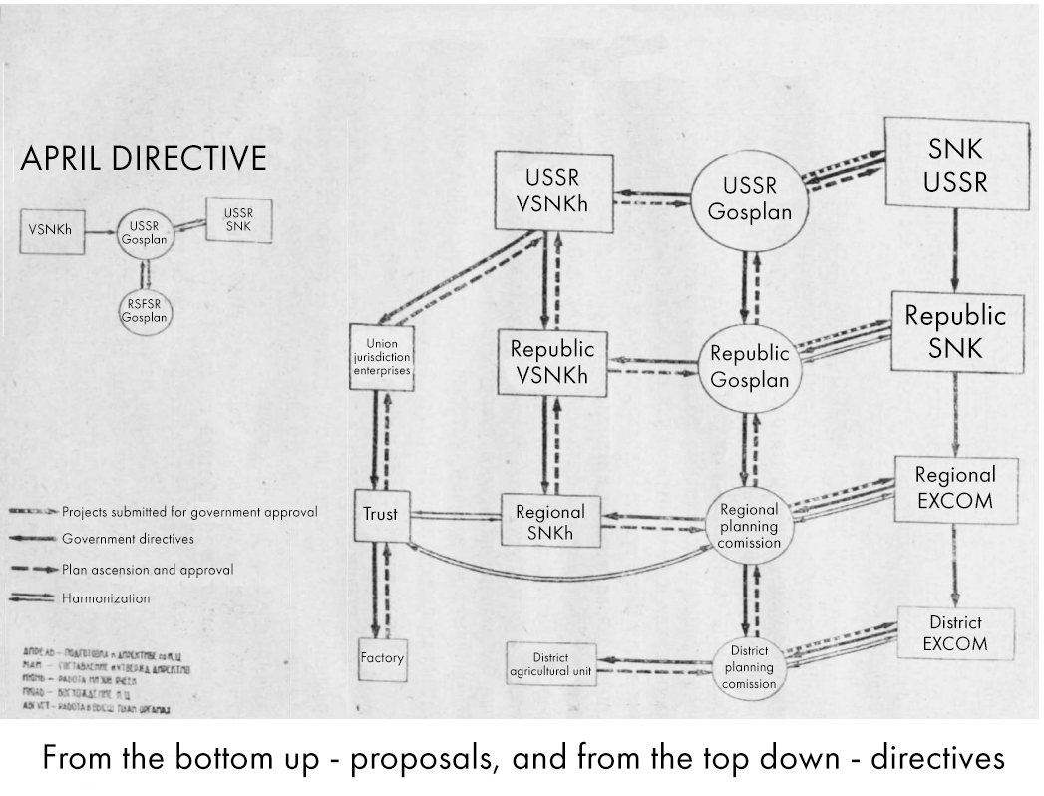
The scheme above, which implies in the planning mechanism not only condescending directives, but also incoming proposals, demonstrates the working management of production in the USSR. The advantage of such a planned national economy over the capitalist one is the participation of the broad masses of the population, mobility, and the elimination of the anarchy of production.
As noted above, the systematic management of the socialist national economy is directly connected with the broad participation of the working masses in the management of that economy. This is the key difference between the socialist mode of production and the capitalist one, which, by contrast, means the alienation of workers from the management of production and economy.
Having dissolved the exploiting classes, the USSR tirelessly established and enlarged the role of Soviet workers in the management of economic power. The state plan of the USSR was this fundamentally different from the state plan of fascist Germany (which was openly run by major German industrialists such as Pleiger, Kepler, and Krauch) as well as from the state plan of any other capitalist state – primarily by the fact that its management mechanism, included not the exploiters, but the body of ordinary workers and trade unionists.
A clear confirmation of this can be seen in a sample of the protocol of the plenary session of the State Planning Committee of the USSR from 1930, which includes all sorts of engineers, representatives of locksmith’s collectives and other ordinary workers.
The management of the Soviet national economy was carried out by workers not only from above but also from below. Following Lenin’s words that work control and production management should be carried out with a competent combination of the unity of command and collegiality, the construction of socialism in the U.S.S.R. is familiar with the practice of permanent political-industrial meeting bodies.
It was this practice that helped workers collectives exercise control over the administration of the enterprise, so it was possible to discuss the positive and negative aspects of the next five-year plan — and this trend only grew over the years: for example, if in Leningrad alone in 1926-1927, during such meetings, about 12 thousand proposals were submitted, of which 2/3 were accepted, in 1965, more than 30 million workers of all kinds took part in such meetings throughout the Soviet Union, and about one and a half million proposals were accepted.
According to pre-perestroika statistics, in 1984 there were about 140,000 production meetings in the country. At the same time permanent industrial meetings would be unthinkable without the Party’s leadership role in trade unions. To be more precise, this involved All-Union Central Council of Trade Unions, whose representatives also can be seen in the document at the plenary session of the state planning Commission, presented above.
The participation of the All-Union Central Council of Trade Unions is not only in setting wages and distributing housing; this council’s actions confirm Lenin’s words that trade unions become a school of communism, attracting the broad masses of workers to the management of production. This is not to mention other ways to attract workers, such as socialist competition and innovation, which allowed them to bring a creative approach to the organization of public administration and the State Planning Committee in particular.
Referring to the Soviet statistical official data, the proposals had a wide scope in the USSR and allowed to influence the State Planning Committee at any level. Here is an example from 1981:
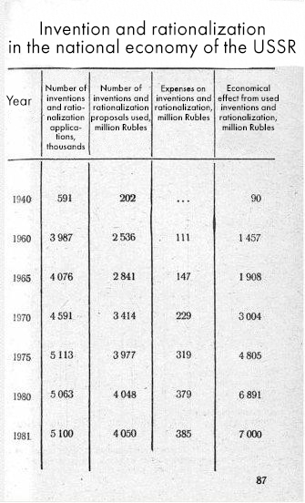
The ultra-left and revisionist critics of the USSR, denying its socialist nature, try in every possible way to conceal or simply deny the role of workers in the management of production in the USSR.
Calling the Union “state-capitalist”, far-left critics tie themselves to the leading neoliberal ideologues, carefully nurtured by global capital, which also deny the Soviet Union the reality of invention by the working masses, its creative energy. The summary of the data, however, reveals the complete inadequacy of such views.
Returning to the plan, it should be noted that a properly drawn up and executed economic plan is one of sustainable, crisis-free development with the ability to build truly ambitious and long-term projects. This is what the capitalists will refuse because of a prolonged payback horizon; something that will not immediately make a profit, but will help many people; what will need to be done by a huge mobilization of forces and what the capitalists will not have the will to enact being unable to organize on such a large scale – all this can be done through planned economy.
There is an absence of unemployment as it is possible for the state to directly create jobs, with no need “to attract the employer”. A fundamentally new level of ability to utilize natural resources is achieved – it is efficient and masterful, instead of blindly emptying out the planet in the race for profit. The possibility emerges of such a powerful conglomeration of industry, in which all modern talk about waste-free production and enterprise complexes will seem like nothing. The explosive introduction of new technologies — something truly of a breakthrough – is no longer any patented trade secret, destined to enrich only the capitalist, – now it is the property of the whole economy and by the next iteration of the plan, it will penetrate wherever it is in demand, and will come to the service of the workers.
If we come to the sum of the above, then the advantages of a planned national economy can be expressed as follows:
- A well-developed methodology for studying “reality” (political-economic processes in society, etc.).
- Public ownership of the means of production (with elements of gradually replaced cooperative).
- No plan made without feedback.
First the directive, then the clarification from the bottom, then the updated plan travels from the bottom to the top, where a final decision on further action is made. In addition, grassroots forms of worker organization allow for the adjustment and creative addition of planning directives.
- Emerging out of the point above: active participation of innovators and other creative enthusiasts whose proposals are being made and implemented to reduce resource consumption when the plan is exceeded, as well as speeding up the process of implementing technological innovations.

// Pricing
Pricing policy is fundamental to the study of the nature of state planning under socialism. Before we begin to analyse pricing under socialism, we need to pay a little attention to how the prices of commodities are formed under capitalism.
When we review Marx’s “Capital”, we can quickly understand that commodity production is the foremost center of the capitalist mode of production. Consequently, the question of price policy is directly related to the question of value, since the commodity is, according to Marx, the exponent of exchange value. Therefore, in the social process of exchange, it exposes its value state.
Can we say that price and cost are synonymous? The correct answer is that price is a form of product expression. Modern bourgeois economic science places the leading role in pricing at the intersection of supply and demand, completely dashing any of the laws of a dialectical development of society, including its capitalist phase.
The skittish price policy in capitalist society can be explained by the lawlessness of production, which, as we have seen in the previous chapters, is an ineradicable element of capitalism, even when attempts are made to introduce planned principles. As noted by Karl Marx in his report “Value, price and profit”, as addressed to workers:
The value of a commodity is determined by the total quantity of labour contained in it. But part of that quantity of labour is realized in a value for which and equivalent has been paid in the form of wages; part of it is realized in a value for which NO equivalent has been paid. Part of the labour contained in the commodity is paid labour; part is unpaid labour. By selling, therefore, the commodity at its value, that is, as the crystallization of the total quantity of labour bestowed upon it, the capitalist must necessarily sell it at a profit. He sells not only what has cost him an equivalent, but he sells also what has cost him nothing, although it has cost his workman labour. The cost of the commodity to the capitalist and its real cost are different things.
At the same time, you should not be under the illusion that the price, being the cost expression of the product, will always coincide with the cost of the product. On the contrary, even in the first volume of “Capital”, Marx made the following, not unfounded, claims:
The possibility, therefore, of quantitative incongruity between price and magnitude of value, or the deviation of the former from the latter, is inherent in the price-form itself.
It is not difficult to find out why this happens — this is primarily influenced by the ratio of the cost of the product to the money and the possibility of its sale. It would, however, be a mistake to assume that the discrepancy between price and value described by Marx is only characteristic of capitalism.
Turning to the famous work of Joseph Stalin’s, “Economic Problems of Socialism in the U.S.S.R.”, when studying the nature of prices under socialism, it should be noted that this question remained relevant insofar as the law of value remained in force. Ultra-left anarchist dogmatists, adherents to their theory of “state capitalism” in the USSR often put forward an accusation in the direction of this fundamental work in an effort to preserve commodity production – but even here they completely ignore the laws of dialectical development of society.
Marx, whose teaching they perceive not as science, but as the word of God, discussed the construction of socialism under the conditions of industrially developed England in his sample of the 19th century with developed large-scale commodity production, whereas in Stalin’s work we must discuss the material nature of Russia and of the Soviet republics at a completely different stage in productive development. Criticizing the textbook of political economy on the topic of pricing in the USSR, published in the same year as his work, Stalin said:
Here it is written that the law of value has been overcome. Then it becomes unclear where the cost category comes from, without which it is impossible to calculate, it is impossible to distribute labor, it is impossible to set prices. The law of value has not yet been overcome. It is not true that we command prices, we want to command them, but we can’t. In order to command prices, we must have huge reserves, an abundance of goods, and only then can we dictate our prices. In the meantime, there is an illegal market, a collective farm market, and there are market prices. If there is no value, then there is nothing to measure income with. Income is not measured by labor.
If there are no established historical conditions for the complete extinction of the law of value — there is no possibility to command prices. At least, this was the case in the post-war USSR. At the same time, the existence of the law of value does not imply its dominant position. Labor is no longer a commodity. Under these conditions, a jump in pricing policy is a priori impossible – people who lived in Soviet times remember fixed prices. However, when studying the works of Soviet economists of the Stalin era and later decades, there is a certain difference in the understanding of the processes that took place during the formation of prices.
For comparison we can take two works: M. Maisenberg “Pricing in the National Economy of the USSR” (1953) and L. Cantor “Pricing in the Soviet Union” (1964). Speaking about the nature and significance of the latter work, it should be noted that the author also provides concise clarity about the concepts of price dependence on the cost of goods and explains the need to reduce the cost of goods in order to reduce their price in the course of socialist construction.
In the work of 1964 the problem of the fate of the value law under socialism is given much less attention due to that work being written almost 10 years after the 20th Congress of the CPSU, which put an end to the author’s acquaintance with the basic economic laws of capitalism and socialism in its Stalin-era presentation. However, what is written allows us to briefly define a watershed between the formation of prices under capitalism and socialism:
In the conditions of developed capitalism, when a single average rate of profit is formed for all branches, and value takes the transformed form of the price of production, goods produced in industries with the low organic capital structure are sold below their cost and, conversely, goods produced in industries with a high organic structure of capital are sold at prices higher than their cost. Now the price of production, the value of which deviates from the cost, is the rod, around which the market prices of goods ultimately fluctuate, that is, the prices at which goods are actually sold and bought in the market. Fluctuations in market prices, in turn, are determined by the ratio of supply and demand. All this spontaneous process of capitalist pricing creates a constant discrepancy between price and value.
In itself, the competitive struggle of capitalists and their associations, especially in the international market, the desire to displace their competitors cause the prices of individual goods to fall. There are numerous cases of selling goods abroad at so-called dumping prices, that is, at prices below production costs.
As a result of the deviation of market prices from market value, capital and labor flow from industries where the price is lower than the cost to industries where the price is higher than the cost. As a result, production expands and the supply of insufficient goods increases, while the production of excess goods decreases. In the future, however, inconsistencies between the supply and demand of individual goods are created again, and new deviations in prices from values occur. Therefore, the discrepancy between price and value is a law of the capitalist economy.
Then, as under socialism:
Pricing in the conditions of a socialist economy is radically different. Unlike capitalism, where the price level is based on natural factors, in a socialist society, prices are planned and set centrally by planning and economic authorities. At the same time, price planning in the USSR is based primarily on the average industry cost, which is the main element of the price.
The possibility of a systematic price setting is a great advantage of the socialist economy over the capitalist economy. Due to the fact that the means of production in the USSR are public property, and in the majority of cases-state, national property, the Soviet state has the ability to systematically develop the national economy and systematically set prices for both means of production and personal consumption items.
However, going deeper into the question of the correspondence between price and value under socialism, the Soviet economist of the 60s falls short of the main aim as was mentioned by Stalin: commodity production in the USSR is preserved insofar as the addition to the social form of the economy there is a collective farm, what Maisenberg’s work speaks eloquently about:
Since price is a form of value, the formation of prices and changes in their level cannot be arbitrary, it has, in the final analysis, an objective basis for changing the socially necessary costs of production, expressed in monetary terms.
At the same time, due to the socialization of the means of production, under the conditions of the basic economic law of socialism and the law of planned, proportional development of the national economy radically changes the purpose of prices and the nature of their movement under socialism.
First of all, on the basis of the socialist socialization of the means of production and the actions of the law in a planned, proportional development of the national economy for the Soviet state, it was possible to systematically set prices for a crucial part of the national economy’s output. In carrying out planned price setting, the Soviet state proceeds from a policy that provides for a systematic reduction in prices for the products of state-owned enterprises. This policy reflects the essential requirements of the basic economic law of socialism.
The continuous growth and improvement of production on the basis of higher technology inherent in socialism leads to the continuous growth of the productive power of social labor and a reduction on this basis of socially necessary costs, the cost of production. Since socialist production is subordinated to the interests of satisfying the needs of society, the benefits that arise for society as a result of increased productivity of social labor are realized in the reduction of prices. In turn, lower prices lead to an increase in the capacity of the domestic market, increasing the effective demand for products and thus it is an incentive to increase production.
Thus, a systematic decline in prices represents an objective regularity of a socialist society. It assumes that the main means of production belong to the entire society and the goal of social production is to meet the needs of the entire society as much as possible.
Here it is – the very core of Marxist scientific economic thought on planned national economy under socialism makes public goods more accessible to broad public circles – so clearly expressed in the early 50s, yet clouded in the mid-60s – public ownership of the means of production and the introduction of the latest technological base.
Conclusion: prices are regulated by the state in order to replace distribution based on exchange. This provision, which runs like a red thread through the Soviet political economy textbooks of the 50s, was particularly relevant in view of the interaction of two economic sectors — the state and the collective farm, under one national economy, this made it possible to establish centralized relations in the field of trade.
In those conditions when the law of value is not yet dominant, a striking contrast between the cost of consumer goods and their price is a priori impossible – even in times of neglect of this principle – in the Khrushchev era, which is characterized by dissatisfaction with certain circles of workers and entire regions in the issue of price policy, (ironic that this is the time when the shield was raised in the slogan of economists for the adjustment of cost and prices), the population was not left without pants, as in the 90s (as it is today).
The reason is simple: first, the planned national economy in the matter of pricing policy deliberately excludes the anarchy of production and the anarchy of price movement, establishing a single integrated pricing scheme, which includes the entire range of consumer goods. At the same time, in no case should we forget that the organized market of goods in the USSR circulated not as a commodity exchange, but as a distribution.
Second, the state in the USSR was the state of the dictatorship of the proletariat (in its “best” years, it was “the people’s state”), and therefore – as alien as it may sound today, the broad masses of the population took part in pricing through the Supreme Council, which directly regulated the State Committee on Prices under the Council of Ministers of the USSR.
As a result of the actual success of this pricing policy, we can note what Maisenberg described in the past to which even Khrushchev’s economists referred:
If we summarize the practice in the field of pricing over the past 20 years, we can conclude that our prices are increasingly determined by the social cost of production. And this is confirmed by the following facts.
The state subsidy regime has been eliminated. We may have some unprofitable industries due to different conditions. But this is a temporary phenomenon, considered as an emergency. The measures taken, including in the area of prices are provided by the elimination of the loss in these sectors.
The level of profitability of heavy industry has been sharply increased. According to the plan for 1957, the net income in the heavy industry will be 9% of the cost of production. If take into account interest on the loan and social insurance contributions, this realized net income in heavy industry will reach 11.5%.
Prices for agricultural products have been raised to a level that provides compensation for the production costs of collective farms and the formation of savings necessary for expanded reproduction.
The ratio between profit and turnover tax in the national economy of the USSR has changed. During the period from 1940 to 1957, the turnover tax increased by 2.6 times, and profit by 5 times. If in 1940 the profit and turnover tax was 31%, now it has grown to 62%
These are not the final achievements of the socialist pricing policy — as noted above, the policy of low prices in the Soviet Union always made it possible to provide any worker with a proper living wage. Even the collective farm market, to which one could always turn in case of a shortage of specially subsidized state goods, never burdened the buyer.

// Achievements of planned national economy
Exploring the nature of the state plan in the USSR, it is necessary to approach the two hottest points, those that directly concern its history; its achievements and its decline.
Of course, mass electrification and industrialization are the indisputable achievements of Soviet state planning. Many readers who have studied the history of the Soviet Union are probably familiar with the wide scope and pace of the G.O.E.L.R.O. plan and of industrialization, but it will not be superfluous to demonstrate them again.
Within the framework of the national strategic project — G.O.E.L.R.O. plan, in just 19 years, it was possible to increase the productivity of electricity from 2 to 13 billion K/h. Krzhizhanovsky, a talented Soviet leader, managed to attract more than 200 scientists and engineers to the electrification project in the shortest possible time – this was the first plan of strategic importance in the whole world that had mass popular support, its adoption was voted on at the VIII all-Russian Congress of Soviets, and approved at the IX All-Russian Congress. As a result of the adoption of this plan the Soviet Union achieved a powerful breakthrough in the country’s electricity supply: starting with 33 power plants in 1913, in 1927 their number grew to 858, and consumption increased from 427 thousand kWh to 10 000 thousand kWh.
Lenin’s legendary formulation: “Communism is the Soviet power plus electrification of the entire country” turned upside down not only the perspective of the English science-fiction writer H. G. Wells, but also the climate of hopeless technical backwardness that once reigned in the Russian Empire, becoming a direct help for the shock five-year plans for industrialization.
Speaking of industrialization, as well as electrification – revisionist, anti-Soviet historians do their best to point out the predominant role of foreign specialists in these processes, declaring all the success to be the result of exclusively economic participation of private American companies in the construction of leading Soviet enterprises.
In every possible way trying to point out the enormous importance of Albert Kahn and other not only American, but also German, Czechoslovak and other designers, reviewing and rewriting the main milestones of Soviet history, bourgeois scribblers carefully do not indicate any circumstances under which Lenin and Stalin indicated the extreme necessity of introducing the latest technology produced by the capitalists, no reason why they learned to defeat capitalism by learning to trade the same way as the capitalists. Anti-Communist thought is always estranged from any dialectical analysis. Therefore, they do not take into account the historical conditions which forced the purchase of foreign equipment from private enterprises, but it also glosses over the import substitution that was a reality of the time, but today remains a demagogic fairy-tale of Russian capitalists.
So, anti-Communists sardonically point to the training of the first generations of Soviet engineers by the West, as well as the participation of American companies in the construction of the Dnieper Hydroelectric Station and Magnitogorsk Iron and Steel Works, but they are silent about the leadership role of the All-Union Communist Party (Bolsheviks), which hired the foreign specialists and actively trained its own staff – this, by the way, was one of the key tasks of that very plan. Needless to say, among the arguments of the “denouncers of industrialization” can one never see that by 1940, the Soviet Union was able to fully supply itself with metal-working machinery?
Here is another striking example, which testifies to the correct calculation of the Soviet leadership to soon rid the Soviet machine tool industry of foreign dependence by means of competent planning and management. The statistical compendium “The USSR for 15 years: Statistical materials on the national economy” (State socio-economic publishing house) for the time period 1932-1941 calls the following figures-an increase from 2,000 units in 1928 to 58,400 in 1940. This is when imports fell from 15,300 units in 1932 to 4,589 units in 1940. By 1941, metal-cutting machines of domestic production accounted for 68% of their total number. Metal-working machines also grew in number from 10,231 in 1932 to 35,117 in 1941, wrestling 56% of the total demand.
It is noteworthy that at the time of 2017, capitalist Russia was more than 80% dependent on imports of foreign-made metal-cutting machines.
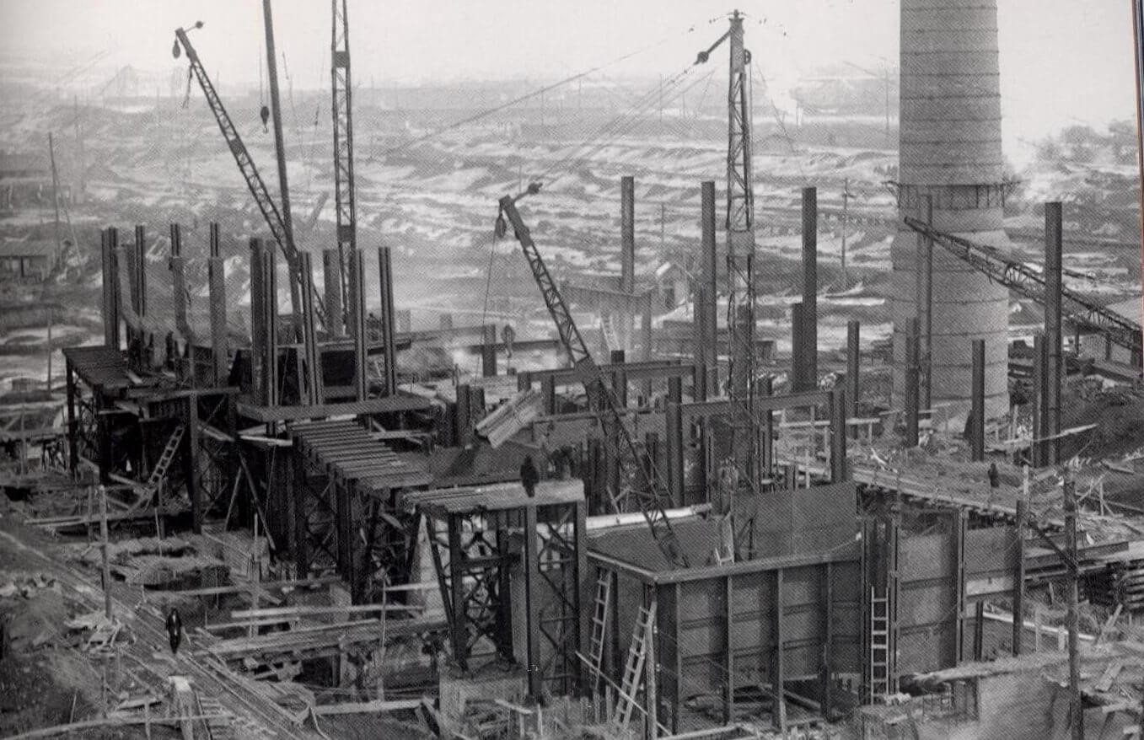
Industrialization, which raised more than 2 million engineers in the shortest possible time and started actual import substitution in the industry group “A”, having ensured the USSR’s independence from the capitalist world, it demonstrated the success of the planned national economy, testing its strength and durability at the most acute historical moment.
These grandiose achievements would not have been possible without lowering product prices and lowering the cost of production. This greatly facilitated the production of the most strategically important units of group “A”, including military equipment (this is how it was managed to establish mass and cheap production of main battle tanks, which became the key to Allied victory on the Eastern Front of World War II), it also provided collective farms with mechanized tools, establishing a network of machine tractor stations (MTS) during the same decade.
This is what gave such a considerable boost to the already rapid pace of scientific and technological progress, which rushed forward like an unstoppable steam-engine through all of Soviet history. Much has been said of this: and about the human entry into space and all the other fantastic successes of the Soviet space program, up to the junction of the “Apollo” and “Soyuz” and the invention of “Buran”, and about the huge construction projects of socialism, and about the significant victories of Soviet science. And it is said with good reason: socialist education, being of high quality and accessible to all, surpassed even elite bourgeois education by many stages, which remains commercialized and inaccessable. Thus, according to the statistics of the Central Statistical Directorate (CSD) of the USSR, already in 1940 the number of Universities in relation to 1914 jumped almost 10 times, and the number of students reached 812,000.
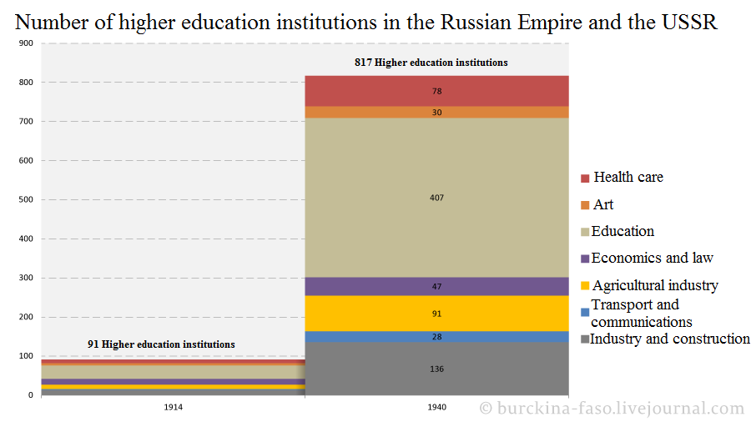
Thanks to systematic development across all economic sectors, the USSR achieved the same incredible success in many other areas of the national economy: by the 70s, the USSR had become one of the leading leaders in the automotive industry and cement production, and the pace of widespread introduction of computer systems boldly placed the Soviet Union on the same pedestal with the United States and Japan.
Other countries that followed the road of building socialism, in some places successfully and in others not, in the shortest possible time became industrially developed countries and acquired for themselves advanced technology, as, for example, happened with Bulgaria and Yugoslavia. The GDR earned the legendary “Robotron” — and of course, as in the case of the USSR, no one denies the role of technological innovation on the part of IBM, but on the contrary – should specify how both “showcases” – East and West Germany, under completely different conditions of mutual existence, they used these innovations to improve the national economy.
In tightly sponsored capitalist Germany, chemical enterprises were automated, developing as follows: in 1964, the index of labor productivity per worker in the chemical industry was 243 (1950 = 100), while in the entire industry it was only 186. The growth rate becomes even higher when calculating labor productivity per person-hour of work of a production worker. This is due to the fact that with the growth of automation of production, the number of production workers decreases, and the number of specialist engineering and technical workers increases. Thus, in 1953, the share of production workers in the chemical industry in the total number of workers was 71.6%, and in 1964 it decreased to 65.6%.
Let’s not be sarcastic for long about the acute class antagonisms in West Germany, about how workers in Germany had to fight for an 8-hour working day and how automation processes were accompanied by layoffs. It is better to describe the mirrored experience of the German Democratic Republic. For this it is quite appropriate to open the study of Dmitry Verkhoturov, who exposes the propaganda narratives of the Western imperialists regarding “brown-coal socialism”. Devoting a separate description to the processes of deep automation of enterprises in the midst of the dissolution of small and medium-sized enterprises, he describes the following:
By the end of the 1970s, the reorganization was complete, the GDR industries were virtually eliminated, and 177 large industrial plants were created instead. Along the way, many small and medium-sized enterprises were liquidated, the total number of them fell by about 28 thousand to 5 thousand units. At the expense of liquidated enterprises, large and major ones were strengthened and expanded.
During the reorganization of industry, Honecker carried out a decisive reform of science. The research institutes were disbanded, and all the existing staff of the research institute was transferred to the combine. This provided a direct link between science and production. In general, the GDR paid a lot of attention to the scientific and technical revolution, the unification of science and production, and therefore went to this scrapping of partitions. Many enterprises for the production of tools and equipment were also transferred to the factories, and they were able to produce for themselves a significant part of the equipment they needed, which they themselves designed in their design bureaus.
The factories were independent units that produced and sold their own products, including for export. Foreign trade with COMECON countries was based on long-term agreements, which were taken into account in the plans of all members of the organization. The GDR industry was able to rhythmically supply raw materials and sell products. In addition, the COMECON specialized in machine-building production. GDR produced approximately 85% of the world’s engineering product range, receiving the rest from COMECON partners. The GDR ranked fifth in the world in mechanical engineering.
In the late 1970s, the GDR industry saw a wave of automation, which included the very widespread introduction of industrial robots, automated data processing, and the creation of data banks. Robots in mechanical engineering provided productivity and quality that were completely inaccessible even to skilled workers, this is why at this time automated workshops appeared in the GDR, and the development of flexible production systems (FPS) began.
An attentive reader will notice two key points. First: that the processes of mass automation of production in the G.D.R. began just 5-10 years after similar events in West Germany. Second, that the main factor hindering automation was the presence of non-centralized, or even non-socialist, forms of ownership, which by their existence naturally generated anarchic production, interfering not only with automation but also with planning. The G.D.R. approached the issues of drawing up a plan somewhat differently than the post-Stalin USSR:
Planning in the GDR returned to the system of material balances, but, unlike the USSR, acquired completely different features. Under the influence of a constant shortage of raw materials and energy, the need to reduce their consumption per unit of production, German planners quickly came to the conclusion that they need to plan their economy in real terms and developed the concept of “material economy”, which represents production in the form of a flow of raw materials, materials and energy, which originates from sources, goes through a series of transformations and turns into finished products.
Indeed, at a certain stage in the Soviet Union, the planning principles moved from natural values to formal numerical indicators, what, for example, can explain a certain lag in the quality of Soviet consumer goods in comparison with East German ones. What was the reason for this?

// The nature of the deficit and the reasons for the fall of the plan
No critic of the Soviet system avoids the topic of the shortage of consumer goods, declaring this phenomenon inevitable within Soviet socialism, declaring it a permanent and unchangeable feature of life in the USSR. It is true that there had sometimes been deficits, but it is absurd to believe that this is exclusive to socialist countries and that a deficit will be an inevitable consequence of the planned economy.
The pricing system under socialism, which is observed in the conditions of total implementation of planned economic development, was considered above. But, as already noted, these laws were not absolutely unchanged throughout the entire existence of the USSR.
Starting from the scientific definition of the commodity deficit: “product offer does not match demand”, and official statistics, we will consider two milestones in Soviet history – the Kosygin-Liberman reforms and Perestroika.
In the first case, the ambiguously estimated level of technology in the 70s and 80s, including computers and consumer electronics, as well as the systematic deterioration of the quality of the latter can be explained by the non-compliance with Marxist-Leninist pricing principles. The pursuit of the difference between the cost price and the selling price led to the fact that “for new products of higher quality, there should be a mark-up — a “reward” for enterprises to stimulate their production” (c). Accordingly, new products will be consumed less, because lower quality goods will be cheaper. As a result, it is not profitable to produce higher-quality goods. Given the low profitability of enterprises (held specifically at the level of 5%), this part of their profit depended on reducing the cost of production, and what the company received was distributed in the form of bonuses between employees and the director.
As a result, the company itself needs to reduce its cost by introducing new technologies, applying new production methods, and so on: in this way, a constant renewal of productive forces was achieved, and this was not done at the behest of the State Planning Committee, but instead by the enterprise itself. It is obvious that under such conditions the petty-bourgeois elements begin to show their strength, which are opposed to the centralization of the means of production and in every possible way pull the blanket personally on themselves, hoping to chip away at their profit margins, aiming for industrial autonomy. While even imperialists in many of their leading industries have historically sought to affiliate the private sector with the state, even to the point of nationalization.
In the second case, which follows from the first, for which Lenin had warned, came about: syndicalism, as a current in the working-class movement, tends to go against the dictatorship of the proletariat. Why? Because syndicalism implies self-government and the autonomy of enterprises, whereas the dictatorship of the proletariat is based on the centralization of socialized means of production. It was syndicalism that began to develop rapidly during the years of Perestroika: traditionally, it is believed that in the late 80’s, production cooperatives became the main organizational and legal form of legalized business activity in the USSR, this was explained by the processes of decline in production and growth of income of the population. Indeed, if we turn a little to the schemes, we can pay attention to the growth in the circulation of money among the population:
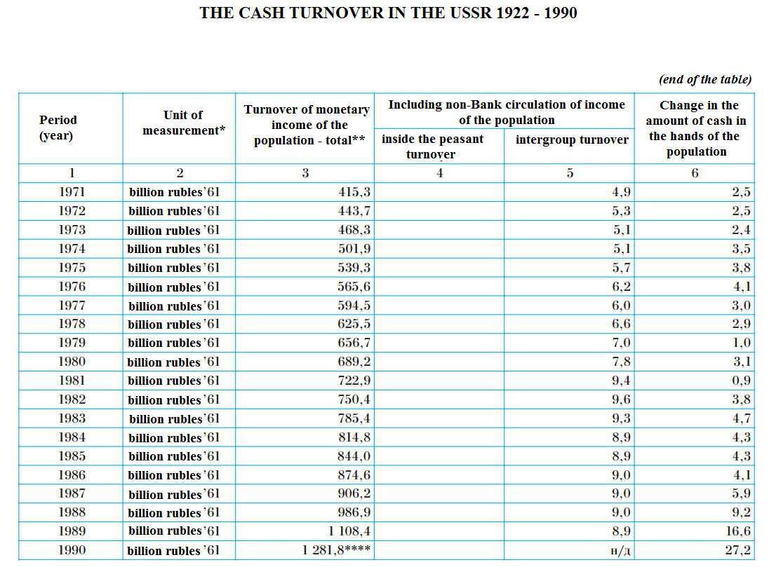
What did this circumstance and the subsequent reform of 1990 lead to, according to economist Krotov:
This leads to the simplest conclusion — the market elements in the economy are to blame for the escalating shortage of consumer goods, which described the anarchy of production described by the classics of Marxism-Leninism, inflated to the level of a perestroika counter-revolution, and kilometer-long queues, as it turns out in reality – this is the prerogative of the late perestroika USSR, and not at all of its heyday.

3. Future prospects
There is no doubt that the planned national economy will go on to show its great potential in the future – large-scale and deepening crises of capitalism will force people to seek alternatives. Public property and economic planning are the most accessible and historically proven ways to adequately accommodate developing circumstances. The course of social development works for us, since the change of productive forces and relations will require a new economic approach, and during crises and wars, revolutionary antagonisms become more acute, especially when the productive forces and productive relations come into their inevitable conflict. As a result, given the single-minded focus of the capitalists on extracting excess profits, even the leading high-tech concerns inevitably suffer when they encounter this inevitable contradiction.
Even now we can see that Microsoft is adding managers to its ranks, and that Elon Musk’s companies are working with a clear lack of profit, the costs thus tightening the belts of employees, including those working in inhumane conditions as company assemblers in third world countries. These are merely superfluous examples.
The capitalist class will use the Internet’s power as an all-seeing eye, not merely to track the movements and mentalities of rebellious individuals, but, above all, to establish clearer control by the banks over the income of workers. We are witness to the process of the transformation of productive forces into destructive forces as described in Marx’s “German Ideology”. But how should this manifest itself under socialism?
From all that has been written above, it becomes clear that the experience of building socialism is compatible with the extensive use of the latest technology, which in some places even surpassed the introduction of such in the capitalist camp. This accumulated experience will allow us to avoid repeating the mistakes that occurred in previous implementations of the planned economy and to look for ways to improve the methodology, the most obvious of which are: reducing bureaucracy, building on, clarifying and speeding up the system for collecting statistics, and minimizing the factor of human error.
This is expected to be achieved using the latest advances in telecommunications and automation. Attempts towards inspired technological feats like the Chilean Cybersyn and Soviet OGAS have already been made — and if the former failed due to the victory of Pinochet’s capitalist counter-revolution, it would be absurd to believe that OGAS was not a project of broader significance for large systems of state coordination, such as planned calculations, state statistics, the state bank and the state standard of the USSR were thoroughly automated, or were in the process of becoming automated.
Commanding new technological trends, including fully automated production lines, robotics, 3D printers, etc., will allow us to re-establish the planned development of the productive forces of society, snatching them from the clutches of the capitalists and concentrating them in the hands of the working people. The modern development of productive forces runs counter to the development of productive relations – all modern giant technological innovations are only slowly distributed by the capitalists, who use them only insofar as they can scrape out profitability.
Even in these conditions, assessing the uneven development of scientific and technical development in different imperialist countries and blocs, it should be noted that the post-Soviet space after the restoration of capitalism is noticeably inferior in many key parameters to historically advanced countries. For example, the number of robots implemented in Russian enterprises is dozens of times lower than for those in the United States, Japan, Germany and the Czech Republic, not to mention the presence of automated production lines and machine tools, and the huge sectors of the national economy where all this was actively implemented.
The concrete historical moment is that once socialist countries were plundered by both the local bourgeoisie and its global masters, both of them skillfully use the productive forces destructively, cunningly cybernize the banking system and thereby establish consolidated control of financial transnational capital over the income of workers. Of course, socialism must also use these new tools to bring about effective planning at the most advanced level, but in completely different ways and for completely different purposes than they are being done by state-capitalists.
Kuybyshev, a talented head of the State Planning Committee, said in a report at the XVII conference of the CPSU(b) about the second five-year plan: “The essence of the plan is that it should show not only what needs to be achieved in the end, but also how to do it, what are the levers of execution of the plan and how should the execution unfold in time and space.”
Let us proceed to our conclusions.

// Conclusion I
Systematic development of the national economy is possible only under socialism, where the state is governed by the workers, and a party armed with Marxism-Leninism while educating engineers and specialists, concentrates the productive forces of society in its hands. Under capitalism, the only possible centralization of the means of production is centralization in the hands of corporate board-room monopolies, which does not at all eliminate the lawlessness of their production, but on the contrary strengthens their unregulated power, leaving the workers with empty hands.

// Conclusion II
Systematic development of the national economy is possible only on the basis of the use of the latest technology in order to best meet the needs of the masses when replacing exchange with distribution (which is the basic economic law of socialism). The USSR mastered this latest technology in the 30s and up to the ’80s developed and advanced productive forces successfully, often surpassing the already-developed capitalist countries.

// Conclusion III
The state planning under socialism and capitalism is also distinguished by the fact that under socialism, unity of command and local initiative work in a harmonious way, ensuring broad participation of workers in the management of production from bottom to top – from the Permanent Production Council and factory committees to the plenums of the State Planning Committee, where representatives of labour collectives met, not to mention the significant role of the Supreme Council, where workers also met. In Western democratic planning, the “State Planning Committee” is the board-room of the capitalist.

// Conclusion IV
The history of implementing planned national economies shows what rates of labor productivity can be achieved in all major economic indicators, in the pace of scientific and technological progress, the education of the masses and their standard of living, thus, in the shortest possible time, becoming a fully independent, socialist state.

// Conclusion V
The planned national economy is marked by a new price policy, which is characterized by a centralized movement of goods, the elimination of anarchy of production, and the elimination of the abrupt price movement that is inherent in a capitalist economy. By leveling the law of value, which, under socialism, is no longer dominant, the pricing policy is developed in such a way that exchange is replaced by distribution. Lowering the price while reducing the cost of production and increasing labour productivity allowed the Soviet Union to make such historic and unprecedented leaps.

// Conclusion VI
The reasons for the decline and eventual disappearance of the planned national economy in the Soviet republics should not be found in increased centralization, but, on the contrary, in a departure from the founding principles of the Soviet economy. This is found to be the trend of introducing market elements into the economy and gradually transferring enterprises to self-sufficiency and autonomy.
The weakening of the class struggle led to the gradual growth of industrial petty-bourgeois tendencies and private interests within the Soviet national economy, when profitability was the cornerstone of production. The last nail in the coffin of a socialist planned economy was driven by the law on the property from 1991, which introduced the concept of the private property.

// Conclusion VII
The development of modern productive forces, with its 3D printers, Internet and robotics, is inevitably slowed by the mass impoverishment of workers, the loss of their buying power, and the export of production to the impoverished countries of the “third world”.

Original article

