Socialism will destroy American healthcare?
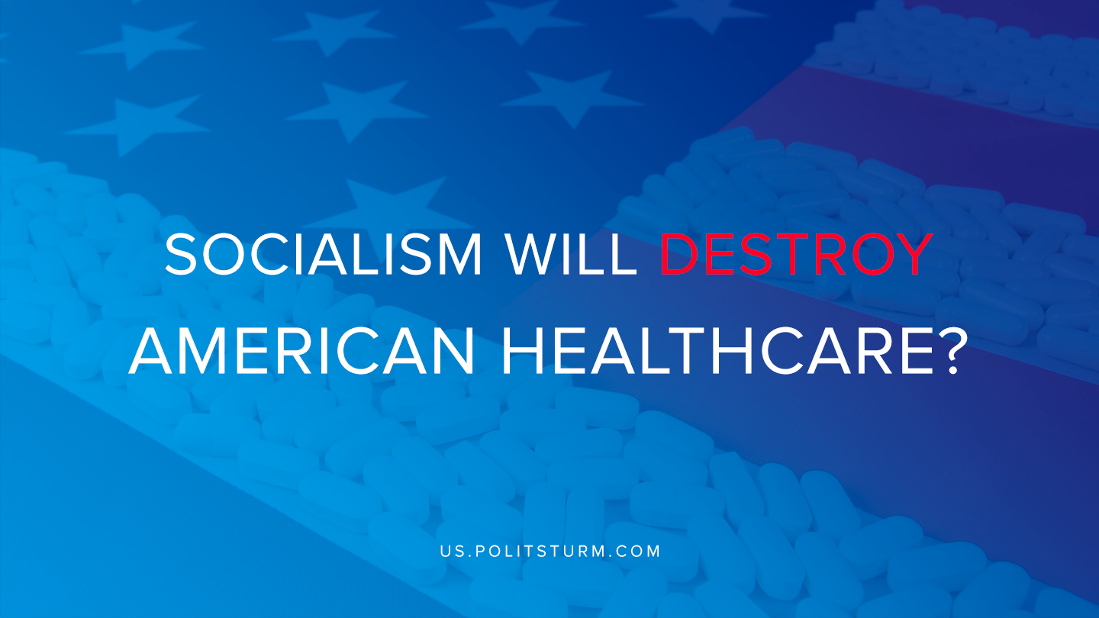

Original article
2020-02-22
2 min read

To this very day we face the struggle where the average American is forced to see so many people unable to afford healthcare. In the United States alone the average spending on healthcare needs for 60% of people or their family members is $1000 per year, while 38% of all asked would spend $2500 or more per year.
To put these numbers into perspective, around 58% of US adults have less than $1000 available for savings. In addition to the tremendous problem of healthcare – 45% of workers feel that the costs of healthcare will bankrupt them.
Yet we face the bourgeois-controlled media that proclaims that privatized healthcare is the most efficient system, that it is impossible to think that the free provision of healthcare could benefit society. This is reinforced by Trump’s statement, “We will never let socialism destroy American healthcare”.
Healthcare in the USA is simply the result of the capitalist system that exists to drain the pockets of the proletariat. It is not that Americans need to fly to Cuba to get cancer treatment instead of seeking it in the USA, it is because large corporations do not see that there is a need at having financial risks and spending money on vital medicine.
In response to the argument that innovation from corporations arises from the capitalist organization of production, is the constant influx of unimportant or simply useless medicine that has no effect on people, but are just widely used and prescribed, often that is the case with cancer medicine that has no effect on the patient.
“One study examines 93 cancer drug uses that were granted accelerated approval by the FDA between 1992 and 2017. Of those, only 19 showed improvement in overall survival.”
“A drug that increases a cancer patient’s well-being and comfort is also considered worthy of FDA approval even in cases where living longer is not likely. However, a recent study published in JAMA Internal Medicine looked closely at 18 drugs that had no survival benefit to see what effect they had on patients’ quality of life. The majority of the drugs either contributed to a worse quality of life—for example, patients suffered from diarrhea, fatigue, sleep disturbances or memory loss—or the evidence was mixed”
Hence Trump’s quote blatantly exposes the intention of the bourgeoisie class. Trump is correct because socialism will destroy American healthcare as we know it and will instead fully and freely provide healthcare to all that would need it, no longer force people to fall into medical debt, under-eat, or limit life opportunities.
We have the availability of computers with the ability to manage distribution, and central planning that will be managed by the people involved in the production process. Only then will American healthcare actually take care of our health. However, we must remember simply having free healthcare at the expense of greater exploitation of other countries is not socialism, as any of these offers made by the social democrats are temporary in nature. Lastly, we must remember, healthcare, in general, is underprovided by the capitalist mode of production, and that will always be so.
Sources: 1, 2, 3, 4, 5, 6, 7, 8

Original article

