Socialism or Capitalism?
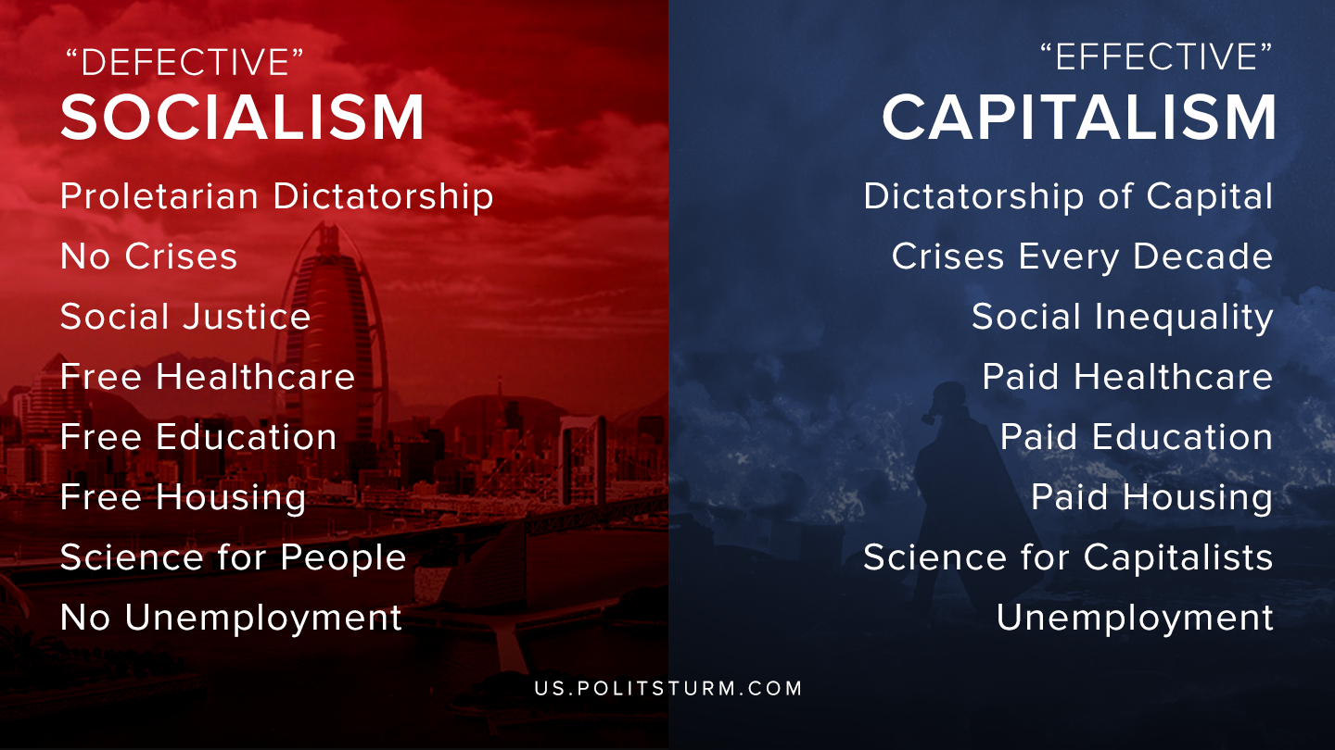

Original article
2020-05-31

–

Original article

