Siqueiros: The Art of Class War
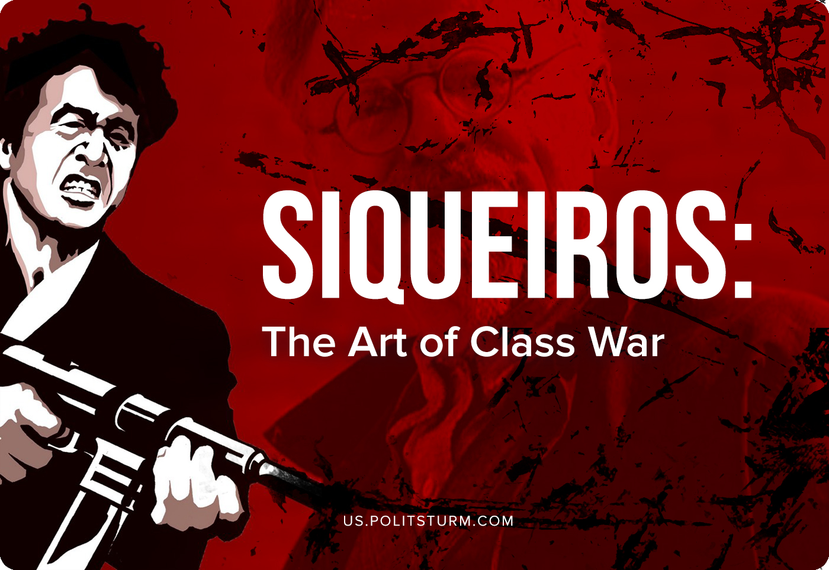

Original article
2020-11-24
15 min read

In the early morning of May 24, 1940, a group of people led by the Mexican artist David Alfaro Siqueiros arrived in Coyocan, a suburb of Mexico City. The purpose of their arrival was to attack the residence of Leon Trotsky, located here and living under the protection of Mexican police.
By that time, Siqueiros was a well-known artist, even outside of Mexico, and one of the founders of Mexican monumental painting.
As a young man, he was involved in the maelstrom of the Mexican bourgeois-democratic revolution, voluntarily joining the revolutionary army of Venustiano Carranza, in which he travelled a large part of the country, personally observing the unbearable life of Mexican workers and rural labourers.
It is these pictures of provincial horror, of hopeless poverty, as well as the huge impact of the example of the October revolution in Russia, which pushed Siqueiros to study Marxism-Leninism.
Error loading image
In 1922, Siqueiros became one of the many artists hired by the bourgeois-democratic government of Alvaro Obregón, who set the goal of educating the masses through art, the new art of a new democratic Mexico. In an effort to break art from the traditional Museum shackles and bring it closer to the masses, David Alfaro becomes one of those, who lays the foundations of Mexican muralism – monumental painting on the facades of walls of public buildings. Moreover, being a Communist and spontaneously moving towards socialist realism, Siqueiros gives his colossal paintings a sharp political sense of the struggle against exploitation – as far as it was possible in a progressive bourgeois democracy.
In 1923, David Alfaro founded the union of revolutionary artists, sculptors, and engravers, publishing the newspaper “El Machete”, which became the official organ of the Mexican Communist Party after Siqueiros himself was elected to the Central Committee of the MCP. On their behalf the artist conducts active “subversive” work both in the international arena (participating in various international political meetings in Moscow, New-York, Montevideo and Buenos Aires) and on the “domestic” front (leading, for example, the struggle of the miners’ union in the state of Jalisco).
Despite the fact that Siqueiros adhered to a strict Stalinist line in the fight against the Trotskyist-Bukharin opposition entrenched within the MCP, in March 1930 the party unexpectedly expelled him from its ranks. Why? Because at that moment, the new government of Pascual Ortiz Rubio launched a large-scale repression against all progressive forces, broke off diplomatic relations with the USSR and banned the activities of Communists. In these circumstances, the MCP decided to abandon their “favourite son”, allowing Siqueiros to avoid reprisals and continue his “educational” activities without being formally associated with the party apparatus.
On May 1st, 1930, Siqueiros, “exiled” from the MCP, took a lively part in the riots in Mexico City during an attempt by the police to disperse a worker’s demonstration. He and 11 of his comrades were arrested and charged with sedition. After 6 months, the artist was released on a large bail, but under the obligation to live exclusively in the city of Tasco.
Error loading image
However, in 1932, the Central Committee of the MCP entrusted the “exiled” Siqueiros with the formation of the “International Proletarian League”, an international artistic and political group of revolutionary artists, sculptors and writers. Following this, again on behalf of the Central Committee, David Alfaro participates in the work of the “Anti-Imperialist All-American League”, an international coordinating body operating under the auspices of the Comintern in the Americas. All this activity causes Siqueiros to leave Tasco more and more often, as a result, in the spring of 1932, the Mexican government finally expelled him from the country.
Living alternately in Los Angeles, Montevideo, and Buenos Aires, Siqueiros everywhere, in accordance with the directives of the Comintern, tried to unite and organize progressive artists around him, to direct their activities to the destruction and exposure of bourgeois culture, to the propaganda of the revolutionary overthrow of capitalism. Everywhere he organizes workshops, gives lectures, tries to initiate internal struggles and politicize existing art schools and associations of cultural workers.
During and after his exile, David Alfaro adhered to two principles of socialist art learned from Eisenstein: the first claimed that only the work that is revolutionary in its content, methods, materials and plastic techniques can contribute to the undermining of the existing system and the victory of the proletariat;
Thus, Siqueiros directly linked the revolutionism of artistic forms with the revolutionism of content. Following this path, David Alfaro was the first in the world to use a spray gun and car paint to create his large-scale, open-to-the-masses paintings, thus becoming the founder of the method that later, in the 70s in the United States will become known under the General name “graffiti”.
Error loading image
The second principle was that the link between artistic and political activity should be indissoluble; the revolutionary artist must lead the revolutionary struggle both through art and through direct personal practice.
Siqueiros is one of the world’s few revolutionary artists, who really observed this principle, not turning into a “salon revolutionary”, but really directing both his mental and physical forces to the cause of the victory of the working class. Both in the United States, Uruguay, and Argentina, David Alfaro relied on the help and support of local Communist parties as part of his artistic activities, working to form associations of artists, politicize them, promote revolutionary ideas and protect them.
It is not surprising that during his active artistic and revolutionary activities, Siqueiros was repeatedly persecuted, forced to move from place to place. In December 1934, the government expelled the artist from Argentina. Through New York, he returns to Mexico, where he re-joined the Communist party and the League of Revolutionary Writers and Artists, an international association created through the initiative of the Comintern, to counter rising fascism.
In January 1936, Siqueiros again arrived in New York, where he immediately formed an experimental art studio, which actively and in sometimes unexpected ways (for example, painting cars or producing monumental posters) supported the election campaign of the Communist Party of the United States, which nominated its candidates for President and Vice President.
From here, the United States, David Alfaro, true to the principle of unity of artistic art and revolutionary practice, at the end of 1936 went as a volunteer to Spain to participate in the war against fascism.
He returned home with the rank of Colonel only in 1939, among the other 50 Mexicans who survived out of more than 300 volunteers who went to defend the distant Republic.
Having witnessed the Trotskyist-anarchist revolt in Barcelona in May 1937, being a supporter of the Stalin’s hard line against counter-revolutionary distortions of Marxism-Leninism, David Alfaro together with members of the Mexican Communist Party and veterans of the Spanish Civil War tried to conduct a legal fight against the presence of Trotsky in the country through attempts to influence the left-wing petty-bourgeois Democrats led by President Lazaro Cardenas.
Here is how Siqueiros describes the facts leading up to the attack on May 24, 1940 in his memoirs, written in the 70s:
“Having exhausted all its possibilities by peaceful means to put an end to the existence of Trotsky’s headquarters in Mexico we turned to Vicente Lombardo Toledano (one of the leaders of the left wing of the ruling “Party of the Mexican Revolution”). Vicente Lombardo gave a real theoretical battle to Trotsky in Mexico. It was he who in our country sharply, in all directions, rebuffed the endless writing of Trotsky himself and other Trotskyists, especially Trotskyists from the United States. In practice, Vicente Lombardo did not leave any of Trotsky’s statements unanswered, using all possible forms of polemic: reports, speeches, articles. Who, we former Republican fighters thought, when we despaired of finding support in the Carden camp, could be our “godfather” if not Vicente Lombardo Toledano? He must have seen Cardenas and had a conversation with Him about Trotskyist activities in Mexico, but everything remained the same.
Cardenas’s position could not, we thought, be the result of mere bureaucratic stubbornness. There was a clear influence of other facts, most likely-this is the ideological confusion, political short-sightedness of General Lazaro Cardenas himself. Perhaps at that time he considered Trotsky’s struggle to be an ordinary “family quarrel” and did not see him as a tool in the hands of fascism on the one hand and American imperialism on the other. Of course, Cardenas did not see what Trotskyism could become in the event of a war with fascism. However, there is no doubt that both Hitler and Yankee imperialism regarded Trotsky and Trotskyism as reserve pawns, which can be used at the right moment – during the war or after it – to “settle accounts with communism”. Don’t counter-revolutionaries and imperialists use such notorious people from other countries for their own purposes?
In short, it was no longer a question of “taking revenge” on former Mexican soldiers who had fought in the Spanish Republican army against the Trotskyists for the dastardly revolt organized by the POUM in Barcelona, in the deep rear of the Republican front. It was now a question of preventing the violent propaganda that was being carried out from Trotsky’s headquarters, ostensibly from a truly Marxist, proletarian position against the Soviet Union. In addition, it became quite clear to us what services such “Marxism” could render to the possible aggression of the United imperialist forces against the first country of socialism. Our desire to eliminate this counter-revolutionary political center corresponded to the very dynamics of the development of the international situation, characterized by an increasing threat of war which could have occurred even before our intention was implemented, and therefore, we believed, it was justified from beginning to end.”
Siqueiros also mentions his meeting directly with President Cardenas, where it was explicitly stated that if the issue of the existence of Trotsky’s international headquarters in Mexico is not resolved peacefully, the former Spanish internationalists will resort to force methods. The last straw was the active participation of Trotskyists in Mexican political life: an old friend of Siqueiros and the muralist Diego Rivera, who became close to Trotsky, was appointed one of the leaders of the election campaign of Juan Almasan, a black reactionary and a protege of the land oligarchy, around which a broad and very heterogeneous coalition of discontents with the left-wing government of Cardenas has rallied.
The Mexican Communists decided to carry out an attack on the residence in Coyoacán. Siqueiros himself writes:
“Our main goal or global objective of the entire operation was to: capture all documents if possible, but avoid bloodshed at all costs. We believed that the death of Trotsky or any of his accomplices would not only not stop the development of Trotskyism as an international movement, the anti-Soviet and anti-Communist character of which has already been determined, but will have the opposite effect…
From the very beginning, we believed that even if we could not succeed and get documentary evidence first of all about those amounts, which Trotsky and his most prominent henchmen received from the owners of ultra-reactionary newspapers in the United States, mainly from the Hearst concern, nevertheless, the scandal caused by our actions will be another powerful pressure on the Cardenas government and will force it to ban the activities of Trotsky’s headquarters in Mexico.
We were further strengthened in our intentions when we learned that General Cardenas had finally come to a negative assessment of Trotskyism and to recognize the socialist character of the Soviet state”.
Thus, on the morning of May 24, 1940, a group of 25 members of the Mexican Communist Party, the miners’ Union, and veterans of the Spanish civil war led by David Alfaro Siqueiros attacked Trotsky’s headquarters in Coyoacan. Carefully neutralizing the police guard and overcoming the true fortress wall that separated the Trotsky residence from the street, members of the group broke into the house, but during a brief search found no papers or documents. After that, a random fire was opened in all directions, in the hope of raising as much noise as possible. Even a few incendiary bombs were thrown on the lawns in front of the house, some of which never exploded. After this, the attackers withdrew.
Siqueiros himself in his memoirs did not go into details of the attack, pointing out only that “…the details of this, yet another, our military operation is detailed in 15 or more volumes of our trial. With regard to my personal participation in this operation, I will only say that my task was to block the external security of the Trotsky house, consisting of 35 Mexican police officers armed with Mauser guns, and that this task was duly performed by me”.
The police quickly managed to identify individual participants in the attack, including the identity of David Alfaro Siqueiros, who was forced to hide in a mountain village in the state of Jalisco, with the help of activists from the Federation of Miners. On October 4, 1940, however, he was finally arrested.
At the trial, Siqueiros emphasized the political significance of the attack and placed some of the blame on President Cardenas, the progressive leader of the national reformist “Party of the Mexican Revolution”. Who, in spite of the open sabotage of the Trotskyists in the defense of the Spanish Republic (recall that Mexico was the only country in the world, with the exception of the USSR, that provided assistance to Spain in the fight against fascism), gave Trotsky an open platform to recite his anti-Communist and anti-Soviet principles, which contradicted the practice of granting political asylum. The image of a “poor persecuted politician” sitting in romantic self-isolation and maintaining “neutrality” in relation to intra-Mexican political life, drawn in the imagination of Cardenas, is false.
Just as false are Cardenas’ beliefs about “neutral” politics. There is no “neutrality”; any “neutrality” in the struggle between capitalism and socialism is a game on the side of reactionary forces:
“The real fact is that … President Cardenas handed the weapon to Trotsky so that from revolutionary Mexico he could fight against the international revolution and thus against the Mexican revolution itself”.
Siqueiros should have been convicted of participating in a demonstrative attack on Trotsky’s residence, but… The day before the verdict was announced, April 1941, the new President of Mexico, Manuel Avila Camacho, signed a decree on the forced expulsion of the artist from the country. The poet Pablo Neruda, also a well-known Communist who was working as Chile’s Ambassador in Mexico City at the time, helped David Alfaro move to this country where for 3 years he settled in the city of Chillian.
Subsequently, thanks to the active protection of the already mentioned Vicente Lombardo Toledano, Siqueiros returned to his homeland in November 1943 to continue his career as an artist and revolutionary.
It is worth noting that even at the end of his life, even after all sorts of “revelations” of the “Stalinist dictatorship” and “Stalinist crimes”, Siqueiros did not think of giving up his contribution to the fight against Trotskyism. In a memoir written in the early 70s, David Alfaro honestly says:
In all my testimony at the trial, as in subsequent statements, I always insisted on the fairness of our political actions, pointed out political reasons of a preventive nature and deplorable contradictions, which in this case entangled the Cardenas government, which was at that time the highest exponent of the ideals of the Mexican revolution…
I have never denied and do not deny that, formally, if we proceed from the current legislation, my participation in the attack on Trotsky’s house on May 24, 1940 is a crime. For this, I spent a long time in prison, more than three years in exile, lost a large amount of money, and was subjected to offensive attacks in the outside world”.

Original article

